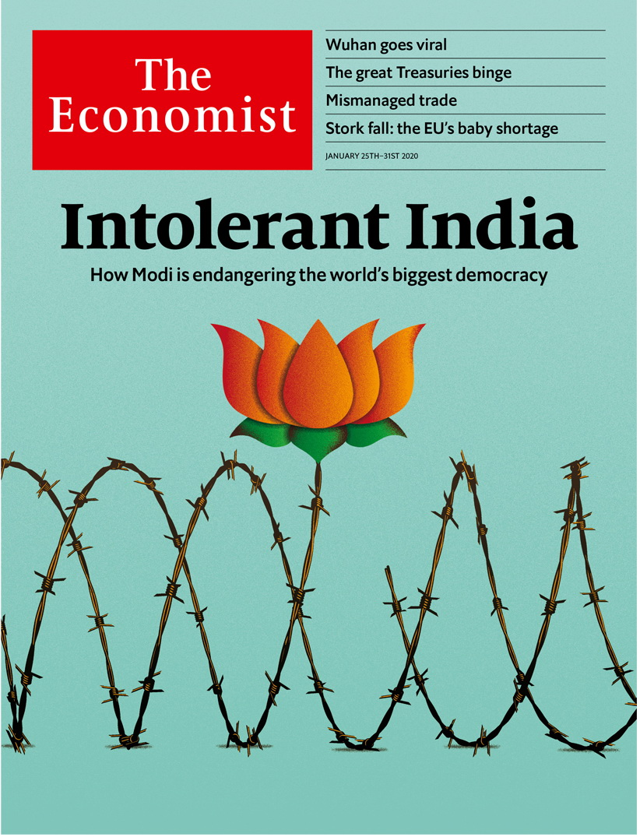

# Table of Contents

The world this week

Politics this week

Business this week

KAL’s cartoon

Leaders

India’s democracy: Intolerant India

Impeachment: Anything goes

Cyber-security: How to handle Huawei

Poland: The Lawless and Injustice party

The Chinese coronavirus: Time and again

Letters

Briefing

Narendra Modi’s India: Marching to a nastier tune

United States

Impeachment: Long days’ journey into acquittal

Regulating firearms: Bad shot

Internet governance: Unexpected domain

Rural demography: Homesteading 2.0

Criminal justice: Make it better

Agriculture: Business has gone sour in America’s dairy capital

Lexington: Could it be Bernie?

The Americas

Bolivia: Elusive estabilidad

Brazil: The press pressed

Asia

Infrastructure in the Philippines: “Build, Build, Build”

Australia’s greenhouse-gas emissions: Smoke and numbers

Vietnam’s energy mix: Sunny spell

Banyan: Sex, lies and videotape

China

Viral pneumonia: The Wuhan crisis

Chaguan: More equal than others

Middle East and Africa

Britain in Africa: Boris Johnson woos Africa

Lesotho: Murder in the mountains

Isabel dos Santos: A self-made something

Libya: The spoiler

Hacking Jeff Bezos: Alexa, define chutzpah

Europe

Poland: Law and Justice v law and justice

Russian disinformation: Memory wipe

Cyber-security in Germany: Their way or Huawei

Romanian farmers: Market-makers

France: Brutal facts

Britain

Aping ARPA: How to invent the future

Management gurus: Losing the title

EU citizens: Another Windrush?

Discrimination: Not black and white

Jobs: Sticky millennials

Scottish politics: Battle commences

Bagehot: The politics of somewhere

International

Private diplomacy: Not your average diplomats

Business

Bartleby: The number of the best

Bushfires and business: Singed but not scorched

European earnings: Techno-charged

Schumpeter: Moutai madness

Finance and economics

America’s public finances: The great Treasuries binge

India’s economy: Good down, bad up

Precious metals: Rhodium ride

Transatlantic trade tensions: Still frosty

Economic growth: Slower is better

Derivatives: Fare play

Energy markets: Special delivery

Free exchange: Tearing up the rule book

Science and technology

Neuroscience: Fly atlas

Personal identification: Finding it in one’s heart

Animal colouration: Beetle drive

Books and arts

Art and genocide: Caught on paper

Opera stars: The high life

American history: Safe havens

The future of work: If you can get it

Economic and financial indicators

Economic data, commodities and markets

Graphic detail

Obituary



### Friday, January 24, 2020

|  |  |
| --- | --- |
| The world this week | 3 |
| Leaders | 5 |
| Letters | 1 |
| Briefing | 1 |
| United States | 7 |
| The Americas | 3 |
| Asia | 5 |
| China | 3 |
| Middle East and Africa | 5 |
| Europe | 6 |
| Britain | 7 |
| International | 1 |
| Business | 7 |
| Finance and economics | 9 |
| Science and technology | 4 |
| Books and arts | 5 |
| Economic and financial indicators | 1 |
| Graphic detail | 1 |
| Obituary | 1 |

|  |  |  |
| --- | --- | --- |
|  | Sections | Leaders |

The world this week

Politics this week

.

Business this week

.

KAL’s cartoon

.

|  |  |  |
| --- | --- | --- |
|  | Sections | Leaders |

|  |  |  |  |
| --- | --- | --- | --- |
|  | Articles | Sections | Next |

# Politics this week

Jan 25th 2020 |

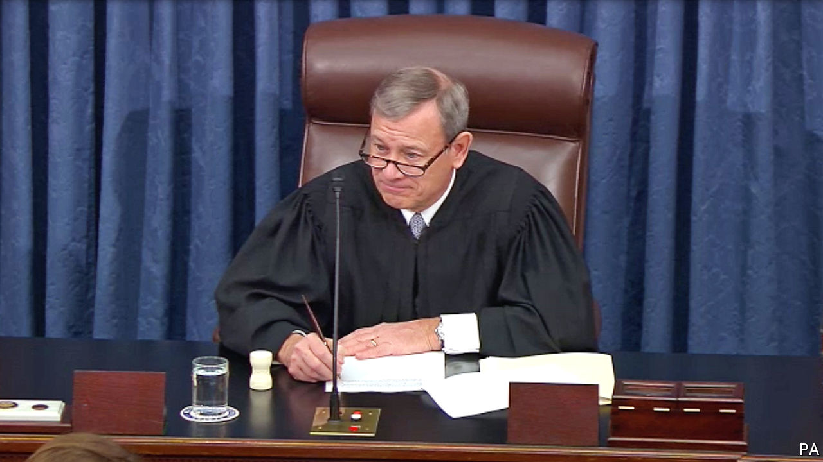

The opening arguments were heard in the Senate trial that will decide whether to remove Donald Trump from power following his impeachment by the House of Representatives. The president faces two charges: abuse of power, for pressing the Ukrainian government to investigate a political rival, and obstruction of Congress, for directing officials to ignore subpoenas. Mr Trump’s defence team includes Ken Starr, whose investigations led to Bill Clinton’s impeachment, and Alan Dershowitz, who helped defend O.J. Simpson. They argue the charges “do not remotely approach the constitutional threshold for removing a president from office”. See article.

## Investigating the investigator

Brazilian prosecutors asked a judge to indict Glenn Greenwald, an American journalist, for helping a group that had hacked the phones of judges and lawyers. Mr Greenwald used messages between judicial officials, including Sergio Moro, who is now Brazil’s justice minister, in stories that revealed inappropriate collaboration in pursuing corruption cases. Mr Greenwald says he obeyed the law and has called the investigation an attack on press freedom. See article.

Roberto Alvim was sacked as Brazil’s “special secretary of culture”, after he appeared in a video outlining the mission of his office in terms that seemed to echo language used by Joseph Goebbels, Hitler’s propaganda chief. Mr Alvim said any similarity with Goebbels’s words was a “rhetorical coincidence”. Jair Bolsonaro, Brazil’s president, said the speech was “unfortunate”.

Honduras ended the mandate of the Mission to Support the Fight Against Corruption and Impunity, which is backed by the Organisation of American States. The mission helped the attorney-general’s office prosecute 133 people for graft. The government said it had committed “excesses”.

Prosecutors in Mexico questioned 53 policemen in connection with the disappearance of Homero Gómez, who manages a habitat for monarch butterflies. Environmentalists fear that Mr Gómez has been harmed by loggers.

## Social-media influencer

UN experts called for an investigation into allegations that the crown prince of Saudi Arabia, Muhammad bin Salman, hacked the phone of Jeff Bezos, the boss of Amazon. A WhatsApp account belonging to Prince Muhammad has been implicated in the breach. It may have been an effort to “influence, if not silence” the Washington Post’s reporting on Saudi Arabia, said the experts. Mr Bezos owns the Post. See [article](https://www.economist.com/node/21778724).

At a summit in Berlin foreign powers promised to stop interfering in Libya’s civil war. But forces aligned with the government in Tripoli, which is supported by Turkey, and those of Khalifa Haftar, who is backed by Egypt, Russia and the United Arab Emirates, continued fighting. General Haftar’s men also shut down key ports and oil facilities. See article.

Iran threatened to quit the nuclear Non-Proliferation Treaty if Britain, France and Germany refer it to the UN Security Council over breaches to the nuclear deal they signed in 2015. The only country ever to withdraw from the NPT was North Korea, which then tested nuclear weapons.

A missile attack on a military training camp in Yemen killed 100 soldiers. The government blamed the Houthi rebels, who control the north. The Houthis did not claim responsibility.

Lebanon formed a new government, ending a months-long political deadlock. But protests continued in Beirut over corruption and an economy in crisis. In Iraq anti-government protests resumed after weeks of relative calm. Several people were reportedly killed and scores wounded in the unrest in Baghdad and other cities.

Some 700,000 leaked documents gave clues as to how Isabel dos Santos became Africa’s richest woman. She is the daughter of Angola’s former president. Angolan prosecutors accused her of embezzlement and moneylaundering. Ms dos Santos, who now splits her time between London and Dubai, denied the allegations.

## No halfway house, just out

Prince Harry and Meghan Markle finalised a deal about their independent future away from duties for the British royal family. In a statement the palace said that Harry and his wife will not use their HRH titles and will not represent the monarchy in any official capacity. The couple also confirmed “their wish��� to repay the taxpayers’ money spent on refurbishing their home in Britain. The couple now also live in Canada.

Vladimir Putin appointed a new cabinet in Russia, following his declaration of sweeping political reforms that could let him stay in power after his term as president expires in 2024. Most of the cabinet retained their jobs, including Sergei Lavrov as foreign minister. The new prime minister is Mikhail Mishustin, a more pliable technocrat than Dmitry Medvedev, who has resigned.

Luigi Di Maio resigned as head of Italy’s Five Star Movement, while remaining foreign minister. The quixotic populist party finished first in an election in 2018 but has since lost half its support. It now ranks behind the nationalist Lega and centre-left Democrats.

## Spreading rapidly

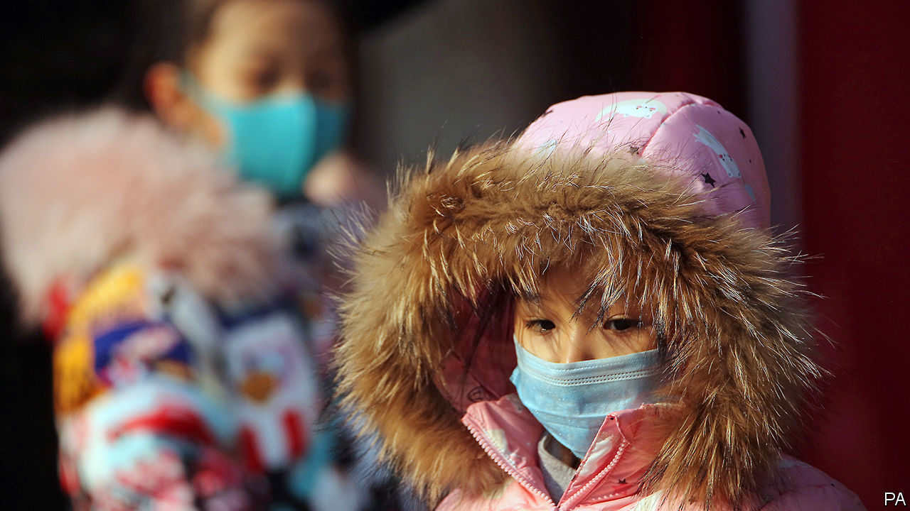

Hundreds of people in China were confirmed to have been infected by a newly identified form of coronavirus, a type that includes the one responsible for a deadly outbreak of SARS in 2003. Most of the cases have been found in the city of Wuhan, where the outbreak began. Seventeen people with the virus, which can cause pneumonia, have died. Travel restrictions were imposed on Wuhan and two nearby cities. See article.

A Chinese court sentenced a former head of Interpol, Meng Hongwei, to 13-and-a-half years in prison. Mr Meng was convicted of taking more than $2m in bribes. He was arrested in 2018 while on a trip back to China from France.

The newly appointed head of the Chinese government’s office in Hong Kong, Luo Huining, strongly hinted that the territory should pass legislation relating to national security. He said current loopholes in the “national-security mechanism” could allow “external forces” to engage in infiltration and sabotage.

The International Court of Justice in The Hague issued an interim ruling in the Gambia’s complaint against Myanmar for genocide. It ordered Myanmar to take measures to prevent further harm to Rohingyas, a Muslim minority that were victims of an army-led pogrom in 2017. The decision comes despite the personal appearance of Aung San Suu Kyi, Myanmar’s leader, before the court in December to argue against any such order. The court has no power to enforce its ruling.

This article was downloaded by calibre from <https://www.economist.com/the-world-this-week/2020/01/25/politics-this-week>

|  |  |  |  |
| --- | --- | --- | --- |
|  | Articles | Sections | Next |

|  |  |  |  |
| --- | --- | --- | --- |
| Previous | Articles | Sections | Next |

# Business this week

Jan 25th 2020 |

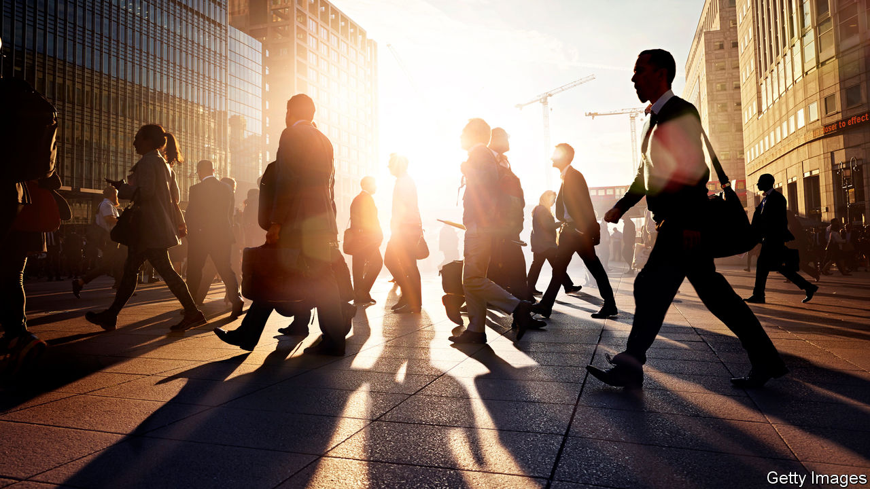

The IMF trimmed its forecast for global growth in 2020, to 3.3%. The fund welcomed both the easing of the trade war between China and the United States and the diminishing probability of a no-deal Brexit, but said the prospects for economic growth remain weak overall. America’s GDP is expected to expand by 2% in 2020 and the euro area’s by 1.3%. Although the clouds are still swirling over Brexit, Britain’s economic outlook is slightly brighter than had been forecast in the past. Its economy is projected to grow by 1.4% this year and 1.5% in 2021. In other good news for the new government, Britain’s labour market has strengthened. The employment rate is at its highest level since records began in 1971, and labour-market inactivity is at a low.

China’s economy grew by 6.1% last year, the slowest pace since 1990. The trade war with America hit already-weak consumer spending and exacerbated a slowdown in the property market. The IMF reckons that China’s GDP will expand at an even slower rate, by 6% this year and 5.8% next year.

An annual worldwide survey of chief executives conducted by PwC found that 53% think that global economic growth will decline over the coming year. That compares with 29% who were asked the same question about economic prospects in 2019 and just 5% in 2018.

Boeing pushed back the date for when it expects regulators will allow the 737 MAX to fly again until the middle of the year. It had hoped to get regulatory approval this month. Airlines now cannot count on the plane’s return to service for the busy summer season.

France agreed to delay collecting revenues from a new sales tax on digital companies, a concession to America, which claims the levy is aimed solely at American tech giants like Google and Amazon and is threatening to retaliate with tariffs on French goods. The two countries hope to reach a formal resolution by the end of the year. Steven Mnuchin, America’s treasury secretary, warned Britain and Italy to hold off on plans for digital taxes of their own, or else “we’ll be having similar conversations with them”.

## Stranger things

Netflix added 423,000 subscribers in America during the last quarter of 2019. Although that was well below expectations, it gained 8.3m customers in other countries. The video-streaming firm tallied 167m users overall, with international viewers accounting for an ever larger slice of its base. In a harbinger of potential problems, the weakness in Netflix’s domestic market coincided with the roll-out of rival services from Disney, Apple and others, which will compete with Netflix worldwide.

Vodafone became the latest big name to pull out of the association that is developing Libra, a digital currency devised by Facebook that has run into difficulties with financial regulators. The departure of the global telecoms group leaves only a handful of widely recognised “partners” in the association, such as Uber.

Gap scrapped a plan to hive off its Old Navy clothing line into a separately listed company. The retailer has concluded that the “cost and complexity” of pursuing the split would not produce the expected benefits.

Prosecutors for the Brazilian state of Minas Gerais charged 16 people with homicide over the collapse of a dam last January that killed 270 people. Among those indicted were the former chief executive of Vale, the mining company that owned the dam, and five people from the German firm that had certified the dam’s safety.

## Train cancelled?

Doubts were raised about whether the HS2 high-speed rail project in Britain would go ahead, after the estimate for its cost soared to as much as £106bn ($140bn). The government is expected to make a final decision on whether to give HS2 the green light next month.

In its biggest acquisition since 2007, BAE Systems agreed to pay $1.9bn for a GPS system widely used by America’s armed forces and owned by Collins Aerospace. The defence company is already one of the Pentagon’s largest suppliers.

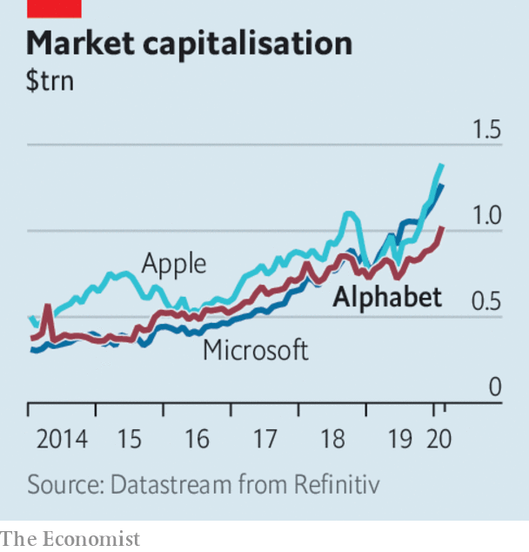

The share price of Alphabet continued to climb, after the market capitalisation of Google’s parent company passed the $1trn mark. It joins three other American companies that have seen their stockmarket value rise above that level: Amazon (briefly), Apple and Microsoft. They all have some way to go to become the world’s most valuable listed company. That crown now belongs to Saudi Aramco, which is worth $1.8trn following its IPO last month.

Tesla’s market value accelerated past $100bn for the first time, making it the world’s second-most-valuable car company, after Toyota. Tesla’s share price has risen by a third since the start of the year. It still accounts for only a tiny fraction of global car sales. Last year it delivered 367,500 vehicles, compared with 11m from Volkswagen alone.

This article was downloaded by calibre from <https://www.economist.com/the-world-this-week/2020/01/25/business-this-week>

|  |  |  |  |
| --- | --- | --- | --- |
| Previous | Articles | Sections | Next |

|  |  |  |  |
| --- | --- | --- | --- |
| Previous | Articles | Sections | Next |

# KAL’s cartoon

Jan 25th 2020 |

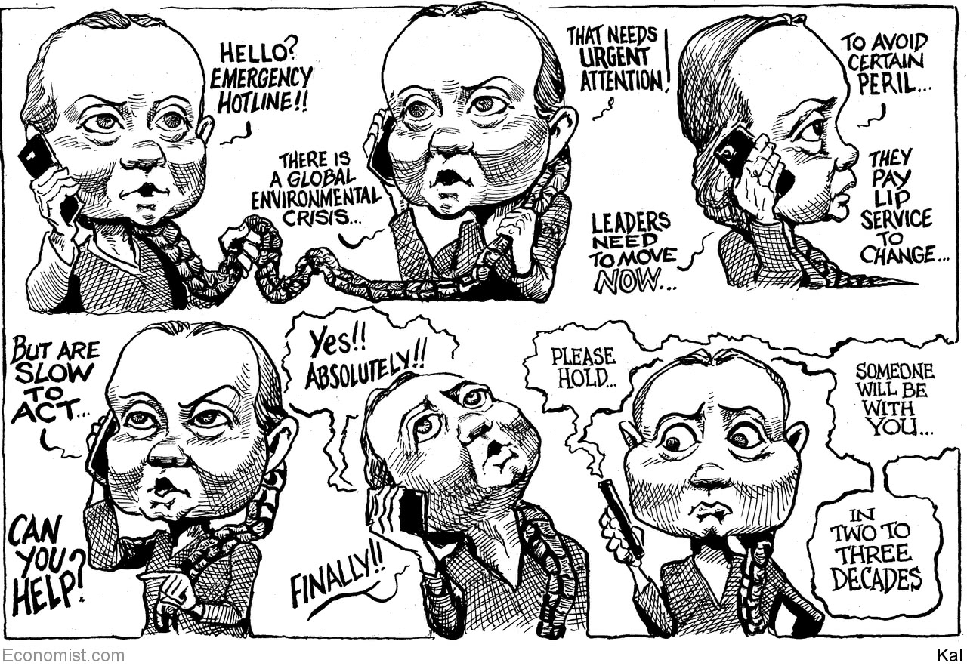

This article was downloaded by calibre from <https://www.economist.com/the-world-this-week/2020/01/25/kals-cartoon>

|  |  |  |  |
| --- | --- | --- | --- |
| Previous | Articles | Sections | Next |

|  |  |  |
| --- | --- | --- |
| The world this week | Sections | Letters |

Leaders

India’s democracy: Intolerant India

.

Impeachment: Anything goes

.

Cyber-security: How to handle Huawei

.

Poland: The Lawless and Injustice party

.

The Chinese coronavirus: Time and again

.

|  |  |  |
| --- | --- | --- |
| The world this week | Sections | Letters |

|  |  |  |  |
| --- | --- | --- | --- |
|  | Articles | Sections | Next |

#### Intolerant India

# Narendra Modi stokes divisions in the world’s biggest democracy

India’s 200m Muslims fear the prime minister is building a Hindu state

Jan 23rd 2020 |

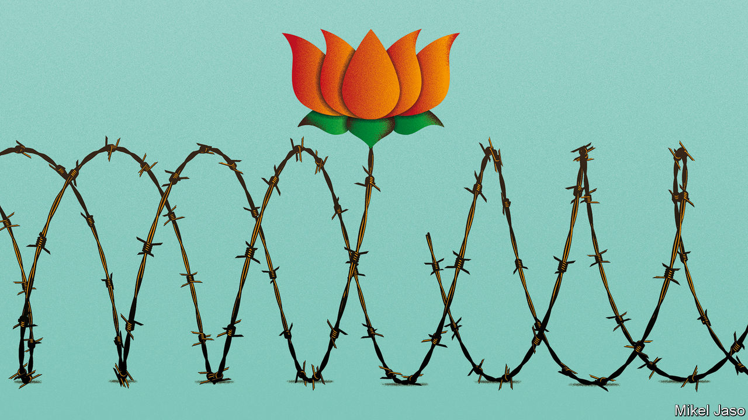

LAST MONTH India changed the law to make it easier for adherents of all the subcontinent’s religions, except Islam, to acquire citizenship. At the same time, the ruling Bharatiya Janata Party (BJP) wants to compile a register of all India’s 1.3bn citizens, as a means to hunt down illegal immigrants (see [Briefing](https://www.economist.com/briefing/2020/01/23/narendra-modis-sectarian-agenda-has-gone-too-far)). Those sound like technicalities, but many of the country’s 200m Muslims do not have the papers to prove they are Indian, so they risk being made stateless. Ominously, the government has ordered the building of camps to detain those caught in the net.

You might think that the BJP’s scheme was a miscalculation. It has sparked widespread and lasting protests. Students, secularists, even the largely fawning media have begun to speak out against Narendra Modi, the prime minister, for his apparent determination to transform India from a tolerant, multi-religious place into a chauvinist Hindu state.

In fact, the scheme looks like the most ambitious step yet in a decades-long project of incitement. The BJP first rose to national prominence by agitating for the demolition of a mosque in the city of Ayodhya, to make way for a temple to Ram, a Hindu deity. The destruction of the mosque in 1992 by a mob of Hindu extremists, followed by deadly riots, only propelled the party’s ascent. Likewise, a massacre of Muslims in the state of Gujarat in 2002, when Mr Modi was chief minister, made him a hero to Hindu nationalists around the country.

Alas, what has been electoral nectar for the BJP is political poison for India. By undermining the secular principles of the constitution, Mr Modi’s latest initiatives threaten to do damage to India’s democracy that could last for decades. They are also likely to lead to bloodshed.

The sad truth is that Mr Modi and the BJP are likely to benefit politically by creating divisions over religion and national identity. Such subjects keep the party’s activists and their allies in Hindu-nationalist groups energised—always a boon, given India’s relentless sequence of state elections. They also distract attention from awkward topics such as the economy, which has struggled since the BJP’s thumping election victory last year (see article). Most important, Mr Modi seems to calculate that a sizeable minority of Indian voters are sympathetic to his constant insinuation that Muslims are dangerous fifth-columnists, always scheming to do Hindus down and sell out their country to Pakistan. That is enough to keep him in office. Because of India’s first-past-the-post electoral system and a divided opposition, the BJP won its outright majority in parliament with just 37% of the vote.

Just now the BJP may be hunting for a new grievance. The Supreme Court recently issued a ruling that had the effect of depriving it of its favourite cause, by clearing the way for a Hindu temple to be built at the site of the demolished mosque in Ayodhya. The citizenship ruckus appeals to the party for the very same reasons that it has prompted widespread alarm. The plan to compile a register of genuine Indians as part of a hunt for foreign interlopers affects all 1.3bn people in the country. It could drag on for years, inflaming passions over and over again, as the list is compiled, challenged and revised. Just how the register will be drawn up, and what the consequences of exclusion are, remain woolly. Indeed, Mr Modi is already claiming it has all been misunderstood. Meanwhile, the hullabaloo helps reinforce the notion, so electorally valuable to the BJP, that Hindus, although about 80% of the population, are threatened by shadowy forces that it alone has the courage to confront.

This imperils the inspiring idea of India as the world’s largest democracy. Mr Modi’s policies blatantly discriminate against his Muslim compatriots. Why should a secular government shelter persecuted Hindus from Afghanistan, Bangladesh and Pakistan, but explicitly vow not to take a single downtrodden Muslim? The citizenship row is only the latest in a series of affronts, from the BJP’s lionising of vigilantes thought to have killed Muslims to the collective punishment of the people of the Kashmir valley, who have suffered arbitrary arrests, smothering curfews and an internet blackout for five months.

Since independence, India has confounded predictions that its democracy would crumble by accommodating its many constituencies of language, ethnicity, caste and religion. A secular and impartial government, even if flawed in many other ways, protects all these groups. The deliberate and sustained persecution of one of them constitutes an implicit threat against all—and so puts the political system at risk. Voters should recall that the BJP has experimented with policies that disadvantage other minorities, from low-caste Hindus who defy the party’s view of their religion to speakers of languages other than Hindi.

Because his rabble-rousing has a human cost, Mr Modi is also tarnishing the memory of Mahatma Gandhi, a preacher of non-violence. As it is, many Muslims have been lynched or beaten to death for supposed slights to Hinduism, such as loving a Hindu woman or killing a cow. From time to time the stoking of anti-Muslim sentiment leads to massacres like the one in Gujarat, in which more than 1,000 people were killed. By perpetually firing up Hindus and infuriating Muslims, the BJP makes fresh bloodshed more likely.

Mr Modi may imagine he can keep communal tensions under control, ramping them up and tamping them down as his political fortunes demand. But even if he is only cynically exploiting religious bigotry, many in the Hindu nationalist rank-and-file are true believers. They are not easily restrained, as the slaughter in Gujarat showed. With his warlike rhetoric about Pakistan, his head-cracking in Kashmir and his flagrantly biased approach to citizenship, the prime minister has raised the zealots’ expectations. He may not want to take things too far—he has a country to govern—but they will have no such compunction.

## Something worth defending

Happily, many Indians have already had enough, as the recent protests show. The Supreme Court, which this week declined to suspend the citizenship law, should heed this, show some unexpected spine and declare it unconstitutional. And rather than stoke hostility between two of the world’s great religions, Mr Modi should look for other paths to voters’ hearts. ■

This article was downloaded by calibre from <https://www.economist.com/leaders/2020/01/23/narendra-modi-stokes-divisions-in-the-worlds-biggest-democracy>

|  |  |  |  |
| --- | --- | --- | --- |
|  | Articles | Sections | Next |

|  |  |  |  |
| --- | --- | --- | --- |
| Previous | Articles | Sections | Next |

#### Impeachment

# America’s anything-goes presidency

What will be the result of Donald Trump’s tussle with Congressional Democrats?

Jan 25th 2020 |

IT IS THE oldest problem in politics: what should you do when a ruler who legitimately holds office betrays the people he rules? The impeachment clause in America’s constitution is a 200-year-old remedy to that problem, but it was informed by a tussle on the other side of the Atlantic that goes back much further—to the impeachment of Michael de la Pole, the king of England’s finance minister, in 1386. When the authors of America’s constitution were designing a system of self-government, they borrowed from that ancient tradition. If Americans picked a president who then committed “Treason, Bribery, or other High Crimes and Misdemeanours”, then the legislature could remove him.

Impeachment has always been hard to use. No president has ever been impeached in the House and convicted in the Senate, and not because no president has done anything that would warrant removal. Although the threshold for removal was thus already set very high, in the course of Donald Trump’s impeachment inquiry and trial, it has been sent somewhere into the outer atmosphere. At the same time, Mr Trump’s defence has rested on an exorbitant interpretation of executive power. This will have consequences for the rest of Mr Trump’s presidency—he will no doubt be acquitted—and for how America is governed when he is gone. They will not be good.

The harm to the mechanism of impeachment is partly the fault of the House Democrats. Rather than wait for support from the courts over whether the White House should be compelled to release evidence and witness testimony to an impeachment inquiry, they rushed the hearings because the most politically expedient thing to do was to get it over with as fast as possible. But much more blame lies with the president and his party—Mr Trump for his blanket refusal to participate, and his party for supporting him in that endeavour (see article).

The Senate majority leader, Mitch McConnell, last week swore an oath “to do impartial justice” in Mr Trump’s Senate trial, a month after he promised “total co-ordination” with the White House. He has kept only one of these promises.

After complaining that the impeachment process in the House was dreadfully unfair on the president, Mr McConnell this week designed a process in the Senate with the aim of letting Mr Trump off the hook in perhaps little more than a week. This has entailed Republican senators swallowing some odd ideas from the president’s legal team. One of these is the circular argument that there is no need for the White House to release any evidence because the president has done nothing wrong, and that the absence of that same evidence means the case against Mr Trump is non-existent. Another is that the president cannot be impeached because he has not broken a federal law. This expansive view of executive power would permit an awful lot of injury to the republic.

Relatively unbounded by the mechanism of impeachment, Mr Trump could do as he pleases in the remainder of his first term (and perhaps in a second). He could interfere in domestic investigations, bend foreign policy out of shape to damage a political rival, or solicit help from another government in November’s election—China, Russia, are you listening? Once re-elected, there would be fewer checks on him. The result, perversely, is that the failed trial of a president deemed unfit for office by the House for misdemeanours that seemed to warrant impeachment and removal would emerge more powerful than ever.

His supporters might conclude that is a good thing. But even they should think again. American politics has a tendency to swing from one pole to another. A Democratic equivalent of Mr Trump would no doubt enjoy freedom from the possibility of impeachment at some future date. Precedent is not binding when it comes to impeachment trials, but what happens in this one will inform the next. And the lesson from the impeachment trial of 2020 seems likely to be: anything goes.■

This article was downloaded by calibre from <https://www.economist.com/leaders/2020/01/25/americas-anything-goes-presidency>

|  |  |  |  |
| --- | --- | --- | --- |
| Previous | Articles | Sections | Next |

|  |  |  |  |
| --- | --- | --- | --- |
| Previous | Articles | Sections | Next |

#### Cyber-security

# Huawei is a cyber-security risk

But risks can be managed

Jan 25th 2020 |

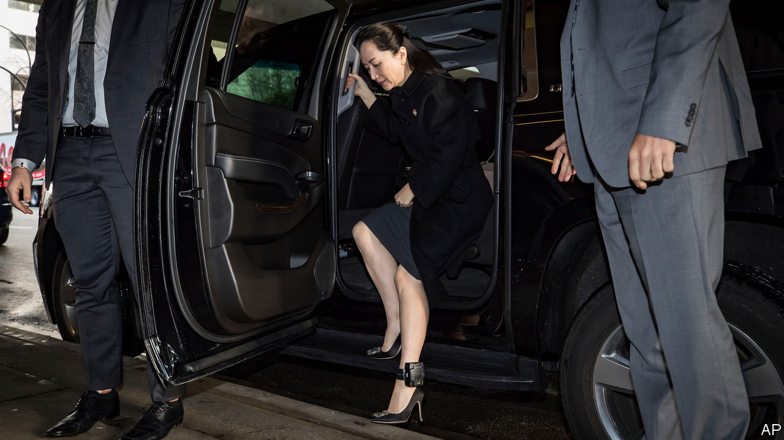

NO FIRM EXEMPLIFIES the arguments around technology better than Huawei. The Chinese firm has risen from an obscure importer of foreign telecoms gear to one of the world’s biggest makers of equipment for fifth-generation (5G) mobile networks. Its prowess has caused jitters in other countries, which worry that Huawei’s kit might come with “back doors”—deliberate security holes that could act as conduits for Chinese spies or cyber-saboteurs.

America, in particular, has the firm in its sights. It orchestrated the arrest in Canada of Meng Wanzhou, Huawei’s chief financial officer (and daughter of its founder), who was in court this week on charges of sanctions-busting (see [article](https://www.economist.com/business/2020/01/25/huawei-finance-chiefs-extradition-hearings-begin)). It has been lobbying allies to freeze the firm out of their domestic 5G systems. Australia and Japan have already done so. A decision in Britain is due by the end of the month; it seems minded to risk a transatlantic tiff and give the firm the green light. In Germany Angela Merkel is at odds with the many in her party who want to keep Huawei out (see article). Other countries, from Brazil to India, must make similar choices.

The hawks have a strong case. No back doors have so far been found in Huawei’s gear. But big countries are not above using tech champions for espionage. It is foolish to assume that China, with its long record of hacking and intellectual-property theft, is an exception. The country is a one-party dictatorship. Under Xi Jinping it has become increasingly repressive at home and assertive abroad. Huawei insists it does not aid spying overseas and would refuse to do so if asked. The most generous explanation of its stance is that its bosses are loyally saving face. The idea that Mr Xi would allow such defiance is fanciful.

Yet despite those worries, this newspaper believes Huawei should be allowed to compete. Its products are high-quality and cheap (albeit with help from large dollops of state aid). Excluding it would be costly and risks delaying 5G. It would add to the pressure to reverse the globalisation that has helped keep costs down and progress ticking in the tech industry. And though the risks are real, countries can adopt three broad strategies to mitigate them.

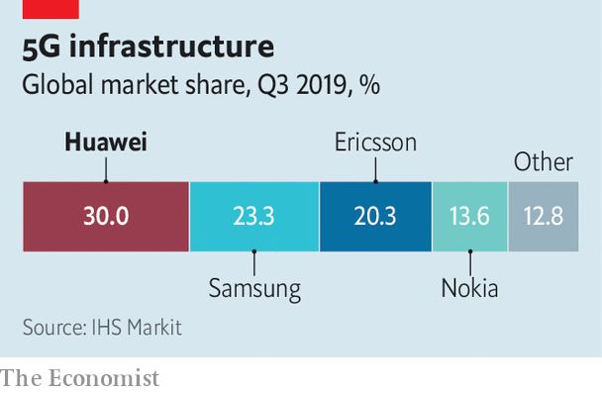

The first is technical. Encouraging encryption would ease spying concerns, since intercepting data would produce only gibberish. Networks should be defended in depth. Attempts to keep intruders out should be backed by monitoring to spot those that nonetheless get through, and systems designed to limit the damage they can do. Britain, for instance, plans to exclude Huawei from sensitive parts of its networks, though geography may limit that approach elsewhere. Because accidental bugs can be as dangerous as deliberate back doors, having several suppliers and spare capacity is a good idea, so that a single flaw does not leave the entire network vulnerable. Redundancy and resilience are the watchwords.

Second, countries should encourage existing industry trends towards openness. Today’s telecoms networks are built with proprietary products. In future they will become just another piece of software running on off-the-shelf computers. That should allay worries about compromised hardware and make it easier for new entrants to compete. Open source is also in vogue. An alliance of tech companies is keen on open-source versions of the antennae and masts that make up a mobile network’s outer edge. Having code and devices open for inspection makes it easier to find security holes, and harder to hide back doors. Open-source software already powers much of the internet. The more that telecoms networks can follow that example, the better.

And third, international co-operation can help. Britain already strips down and inspects all Huawei kit. Sharing its results and experience more widely would make more eyes available to keep Huawei honest. Europe’s efforts to establish a common set of criteria are to be welcomed. In the longer term, an international inspection body, perhaps modelled on the International Atomic Energy Agency, would be a good idea. That may sound unlikely at a time when multilateralism is out of fashion, but it would be in everyone’s interests. Buyers would be reassured that they were not purchasing compromised equipment, and sellers would be able to prove their trustworthiness.

Computer security, like all security, is about trade-offs, not absolutes. It is naive to assume that banning Huawei is sufficient to protect networks from attackers, of any nationality. Back doors are a worry, but most hackers make do with the accidental flaws that plague all digital devices. Russia, for instance, has no domestic electronics industry to speak of, and thus no ability to insert back doors. That does not hamper its hackers—nor those of Iran and North Korea. Designing robust networks, building them with checkable equipment and sharing knowledge and expertise will make life harder for hackers from all countries, not just China. Such measures would be worthwhile even if the doubts surrounding Huawei did not exist. The fact that they do simply makes the need more pressing. ■

This article was downloaded by calibre from <https://www.economist.com/leaders/2020/01/25/huawei-is-a-cyber-security-risk>

|  |  |  |  |
| --- | --- | --- | --- |
| Previous | Articles | Sections | Next |

|  |  |  |  |
| --- | --- | --- | --- |
| Previous | Articles | Sections | Next |

#### Mauling the law in Warsaw

# Poland’s ruling party should stop nobbling judges

Its “reforms” threaten not only Poland but also Europe

Jan 25th 2020 |



A RULE OF thumb about the rule of law is that countries that have it are freer, fairer and richer than those that do not. Independent courts ensure even the mighty are subject to the law. But Poland’s ruling Law and Justice party (PiS) takes a different view (see [article](https://www.economist.com/node/21778707)). It complains that judges are self-serving, unelected elites who substitute their own preferences for those of voters. Since taking office in 2015 PiS has passed laws that give the government ever more control over the judiciary, violating the commitment to uphold the rule of law that Poland made when it joined the European Union.

This conflict is coming to a head. The European Commission and the European Court of Justice (ECJ) have declared several Polish reforms incompatible with EU law. One change would have forced a mass retirement of judges, and given the government and parliament control over appointing new ones. Another set up a disciplinary chamber that can punish judges for their decisions. Others put the justice minister in charge of appointing senior judges who decide which of their colleagues hear which cases. Each time the aim is to make judges bow to politicians.

The bench is fighting back. Some judges have asked the ECJ whether colleagues appointed under the new system are legitimate. In December an ECJ ruling led Poland’s Supreme Court to reject the authority of the disciplinary chamber overseeing it. The government struck back with a still tougher measure barring judges from using European law against its reforms. Polish judges have taken to the streets. The commission has asked the ECJ to order Poland to suspend the disciplinary chamber.

PiS’s efforts against judges could harm not only Poland but also Europe. Each member state’s courts are obliged to apply EU law without political interference, and accept the ECJ as the final arbiter. If one member refuses to do so, the integrity of the whole system will start to crack.

The Polish government gives three reasons for its changes. First, it claims that Poland’s judiciary was never properly de-communised. This is bunk. The average judge was a teenager when Polish communism collapsed in 1989. Second, Poland’s courts are too slow. This is true, but the main problems are creaky IT and a lack of support staff, which the reforms ignore. Third, it says the new disciplinary chambers are needed to punish judges for such things as drink-driving. If so, why have they been used to harass judges who query PiS’s policies?

When accused of undermining the rule of law, Polish officials retort that their new rules are similar to those in other European countries. This is misleading. Poland has taken elements of systems that exist elsewhere and combined them so as to shift power to the ruling party. For example, many countries give both their parliaments and their national jurists’ associations a say in picking judges, as Poland does. But in Poland, since 2017, parliament has appointed most members of the jurists’ association as well. In effect, PiS controls the entire process.

PiS’s other argument is that its critics are biased against Poland. On January 16th the Venice Commission of the Council of Europe, a body of legal experts, issued a withering critique of the new judiciary law. Zbigniew Ziobro, Poland’s justice minister, simply accused the commission of applying different standards for western and eastern EU members, “segregat[ing] European countries into better and worse ones”.

Such naked appeals to nationalism will not deceive legal experts. If Poland nobbles its courts, the ECJ will eventually rule that they cannot be trusted. Any foreigner who loses a case in Poland could then turn to another European country’s courts, which could ignore the Polish decision. Cut off from European law, Poland would, in effect, be cut off from the EU itself.

Only Poland can avert this disaster. The government has rushed its new judiciary bill through the lower house of parliament, where it has a majority. However, the opposition-controlled Senate, though it cannot kill the bill, is likely to send it back for amendment. At that point, the government should drop the measure, just as, under EU pressure, it scrapped its plans for a mass retirement of judges in 2018.

If it does not, the ECJ should suspend the disciplinary chambers. European leaders and the European Parliament should press ahead with plans to dock aid in the next EU multi-year budget to countries, including Poland, that harm the rule of law. Countries outside Europe should weigh in, too, as some American lawmakers have. Businesses operating in Poland should warn the government that a split from EU law would cause grave economic damage. And Polish voters should wake up. Those who defend the rule of law are defending the fundamental rights of all Poles, including PiS’s own supporters. ■

This article was downloaded by calibre from <https://www.economist.com/leaders/2020/01/25/polands-ruling-party-should-stop-nobbling-judges>

|  |  |  |  |
| --- | --- | --- | --- |
| Previous | Articles | Sections | Next |

|  |  |  |  |
| --- | --- | --- | --- |
| Previous | Articles | Sections | Next |

#### Out of China

# The world is better prepared than ever to stop the Wuhan coronavirus

But its true dangers will not be known for some time

Jan 25th 2020 |

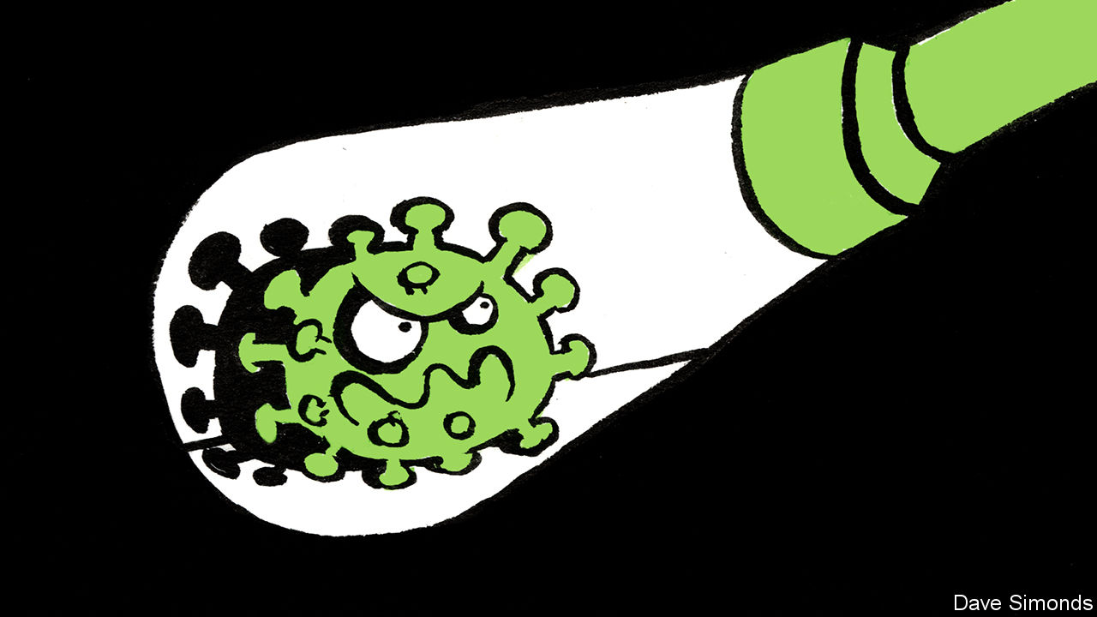

Editor’s note (January 23rd): This article has been updated to mention new cases of the virus and restrictions in Wuhan.

HOW AND when it infected the first human being, by making the jump from an animal, is anybody’s guess. But one thing is certain about the new coronavirus which was discovered in December in China and is now causing a global scare: it is a known unknown. And this, along with the health authorities’ response so far, is mostly good news.

People’s fear is understandable. As The Economist went to press, over 600 cases had been confirmed in six countries, of which 17 were fatal. The new virus is a close relative of SARS (severe acute respiratory syndrome), which emerged in China in 2002 and terrorised the world for over half a year before burning out. SARS afflicted more than 8,000 people and killed about 800, leaving in its wake $30bn-100bn of damage from disrupted trade and travel (see article).

That toll would have been lower if the Chinese authorities had not hushed up the outbreak for months. But things are very different this time. The Chinese have been forthcoming and swift to act. Doctors in Wuhan, the metropolis where it began, have come in for criticism, but the signs are that they promptly sounded an alarm about an unusual cluster of cases of pneumonia—thereby following a standard protocol for spotting new viruses. Chinese scientists quickly isolated the pathogen and shared its genomic details with the world. Back in the days of SARS, genetic sequencing like this took weeks. The genomic data can help scientists spot cases quickly, both in China and abroad. The government stopped travel in and out of Wuhan and two nearby cities, coralling almost 20m people. That is extreme and heavy-handed. Yet, although it could drive some cases underground, it will also slow the spread of the virus across China and abroad.

Even so, an awful lot rests on some of the known unknowns. The two big questions are how easily the virus can be passed directly from person to person and just how dangerous it is. Data from monitoring people who have had contact with those infected will soon help answer the first question. The second will be harder. The 3% mortality rate among cases confirmed so far is alarming, for it is like that of the Spanish influenza pandemic in 1918, which killed 3-5% of the world’s population. But in many people the new virus causes only mild symptoms, so many cases may not have been recognised for what they are and hence not added to the total. As more such people are identified through expanded screening, the estimated death rate should fall. Conversely, though, that rate could go up as more of those infected become seriously ill—a progression that takes about a week and is seen in 15-20% of patients in hospitals.

The true character of the new virus will become better known in the coming weeks. Public-health measures will adjust accordingly, using lessons learned from SARS and MERS, a still-deadlier cousin discovered in 2012 in Saudi Arabia that spreads only through close contact.

The WHO has long worried about the possible emergence of a “disease X” that could become a serious international pandemic and which has no known counter-measures. Some experts say the virus found in China could be a threat of this kind. And there will be many others. Further illnesses will follow the same well-trodden path, by mutating from bugs that live in animals into ones that can infect people. Better vigilance in places where humans and animals mingle, as they do in markets across Asia, would help catch viral newcomers early. A tougher task is dissuading people from eating wild animals and convincing them to handle livestock with care, using masks and gloves when butchering meat and fish, for example. Such measures might have prevented the new coronavirus from ever making headlines. ■

This article was downloaded by calibre from <https://www.economist.com/leaders/2020/01/25/the-world-is-better-prepared-than-ever-to-stop-the-wuhan-coronavirus>

|  |  |  |  |
| --- | --- | --- | --- |
| Previous | Articles | Sections | Next |

|  |  |  |
| --- | --- | --- |
| Leaders | Sections | Briefing |

Letters

|  |  |  |
| --- | --- | --- |
| Leaders | Sections | Briefing |

|  |  |  |
| --- | --- | --- |
| Letters | Sections | United States |

Briefing

Narendra Modi’s India: Marching to a nastier tune

.

|  |  |  |
| --- | --- | --- |
| Letters | Sections | United States |

|  |  |  |  |
| --- | --- | --- | --- |
|  | Articles | Sections | Next |

#### Protests in India

# Narendra Modi's sectarianism is eroding India's secular democracy

The Indian prime minister has united a broad coalition against him

Jan 23rd 2020 | DELHI



AT A FANCY dinner in the Indian capital a newscaster wonders aloud whether India has entered a new and darker era, what he calls a second republic. “More like a Second Reich,” mutters a seasoned politician, staring into his whisky glass. Others nod. One guest disables her phone; someone might be eavesdropping. No one laughs.

Not long ago, such talk would have been derided as churlish. Overbearing and ruthless as the ruling Bharatiya Janata Party (BJP) might sometimes seem, there was no questioning its democratic legitimacy. Narendra Modi, India’s prime minister, won two national elections in 2014 and 2019. And he won them fairly, by outperforming and outsmarting his lacklustre opponents. India’s robust institutions, as well as its sheer size and diversity, also appeared to be adequate brakes against authoritarian rule.

Yet after seven weeks of unrest, sparked by the passage in December of a law that ominously redefines the nature of Indian citizenship, doubts about where the country is heading have grown commonplace. Like the proverbial boiling of a frog, until recently what has been a slow but steady drift—of civil liberties being eroded, democratic institutions weakening and base populist urges being empowered—had met with only sporadic resistance. Now, suddenly, the frog seems to have woken up and found itself in hot water.

## Modi Dominus

India has seen plenty of mass-protest movements; indeed, the republic was created through one. That tradition has continued. In 2011 the cause was corruption, while in 2012 a brutal rape in Delhi prompted a nationwide demand for more protections for women. Today’s protest seems different, and so perhaps more momentous. The initial spark for the unrest was the Citizenship Amendment Act (CAA), a few lines of text added to a law from 1955 that regulates the acquisition of Indian citizenship. But the strength of the movement draws on something more profound. The list of grievances has expanded from questions of citizenship and rising sectarianism to embrace economic woes and deeper questions about the kind of nation India actually is and aspires to be.

For decades after independence in 1947, that last question seemed to have been settled in favour of an “Idea of India” (in the words of Sunil Khilnani, the author of a book thus titled, published in 1997). This is as a secular, broadly inclusive country that draws its strength from diversity. Its constitution of 1950 captured that spirit. So too did citizenship laws that granted rights based not on blood, ethnicity or faith but rather on where people were born.

Even before independence, the Hindu nationalist (or Hindutva) movement posed an alternative vision. This held that India was for people of particular Indic faiths—meaning principally Hindus, but also Buddhists, Jains and Sikhs. After centuries of rule by invading Muslims and then Christians, it was time for “authentic” Indians to reclaim their heritage.

Until the 1980s this was a minority view. But a series of agitations, such as the campaign to destroy a 16th-century mosque in the city of Ayodhya that was allegedly built on top of a temple marking the birthplace of the god Ram, helped spread this Hindutva discontent further.

The BJP, and Mr Modi in particular, have repeatedly won elections by posing as the protectors of Hindus, who are 80% of the population. Mr Modi has burnished his Hindutva credentials. Before entering politics, he was a volunteer in the Rashtriya Swayamsevak Sangh (RSS), a Hindu-nationalist umbrella group with 6m members, some of whom parade in white shirts and wield batons on ceremonial occasions (see picture above). Shortly after Mr Modi became the chief minister of his home state of Gujarat, in 2001, violence erupted there. Possibly 2,000 people, mostly Muslim, were killed. Mr Modi’s role during this period led him to be denied access to America; it was also the Hindu nationalist springboard from which he leapt to national office in 2014.

## A Modified republic

In his first term as prime minister Mr Modi was careful not to project an explicitly Hindutva agenda. His sunny campaign slogan was “all together, development for all”. But there were subtle changes, such as the systematic replacement across government services of the old “Idea of India” guard with proponents of a Hindu Rashtra, or state. The government was slow to condemn a spate of murders committed by Hindu vigilantes claiming to be acting to protect cows from suspected Muslim butchers. Even so, the harder core of Hindutva believers often expressed dissatisfaction with “their” men in power, displeased that the government shied away from putting more muscle behind issues such as crushing separatist sentiment among Muslims in Kashmir.

Having secured an even bigger electoral victory in May 2019, Mr Modi has now taken his gloves off. Despite facing a rapidly slowing economy (see article), his government has used its whopping parliamentary majority to pursue a Hindutva social agenda. In July it criminalised a form of instant divorce still practised by Indian Muslims. This was a welcome social reform; indeed, the practice has long been banned in most Muslim countries. But it was enacted with minimal consultation, breaching India’s tradition of granting each religion some control over family matters.

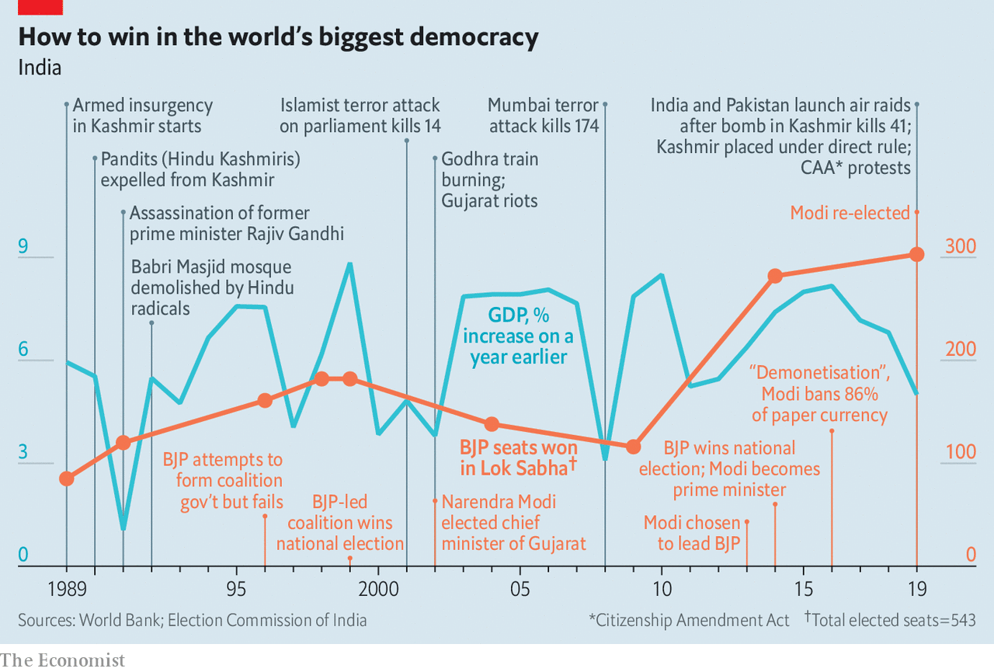

In August Mr Modi annulled the statehood of Jammu & Kashmir, part of a region long disputed over by India, Pakistan and China. The constitution gave the state special status, with its own constitution, flag and degree of autonomy. Now, it is split in two, and both parts of the state have been placed under direct rule. The 7.5m inhabitants of the Kashmir valley—nearly all of them Muslim—are under watch by 600,000 soldiers, who infuriate them with a range of shifting restrictions, such as curfews and roadblocks. Police also rounded up hundreds of potential troublemakers, among them local politicians, and severed mobile phone and internet services. These services have been partly restored, but the region remains isolated and many Kashmiris are fearful. Relative peace was only restored to the valley in the last decade, ending 20 years of violence in which between 40,000 and 70,000 people died.

Then in November a long-delayed ruling from India’s Supreme Court asserted the right of Hindus to take over the contested site at Ayodhya. This was not unexpected, and was even welcomed by many Muslims who wanted an end to the tiresome issue. But the ruling involved such a glaring legal sleight of hand that it marked another shift away from equality between India’s faiths.

All this might have passed without much protest. But Mr Modi’s government appears to have gone too far in its attempts to combat what it terms illegal immigration. This has long been a hobbyhorse for BJP leaders. They have repeatedly claimed that tens of millions of “infiltrators” have sneaked into India from neighbouring countries, despite there being little recent evidence of this. (Indeed, India’s own censuses reveal a steady decline in the foreign-born population, from 6.2m in 2001 to an estimated 5.1m in 2019.)

In the north-eastern state of Assam, where immigration has been a particularly divisive issue, chauvinist demagogues had for years outbid each other, claiming that anything from 5m to 8m intruders, mostly Muslim, had invaded from neighbouring Bangladesh. But when the state actually completed a costly count of its 33m people in August, only 1.9m of its inhabitants had failed to provide sufficient documents. Most of these “foreigners”—who can still contest their status at special tribunals—turned out to be Hindu.

This did not deter Mr Modi. His government has proposed a two-pronged approach to deal with immigration. First is a loophole allowing some long-term immigrants to naturalise as Indians through the CAA, which came into force on December 12th. Second, Mr Modi wants to impose a nationwide version of Assam’s count that would force all of India’s 1.3bn people to produce evidence of their citizenship.

To Muslims, many of whom are India’s poorest and most marginalised, the government’s plans are alarming. The CAA bill grants adherents of particular religions a path to speedier naturalisation, but glaringly omits Muslims from the list. Those who could not produce birth certificates or decades-old ration or voting cards would be declared foreigners, and then be denied a path to citizenship. A government survey in 2016 gives some idea of the difficulty of the task: 40% of Muslim children had no birth certificate (around the same proportion of Hindu children under five also did not have one). The measures could also change the way in which Muslims are regarded, from being equal citizens to second-class ones.

The first protests erupted shortly after the passage of the CAA. Angry crowds appeared at historically Muslim universities and in Muslim quarters of cities such as Delhi, Lucknow, Kanpur and Meerut. They were met with swift and brutal force, led by police but in some cases including “concerned citizens”. Some 27 people died, nearly all of them young, male and Muslim. Many of those released from detention, including children, claim they were beaten and starved.

Such an excessive response shifted public sympathy in favour of the protesters. It received a further boost when, on January 5th, dozens of thugs associated with Hindutva youth groups mounted a night-time raid on Jawaharlal Nehru University in Delhi, an institution that BJP leaders have long targeted as a supposed bastion of “anti-national” thought. This time the victims were not Muslims, but angry middle-class Hindus.

In Delhi not a day now goes by without a protest. Some involve the usual suspects: university students, leftist unions or Muslim slum-dwellers. But the anger can also be glimpsed in more ordinary folk. Several hundred women in a working-class neighbourhood of Delhi have camped out day and night for more than a month through extreme cold and choking smog. They are blocking one of the city’s main bridges, refusing to budge until the government scraps the CAA. Protests in Hyderabad and Mangalore have drawn crowds of 100,000 or more. In the southern state of Kerala, fishermen staged a floating demonstration. Following initial incidents of vandalism and violence—which were notably worse in states ruled by the BJP—the protests have generally been peaceful.

## A bridge to nowhere

Mr Modi initially responded to the outcry by trying to insinuate that the protesters were merely Muslims; you could “recognise them by their clothes”. But the demonstrators have defied easy categorisation by adopting the Indian flag, national anthem and constitution as their symbols.

The protests have also energised other opponents of the Hindutva project. Non-BJP state governments have felt emboldened not just to voice support for the protests but formally to challenge the BJP. Eleven of India’s 28 chief ministers have told Mr Modi they will not apply his citizenship rules in their states. The states of Punjab and Kerala have added their own petition to more than 60 other constitutional challenges to the CAA that have landed before the Supreme Court. Led by Congress, 20 opposition parties have issued a joint demand to suspend the law.

On previous occasions when his will has been challenged, Mr Modi has tended to backtrack. During his first term he abruptly scrapped plans to reform labour laws for fear of irking workers. This time Mr Modi appears less malleable. His government now pretends that, despite the repeated public pledges from top ministers to pursue first the CAA and then a national tally, it never really did intend to do the counting part. The line is that the policy has been “misunderstood”. Yet the government has not explained why its budget in July included initial costs for mounting a count of citizens, nor why it ordered all states to build detention centres for a surge in “foreigners”, with walls three metres (10ft) high and topped with barbed wire.

And even as Mr Modi has backed away from pursuing the controversial national register of citizens, he has doubled down on the CAA. His home minister, Amit Shah, has vowed not to give an inch on the citizenship rules. Instead, the BJP has mobilised the formidable party and government propaganda machines to push their message. The offensive is likely to prove effective among Mr Modi’s base. “There are an awful lot of Hindus, I’d guess 40%, who basically dislike Muslims and have no problem at all with this government’s approach,” says an American political scientist of Indian origin, who prefers anonymity (a subclause of the CAA allows the government to strip émigrés of their Overseas Citizen of India status).

Yet even if Mr Modi and Mr Shah do get their way, and if India’s Supreme Court overlooks the plainly contentious aspects of the CAA, the costs of the citizenship row to Mr Modi and his country are high. From a financial perspective, the outlays would be prohibitive even if India’s economy had not slowed in the past year to its lowest level of growth in four decades. In Assam compiling the citizens’ register took many years, employed 52,000 people and cost the government close to $200m. Given that Assam is home to less than 3% of India’s population, stretching this exercise nationwide would be very costly.

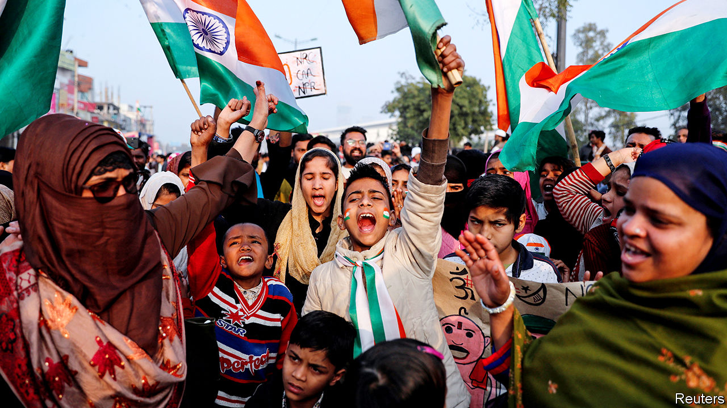

Young, gifted and Indian

A big diplomatic cost looms, too. In December Mr Modi was forced to cancel a summit with Abe Shinzo, his Japanese counterpart, owing to unrest in Assam, where they were scheduled to meet. So too has the government of Bangladesh, one of India’s closest allies, cancelled three ministerial visits to signal displeasure at the repeated implication that millions of “intruders”—Mr Shah has called them “termites”—might be dumped on its borders. (Nearly 1m Rohingya Muslims, fleeing pogroms in Myanmar, live in refugee camps in Cox’s Bazar, a Bangladeshi coastal town.) Ramachandra Guha, a historian, finds all this puzzling, considering the energy Mr Modi has exerted to burnish his image abroad. “All that effort has now come to naught,” he says.

## All together, divided

Such recklessness could be just a matter of ideology; Mr Modi could indeed be pursuing an agenda to undermine secularism and turn Muslims into second-class citizens. Others ascribe his moves to hubris. Mr Modi and Mr Shah have shared unchallenged power for so long it has “curtailed their ability to tolerate dissent...and accommodate different opinions”, according to Amit Ahuja and Rajkamal Singh of the University of California.

More likely, the citizenship row is chiefly political. The BJP has repeatedly and successfully bet on sectarian issues. Many point to a looming electoral battle in West Bengal, a big state with a large Muslim population, where the BJP has made steady inroads. Its tactics there have been blunt: in a recent speech the local BJP head asserted that there were 10m “Muslim infiltrators” in the state, and that other states ruled by the BJP had done the right thing to quell protests by “shooting these people like dogs”. It is said that Mr Shah is so obsessed with winning West Bengal in 2021 that the Gujarati is learning to speak Bengali.

With 56% of seats in the lower house of parliament, and enough allies to command the upper one, Mr Modi could have used his second term to pass badly needed reforms to make it easier to build homes, lay roads or create jobs in India. But six years in power appear to have made him stubborn. Many people have underestimated the grit and political acumen of the former tea-seller from Gujarat. Even so, he has now created a broad coalition against him. ■

This article was downloaded by calibre from <https://www.economist.com/briefing/2020/01/23/narendra-modis-sectarianism-is-eroding-indias-secular-democracy>

|  |  |  |  |
| --- | --- | --- | --- |
|  | Articles | Sections | Next |

|  |  |  |
| --- | --- | --- |
| Briefing | Sections | The Americas |

United States

Impeachment: Long days’ journey into acquittal

.

Regulating firearms: Bad shot

.

Internet governance: Unexpected domain

.

Rural demography: Homesteading 2.0

.

Criminal justice: Make it better

.

Agriculture: Business has gone sour in America’s dairy capital

.

Lexington: Could it be Bernie?

.

|  |  |  |
| --- | --- | --- |
| Briefing | Sections | The Americas |

|  |  |  |  |
| --- | --- | --- | --- |
|  | Articles | Sections | Next |

#### Designed to acquit

# The strange impeachment trial of Donald Trump

As rivals wrangle over procedure, all eyes are on five vulnerable Republican senators

Jan 25th 2020 | WASHINGTON, DC

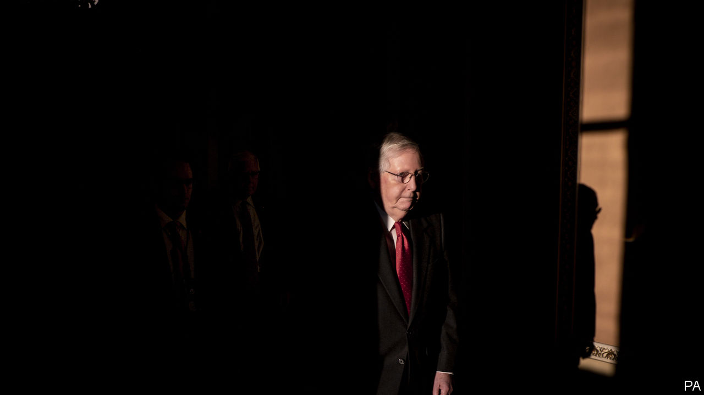

OUTSIDE THE Capitol building on January 21st it was business as usual. A group of demonstrators chanted on the lawn. One man silently held up a sign warning “God is watching”. Another, with a placard taped to his purple shirt proclaiming, among several other things, “I am Jesus Christ”, screamed tirelessly.

The closer you drew to the Senate floor, however, the more unusual things became. Reporters who wished to enter the Senate’s half of the building required not just press credentials, but special tickets, and were confined to roped-off pens outside the Senate floor. The Senate’s presiding officer was not, as is customary, a senator or the vice-president, but John Roberts, the Supreme Court’s chief justice. During the proceeding, senators had to surrender their mobile phones, forswear coffee—only water or milk allowed on the Senate floor—and heed the sergeant-at-arms’s warning to “keep silence, on pain of imprisonment”.

For the most part, the customarily garrulous senators complied, notwithstanding the occasional passed note. After more than 12 hours of bitter debate, the Senate approved rules governing Donald Trump’s impeachment trial on a party-line vote. The trial began the next afternoon, and will probably be over by the time Mr Trump delivers his state-of-the-union address on February 4th. The outcome is not in doubt. To remove Mr Trump from office, 20 Republican senators would have to cross party lines, which is not about to happen. But the trial still reveals much about Mr Trump’s hold on his party.

The two sides gave previews of their arguments and tactics during the debate over rules. Adam Schiff, who chairs the House Intelligence Committee and is one of seven House managers acting as prosecutors, argued that Mr Trump had abused his power by subverting American foreign policy for his personal political benefit, had obstructed Congress by ordering his subordinates not to co-operate with its investigation, and that these comprise “the most serious [misconduct] ever charged against a president”. He also argued that the trial rules proposed by Mitch McConnell, the Senate majority leader, would make “a mockery of a [fair] trial”, because they threaten to block Democrats from introducing witnesses and evidence.

The president’s lawyers, by contrast, focused on process. Jay Sekulow, Mr Trump’s lead outside counsel, argued that Mr Trump was “denied the right to cross-examine witnesses” during the House inquiry, which is untrue. Pat Cipollone, the White House counsel, asserted that Republicans were denied access to a secure room where Mr Schiff held a hearing, which is also untrue. He accused Mr Schiff of having “manufactured a false version” of Mr Trump’s phone call with Ukraine’s president, when in fact Mr Schiff introduced it as a paraphrase.

Alan Dershowitz, a law professor who volubly defends Mr Trump, plans to argue that impeachment requires an actual crime or “criminal-like behaviour”—a view that is at odds with mainstream opinion and American history. (Richard Nixon was nearly impeached for abuse of power, which is not a crime, and Andrew Johnson was impeached for, among other things, “declar[ing] with a loud voice, certain intemperate, inflammatory and scandalous harangues”.) The debate between the two sides grew so heated that after 12 hours in session, the perennially decorous Mr Roberts moved to admonish them to “avoid…using language that is not conducive to civil discourse.”

An hour later Mr McConnell’s rules passed. Each side will get 24 hours to make its case, spread over three days. The Senate will be in session six days a week, excluding Sundays, until the trial ends. After the initial presentations, the Senate will get 16 hours to ask questions, submitted in writing for Mr Roberts to read aloud, followed by four hours of argument and deliberation. The Senate will then debate whether to call for more witnesses and evidence.

That last rule rankled Democrats. Since the House impeached Mr Trump, John Bolton, a former national security adviser, has said he would honour a subpoena for testimony. Lev Parnas, a Ukrainian-born Republican donor indicted for campaign-finance violations, said that Messrs Trump and Bolton, as well as Vice-President Mike Pence and William Barr, the attorney-general, were all aware of the scheme to press Ukraine’s president to open an investigation into Joe and Hunter Biden.

Democrats want to hear from them, as well as other witnesses whom the White House has blocked. On January 21st they forced—and lost—many votes on subpoenas for documents and witnesses, less because they thought they stood a chance of winning than because they wanted to force vulnerable incumbent Republican senators to cast votes that can be used against them in an election campaign.

These five senators, running this autumn in states where Mr Trump has a negative net-approval rating—Susan Collins of Maine, Martha McSally of Arizona, Thom Tillis of North Carolina, Cory Gardner of Colorado and Joni Ernst of Iowa—are in an unenviable position. Voting to convict Mr Trump risks prompting a Republican primary challenger. Helping to form majority support for more witnesses and evidence risks inviting a long court fight—Mr Trump will probably try to block Mr Bolton from testifying—which leaves time for questions from pesky reporters. Yet, appearing too eager to rush to a verdict risks harming them with the independent voters they need to hold on to their seats.

Mr Trump, watching the initial proceedings from Davos, appeared supremely unconcerned with anyone’s fate but his own. He called the House managers “major sleazebags”, and fantasised about attending his trial in order to “sit right in the front row and stare into their corrupt faces”. And he boasted, “Honestly, we have all the material. They don’t have the material.” That is, of course, precisely what is alleged in the second article of impeachment.■

This article was downloaded by calibre from <https://www.economist.com/united-states/2020/01/25/the-strange-impeachment-trial-of-donald-trump>

|  |  |  |  |
| --- | --- | --- | --- |
|  | Articles | Sections | Next |

|  |  |  |  |
| --- | --- | --- | --- |
| Previous | Articles | Sections | Next |

#### Bad shot

# Virginia’s gun rally won’t halt gun-control laws

An army of 22,000 protesters cannot reverse demographic change

Jan 25th 2020 | RICHMOND

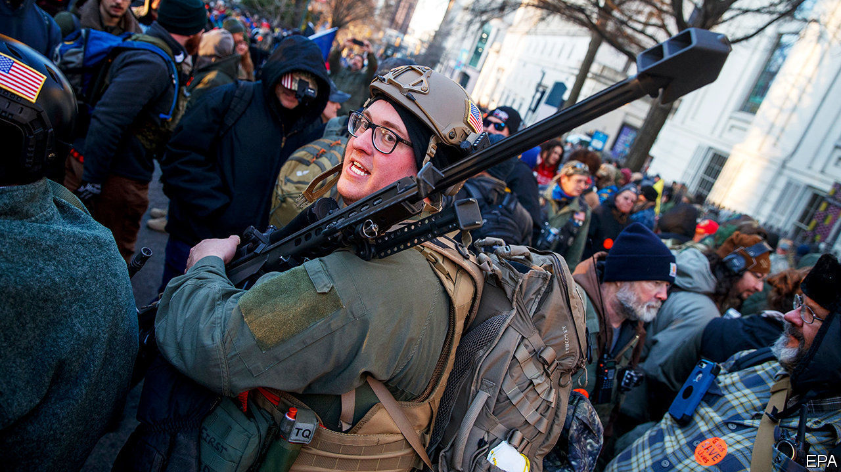

IT WOULD BE difficult to find a more polite crowd than the one which gathered in Richmond, Virginia on the morning of January 20th. As a helicopter buzzed overhead and police officers manned a cordon, thousands of people marched on the centre of the city waving handmade signs with jokes, chanting amiably. That many in the crowd were carrying guns and several signs called for violent insurrection against a “tyrannical” government only slightly distracted from a mostly good-natured protest. Men in full-body camouflage apologised when the barrels of their AR-15 rifles bumped into people.

The protest, by about 22,000 people, was organised by the Virginia Citizens Defence League, a statewide pro-gun lobby group, to campaign against gun-control measures planned by Virginia’s new legislature. In November the Democratic Party took control of all three branches of the state’s government.

The calm of the event came as a relief. A few days before, the FBI arrested three men, alleged to be part of a white-supremacist movement, who had planned to attend the rally. They had apparently expressed hope that the protest might spark a “civil war”. Various far-right figures attended, including Alex Jones, the founder of InfoWars, a conspiracy-theory website. Many Virginians feared a repeat of the far-right rally in 2017 that rocked Charlottesville, another city in the state, and led to the death of a counter-protester.

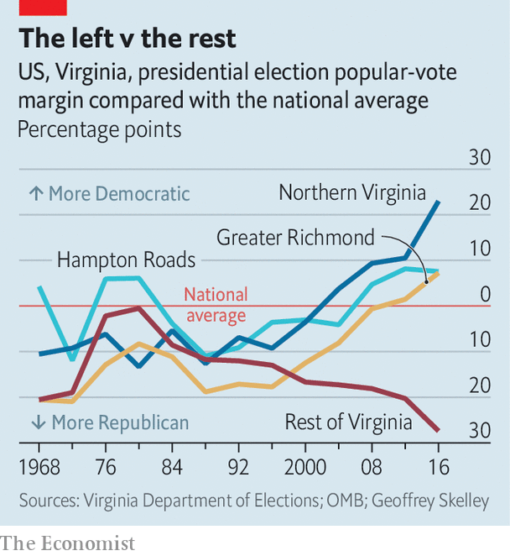

Cool heads probably prevailed because, unlike the rally in Charlottesville nearly three years ago, most protesters in Richmond were not actually white supremacists. Most were gun-owners who could not believe that in Virginia, associated with hunting and conservative political values, the public had voted for a government that might pass tighter gun restrictions. “Our country was built on the ability to protect your family, protect your property and fight for your freedom,” said Jamie LeBeau, who drove from Lynchburg, two hours away, to attend the rally. Her husband Erich expressed outrage that congressmen would continue to have armed guards, but his guns might be taken away.

Yet the chance of that is minimal. While various gun-control bills have been introduced in Virginia, most are modest. They involve expanding background checks and limits on how many guns someone can buy at once. The most controversial is a “red-flag” law, which would allow family members or the police to petition a court to take guns from somebody who may be dangerous. To many protesters, that is a front for a wider plan to confiscate guns or even to introduce communism. “Once they take our ability to fight back, what are they going to do? They can take anything they want,” said a man who called himself “Geoff”, wearing camouflage, a rifle and several magazines of ammunition. He suggested—falsely—that Democrats won Virginia’s elections by getting illegal immigrants to vote.

Over the past decade or so, as the suburbs of Washington, DC, Richmond and the Hampton Roads region have grown, the state has gradually become more Democratic-leaning than the rest of the country. At the same time, the rest of the state has become sharply more Republican-leaning. In rural parts of Virginia, gun crime is quite rare but almost everyone will know somebody who uses a gun safely.

Yet as urban America has grown at the expense of its rural parts, the share of Americans who support stricter gun laws has risen from less than half in 2010 to two-thirds now. For the most part, that has not led to much tightening of gun laws. Virginia may be a hint that politics is at last catching up. Rallying in Richmond may have made gun-toting Virginians feel better, but it has made no difference to their chances of stopping the new laws.■

This article was downloaded by calibre from <https://www.economist.com/united-states/2020/01/25/virginias-gun-rally-wont-halt-gun-control-laws>

|  |  |  |  |
| --- | --- | --- | --- |
| Previous | Articles | Sections | Next |

|  |  |  |  |
| --- | --- | --- | --- |
| Previous | Articles | Sections | Next |

#### Unexpected domain

# A proposed sale of rights to .org web addresses sparks a backlash

Advocates fear the commercialisation of a traditionally non-profit suffix

Jan 25th 2020 |

THE OFFER would confound anyone who has ever used a web browser. A corner of the internet associated with charities attracted an investor willing to take it over by paying a sum typically reserved for stakes in hot startups. But a private-equity firm’s bid for control of the .org domain used by millions of non-profit groups—some as large as the UN, some as small as local schools—has jolted internet-policy wonks. The proposed sale has also spurred into action internet advocates who want to protect one of the few parts of the online realm that has not gone commercial.

The controversy erupted in November. The non-profit organisation called the Internet Society (ISOC) that runs the .org registry announced that it was selling the management rights to Ethos Capital, a private-equity firm based in Boston. ISOC was created in 1992 by the net’s founders to help manage it. It was awarded control of the .org registry in 2002 for no fee.

Back then ISOC was in financial distress. Running .org was intended to fund the organisation’s work. A domain-name registry—with its annual renewal fees—is a lucrative monopoly, even if users of the addresses are charged only around $20 each year. In 2002 the .org registry generated around $15m in revenues. Today it collects more than $90m a year.

That may explain Ethos’s offer of $1.1bn. Yet the firm’s motivations remain opaque. Neither the investors in Ethos nor the directors of a firm that would control the .org registry, Purpose Domains Direct, have been disclosed. Documents released this month by the current .org registry, describing the deal, are full of redaction lines.

At the same time, a number of former officials of the body that manages the entire internet-address system are advising Ethos. That body is called the Internet Corporation for Assigned Names and Numbers (ICANN) and must give its consent to any new arrangement over .org.

To many internet users concerned about its technical management, the deal seems like a betrayal. To them, it is as if the internet’s founding fathers are selling out. Non-profit users had long been guaranteed price caps on their .org addresses. But they were lifted in June despite loud opposition.

A group of internet grandees came forward this month with an alternative proposal. They want to turn the .org registry into a co-operative owned by the address holders themselves. The group includes Esther Dyson, an internet pioneer who was ICANN’s founding chair from 1998 to 2000. On January 16th several American legislators, including Elizabeth Warren, called on ICANN “to reject this private-equity takeover”. They fear the deal lacks transparency and could increase users’ costs. They also fret that the potential new owners, who plan to finance a third of the deal with debt, might skimp on service.

Ethos says it will honour the previous price cap and will set up a “stewardship council” to hear feedback from .org registrants. ISOC’s president argues that the deal gives the organisation a hefty endowment to support the net’s development without being tied to a single funding source, .org.

The ICANN board is to meet on January 24th-26th in Los Angeles. The body’s rules require it to reach a decision on the matter by February 17th. ICANN argues that its remit is narrow—not to approve the sale per se, but to give its consent to the change of control of .org from ISOC to Ethos. Yet that change would represent something much broader: a shift away from the internet’s non-commercial roots.■

This article was downloaded by calibre from <https://www.economist.com/united-states/2020/01/25/a-proposed-sale-of-rights-to-org-web-addresses-sparks-a-backlash>

|  |  |  |  |
| --- | --- | --- | --- |
| Previous | Articles | Sections | Next |

|  |  |  |  |
| --- | --- | --- | --- |
| Previous | Articles | Sections | Next |

#### Homesteading 2.0

# Shrinking states offer perks for new residents

Incentives include cash, land and job connections

Jan 25th 2020 | MONTPELIER, VERMONT

IT STARTED AS a joke. Beth Dow received an article from her husband about Vermont paying workers to move to the state. But the jest soon became reality. Within a few months, Mrs Dow and her husband had left their home in Denver for Bennington, a town of 15,000 in southern Vermont, and were paid $5,000 to cover their move.

Vermont is one of many states with a population that is dwindling. Around 80% of counties across the country—largely those clustered in the north-east and Midwest—lost working-age adults from 2007 to 2017, according to the Economic Innovation Group (EIG), a think-tank. Some 65% will lose working-age adults over the next decade. The scale of this decline is new, precipitated by an ageing workforce, falling fertility rates and less immigration. Population declines affect housing markets, municipal finance and local economies. Fewer people means less housing demand, tax revenue and business.

To forestall further depopulation, Vermont’s Republican governor, Phil Scott, signed a bill that went into effect on January 1st offering to pay people $7,500 to cover their moving costs if they relocate and work for local employers. This follows the programme that lured the Dows to Vermont, intended for remote workers. (Mrs Dow still works for the same firm she did in Denver, remotely.) Other states, counties and cities—along with a host of local organisations—have recently taken similar measures. They call to mind America’s homestead programmes of the 19th century, when the federal government gave land to settlers willing to move west.

Depopulation is particularly acute in Vermont. During his annual budget address on January 21st, Mr Scott called the current demographic crisis “the greatest challenge we face as a state”. More than half of Vermont’s counties have seen population declines since 2010. The rural ones have been especially hard-hit. In seven counties, more people died than were born. The remaining population can no longer support the local restaurants or hardware store.

In all 371 people, including 79 children, moved to the state last year to claim its remote-worker grants. This included a number of people with six-figure salaries. “For a small state like Vermont, that’s a good number,” says Joan Goldstein, the state’s economic-development commissioner.

Over 1,500 miles away in Oklahoma the George Kaiser Family Foundation, a charity, has run a programme since 2018 called Tulsa Remote. It will give $10,000 and work space to people who move to the city for at least a year. In the first year, some 10,000 people applied for the programme’s 100 slots. Aaron Bolzle, who runs Tulsa Remote, said he is expecting between 350 and 400 people to move in this year.

In central Nebraska, a town of 938 people called Curtis offers free land to new residents willing to build homes on their lots. Families with school-age children are eligible for up to $1,000 in cash incentives if they move to Curtis and enroll in local public schools. Massachusetts is considering paying remote workers to move to its four western counties. Some Kansas counties will help pay student-loan debt for recent graduates who move there.

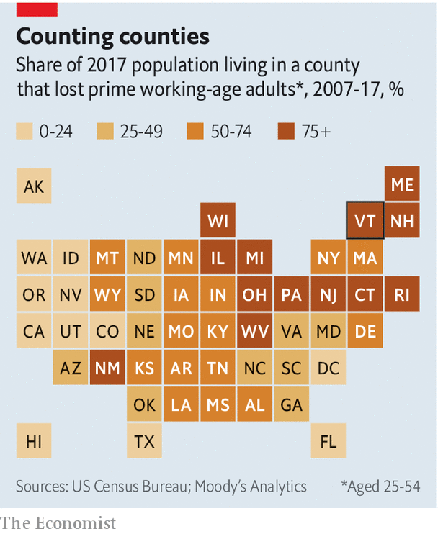

Are such efforts effective? Amy Liu, who directs a metropolitan-policy programme at the Brookings Institution, a think-tank, warns that local attempts to woo companies can backfire. Sometimes companies leave when incentives such as tax breaks expire. Attempts to woo people could suffer from some of the same pitfalls. Ms Liu also wonders if such experiments might be too small to have an impact.

John Lettieri, the head of EIG, says place-based visas for immigrant workers may help areas with population and labour shortages. Vermont could certainly do with an immigration boost. Fewer than 500 people arrive each year. Those counties that are growing have immigrant populations.

Vermont’s commerce secretary, Lindsay Kurrle, says she is “realistic” about her state’s programme. She says she knows people are not going to move to a new state for only a few thousand dollars. Nor will the programme alone solve the state’s demographic problems. Still, she hopes it will encourage more people to consider Vermont. Had they not read the article, the Dows say they would still be in Denver.■

This article was downloaded by calibre from <https://www.economist.com/united-states/2020/01/25/shrinking-states-offer-perks-for-new-residents>

|  |  |  |  |
| --- | --- | --- | --- |
| Previous | Articles | Sections | Next |

|  |  |  |  |
| --- | --- | --- | --- |
| Previous | Articles | Sections | Next |

#### Criminal justice

# Michigan plans to overhaul its jail system

The state could prove a model for others

Jan 25th 2020 | CHICAGO

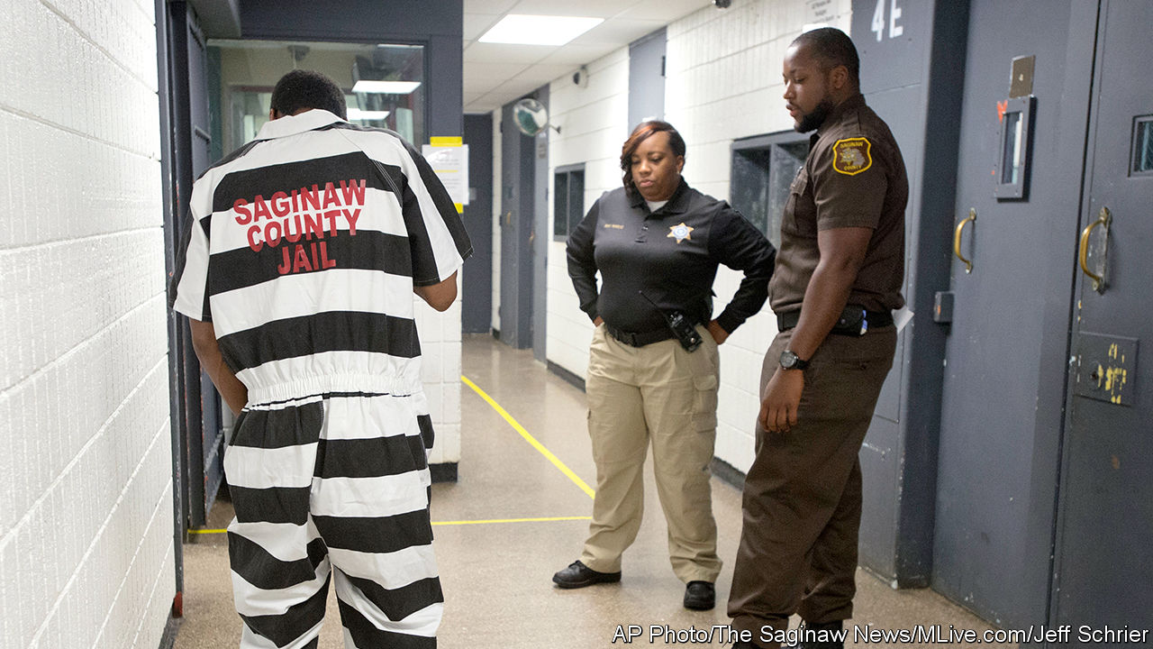

WHEN CRIME rates were last as low as they are today in Michigan, the Beatles topped the charts with “Hey Jude”. Half a century on, Michigan’s police arrest fewer people with each passing year. In the decade to 2018 arrests fell by one-fifth. One might expect, in turn, the state’s jails to be eerily empty. Quite the opposite. A new study by Pew Charitable Trusts found 16,600 people were held in county jails on an average day in 2016, over three times more than in 1970.

This fits a nationwide pattern. Even as crime rates and the number of arrests fall, jail populations in many states remain high. County-run jails are the front end of America’s criminal-justice system, where more people are put behind bars than are ever thrown into prison. (Jails house people who are awaiting trial, whereas prisons are typically for locking up felons.) In 2017 jails nationally handled 10.6m admissions, compared with just 607,000 who went into the country’s prisons.

That is good for nobody. Crowded jails are a financial burden for counties. It cost $478m to run Michigan’s in 2017. Pew researchers point to evidence that people jailed or imprisoned, even briefly, are far likelier to be rearrested within two years than others who pass through the justice system but are not locked up.

If America is to put fewer people behind bars, the priority will be fixing its jails. Several states are trying. Starting this month, New York no longer demands cash bail from those arrested for minor, non-violent crimes. New Jersey ended cash bail in 2017 and has seen its jail population shrink, even as crime rates continue to fall.

Now it is Michigan’s turn. After holding public hearings and gathering expert testimony across the state in the past year, a task force on jail reform published 18 policy recommendations for legislators on January 14th. These include spending more on mental-health care, reclassifying many of the 1,900 misdemeanour offences as civil infractions, changing rules on cash bail and promoting more non-custodial sentences for minor crimes.

Some of this builds on other states’ efforts. But Michigan is worth watching for at least two reasons. For a start, the proposed reforms are based on unusually fine-grained data gathered by Pew researchers. The state’s lieutenant-governor, Garlin Gilchrist, admitted last month that officials previously could not even say “with a straight face” how many inmates were held in its 81 county jails, for how long and why.

Pew sampled data from 20 jails accounting for 40% of inmates in 2017. It found many locked up for non-violent and modest wrongdoing, including traffic offences. Overall, African-Americans were over-represented behind bars and women increasingly likely to be detained. Researchers noted a striking boom in rural jail populations. That might be explained by the lack of mental-health services beyond cities. Pew also found a small core of one-fifth of all inmates who stay inside the longest and account for over 80% of all “jail-bed days” per year. Getting more of these long-termers out of jails would do most to reduce the pressure on them.

The second reason to watch Michigan is its bipartisan approach. A Democratic governor, Gretchen Whitmer, and Republican legislative leaders are co-operating, at least so far. Ms Whitmer convened the task force—which included members from both parties—and legislators are likely to implement many of its recommendations.

Changing laws at the federal and state level will not fix everything. The MacArthur Foundation, a grant-giving organisation, notes wide disparities in jail populations between counties within states, which suggests that training for local decision-makers, such as sheriffs too fond of jailing people, or allocating more money for local health services, could matter as much as legislative change from above.

The opportunity in Michigan is to track the data to see how things change and for the parties to co-operate on policy. The jail population may not shrink back to levels of the early 1970s, but Michigan seems poised to take a hint from the Beatles lyric and make it better. ■

This article was downloaded by calibre from <https://www.economist.com/united-states/2020/01/25/michigan-plans-to-overhaul-its-jail-system>

|  |  |  |  |
| --- | --- | --- | --- |
| Previous | Articles | Sections | Next |

|  |  |  |  |
| --- | --- | --- | --- |
| Previous | Articles | Sections | Next |

#### Changing tastes

# Business has gone sour in America’s dairy capital

Wisconsin’s small farms are vanishing

Jan 25th 2020 | MONROE, WISCONSIN

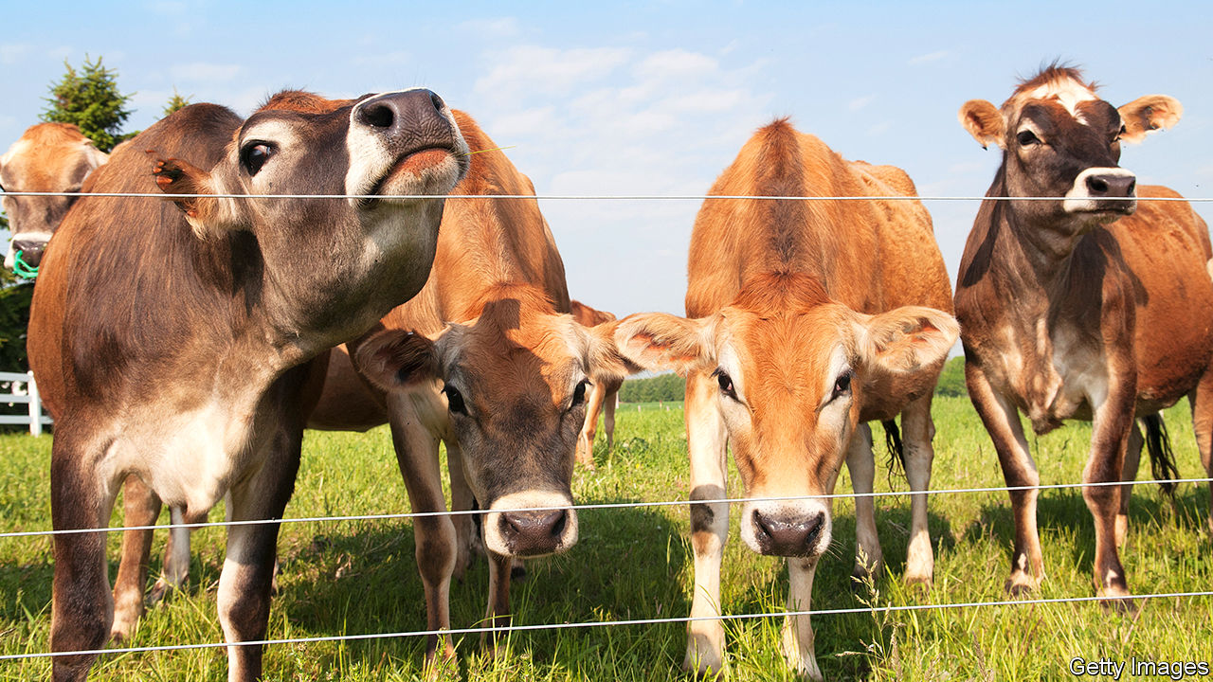

TO WALK AROUND Dan Wegmueller’s farm in southern Wisconsin is to conjure up the past. He says each of his 50 Brown Swiss cows—with white-tipped ears and bells clanging from their necks—has a name and distinct personality. His red-painted barn is crowned by an elegantly arched roof. He trundles over the snow on a green John Deere tractor. Such small-scale farming looks wonderfully quaint. But it might as well exist in a museum.

The farm, set amid rolling hills on 350 acres, has been in Mr Wegmueller’s family since the 1930s, the decade when dairy farms in America peaked at 3.6m. Today the country has 37,000 left, with just over 7,000 in Wisconsin. The state still brands itself as “America’s Dairy Land” (though California has long produced more milk), and turns most of its white stuff into cheese. Farms are either going bust or industrial. Almost two dairy farms close each day in the state. In 2019 one-tenth of Wisconsin’s dairy farms shut down.

Wisconsin is witnessing what other states—especially in the south and west—saw in earlier decades. Consolidation has come late partly because its small farms had previously remained relatively productive. Mostly, now, it is the small that go.

Industrial-scale ones do well from technology, economies of scale and easier access to capital. A few minutes’ drive away from Mr Wegmueller’s farm is Pinnacle dairy. It opened in 2018 and has a 5,000-strong herd in six enormous white barns. Pumps at a warehouse fill several steel tanker trucks at a time. Tuls Dairies, a growing dairy firm, owns Pinnacle and six more big farms in Wisconsin and Nebraska. A state report last year noted that such big farms, with at least 200 cows, already churn out two-thirds of all Wisconsin’s milk. That share is likely to rise.

The industry is consolidating for several reasons. In the long run, blame an ageing rural population. Many older owners cannot persuade their adult children to take over. And why would they? It is ever tougher to turn a profit from a small herd of cows. Milk prices have slid for decades, largely because ever better techniques, genetics and technology ensure rising supply. Consumers at the same time are losing their taste for drinking milk. On average an American gulped 247lb (109 litres) of it in 1975, but only 146lb in 2018.

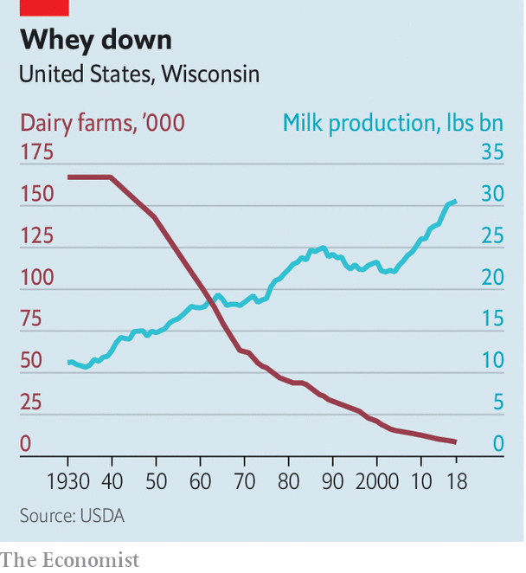

Tina Hinchie, who has 220 cows on another picturesque lot with red barns, mentions more recent problems. She laments volatile weather, especially floods, in the past few years. And although most milk is sold domestically (in Wisconsin 90% goes to local cheesemakers), exports that once accounted for 15-18% of national sales have been hit. China last year shunned many products, including whey, which it previously lapped up; after an outbreak of swine fever in China killed half its pigs, demand for whey as animal feed collapsed. Exports of cheese to Mexico have also suffered. Mrs Hinchie blames “horrific” trade disputes engineered by Donald Trump, although other difficulties are also to blame.

Farmers complain it is getting hard to find labour, even as wages rise. Mr Wegmueller can lure part-time help only by offering free accommodation. Mrs Hinchie last year invested $3.3m in a laser-guided robot milking system she calls the “Taj Mahal” of high-tech help. It means she can cut her labour force to a single farm hand, from four. She boosts income with farm tours—with as many as 10,000 visitors a year—that city folk enjoy. Mr Wegmueller is also betting that farm stays will be a bigger business than milk sales. Small farms that do not diversify are unlikely to hang on.

Somewhat bigger ones do better. Travis Tranel, a Republican state representative, co-owns a 600-strong herd in south-west Wisconsin. It is getting by because he switched to organic milk, which sells at a higher price than regular. Yet he too sees problems, especially with supplies of labour. He says the federal government needs to “figure out a realistic immigration policy” so that more migrants “who want to work hard” can repopulate rural areas.

Could that matter in this year’s election? Attracting rural voters is part of Mr Trump’s plan for keeping the state in 2020. Democrats, in turn, are focusing on the dairy crisis in a push for votes beyond cities. The numbers are small. Mr Tranel says dairy farmers account for some 200,000 votes. But that is an important chunk, as Mr Trump won Wisconsin by just over 22,000 in 2016. And the issue may resonate more widely, because many Wisconsinites see dairy as a defining feature of their state.

More generally there is anxiety that rural Wisconsin is losing people as the more educated move to cities, leaving mostly the elderly behind. Schools in many places—especially where Hispanic migrants are not settling—are emptying. Small towns suffer as businesses such as local feed-suppliers go bust and shops, cafés and bars close. What might save Mr Wegmueller’s farm and a few others is that urban visitors are ready to pay for the experience of trudging in mud and milking a cow for a day. Even if dairy fails, tourism may yet boom.■

This article was downloaded by calibre from <https://www.economist.com/united-states/2020/01/25/business-has-gone-sour-in-americas-dairy-capital>

|  |  |  |  |
| --- | --- | --- | --- |
| Previous | Articles | Sections | Next |

|  |  |  |  |
| --- | --- | --- | --- |
| Previous | Articles | Sections | Next |

#### Lexington

# Could it be Bernie?

The weaknesses of the Democratic field hand an opportunity to America’s most famous socialist

Jan 25th 2020 |

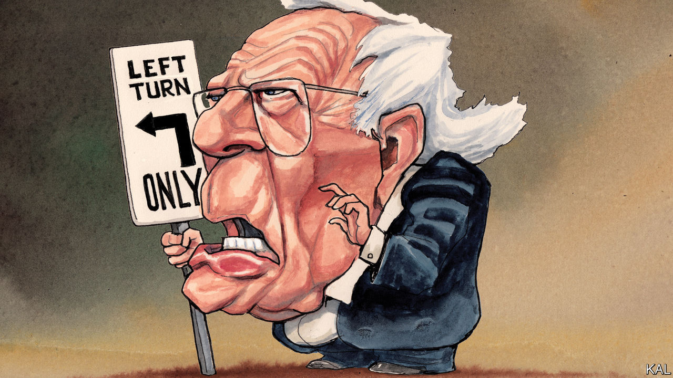

AFTER RATTLING through one of the most radical campaign platforms in American history, inside a craft brewery in snowy New Hampshire last weekend, Bernie Sanders turned to the practicalities. His to-do list, the senator from Vermont acknowledged to his crowd of well-wrapped New Englanders, was ambitious. His promised health-care, education and infrastructure programmes would in fact represent the biggest expansion of government spending in peacetime; by one estimate Mr Sanders would double the federal budget. And he would not be done there. He told the audience of his hope to persuade China, India and Pakistan to redirect their nuclear-arms budgets to fighting climate change. Yet lest anyone considered all this improbable, Mr Sanders offered a reassurance. “Social change happens in radical moments,” he said, citing the struggles of the early labour movement, suffragettes and gay-rights campaigners. “When millions stand up to fight for justice, nothing can stop us!”

To committed Sandernistas, the independent senator is another reason why the political revolution he promises is nigh. A little-known left-winger before his impressive run against Hillary Clinton in 2016, he has since developed a raging personality cult. His campaign slogan used to be “A future to believe in”; now it is just: “Bernie”. The encomiums his cheerleaders offer him, a veteran professional politician in a baggy suit, are as extreme as his ideas. “It turns out Bernie is a man of the future!” gushed Naomi Klein, his main warm-up act in the brewery, in acknowledgment of the fact that Mr Sanders has been offering much the same critique of the “corporate elite” that he blames for all evils for over three decades. “He was just waiting for the world to catch up!”

In fact there are few indications, in the chilly world outside the brewery, of enthusiasm for the massive changes Mr Sanders promises. His success in 2016 mainly reflected dissatisfaction with Mrs Clinton. And notwithstanding a long-standing and continued leftward drift among Democrats, to which he has contributed, his ideas remain fairly marginal. Mr Sanders’s most popular policy, a universal expansion of Medicare, is backed by 38% of Democrats. That is significant, but hardly augurs the stampede of radical activism he foresees. Despite possessing advantages that most of his Democratic opponents would kill for—including near-total name recognition and an ability to raise millions from his enthusiasts online—Mr Sanders has consistently polled under 20%, less than half the vote-share he won in 2016. He has never looked like challenging Joe Biden as the Democratic front-runner.

Yet two weeks before Iowans get things started, and despite only a modest uptick in his polling, Mr Sanders has started to look more imposing. His fundraising is going gangbusters. He is surging in betting markets. Three months ago they gave him a 6% chance of victory; now he is at 29%. The Democratic establishment is alarmed—led by Mrs Clinton, who this week trailed her assessment of Mr Sanders in a forthcoming documentary: “Nobody likes him, nobody wants to work with him.” What has changed?

As in 2016, Mr Sanders is drawing strength from his opponents’ weaknesses. Mr Biden, a wearier and less articulate septuagenarian, has dominated but failed to unite the centre-left. Sitting atop the Democrats’ biggest faction like a wet sponge, the former vice-president has dampened its ardour, while stifling more inspiring moderates such as Pete Buttigieg. Mr Sanders’s rival on the left, Elizabeth Warren, has meanwhile faltered. By trying to appeal to left-wingers and moderates, she has irritated both. This has made Mr Sanders’s small but committed minority of supporters more significant. If he can unite the left, by convincingly outperforming Ms Warren in the early states, while the centre-left remains divided, he could establish a useful early lead. And Mr Sanders’s especially strong polling in Iowa, New Hampshire and Nevada, where he is currently tied with Mr Biden, suggests this may be on the cards. It was the means by which Donald Trump, another populist with a small but zealous base, won the Republican nomination.

Mr Sanders would still face obstacles Mr Trump did not. In particular, where Republican primaries operate under a winner-takes-all system—which maximised the spoils of Mr Trump’s early lead—Democrats allocate their delegates in proportion to the vote-share each candidate wins. Yet while this would make it harder for Mr Sanders to emerge from the pack, he might still be equipped to do so. His fundraising prowess will ensure he can weather a close contest even as similarly placed candidates drop out. His deep disdain for the hostile Democratic establishment will make him especially determined to do so. Moreover, appearing for the first time as the front-runner, Mr Sanders might be able to expand his appeal across the party more successfully than many imagine.

## Authentically crazy

Whatever moderate Democrats may think of his policies, American voters ultimately do not select their leaders on that basis. They mostly choose those they like or feel understood by; and Mr Sanders performs well on such markers. Democrats of all stripes consider his crabbiness authentic and his ideological pigheadedness a mark of integrity. Over 70% say they like him. Those filing out of the brewery in New Hampshire said he was “honest”, “inspirational” and that they “related to him”. Hardly anyone mentioned any detail of a platform that would make the New Deal look austere. And when your columnist raised the fact that Mr Sanders is a socialist, he was gently chided. Most of the rally-goers seemed to consider this a slightly awkward irrelevance.

Given how unfeasible Mr Sanders’s promises are, there is a sort of logic to this. Yet Democrats can be assured it is not an example Mr Trump would follow if he were lucky enough to have an actual socialist as his opponent. If Democrats nominate Mr Sanders, it will be mainly in spite of his radical views. But that would not stop Mr Trump winning re-election because of them.■

This article was downloaded by calibre from <https://www.economist.com/united-states/2020/01/25/could-it-be-bernie>

|  |  |  |  |
| --- | --- | --- | --- |
| Previous | Articles | Sections | Next |

|  |  |  |
| --- | --- | --- |
| United States | Sections | Asia |

The Americas

Bolivia: Elusive estabilidad

.

Brazil: The press pressed

.

|  |  |  |
| --- | --- | --- |
| United States | Sections | Asia |

|  |  |  |  |
| --- | --- | --- | --- |
|  | Articles | Sections | Next |

#### Elusive estabilidad

# The current calm in Bolivia is fragile

The main political forces have agreed on the ground rules for a new election. But that does not guarantee stability

Jan 25th 2020 | EL ALTO

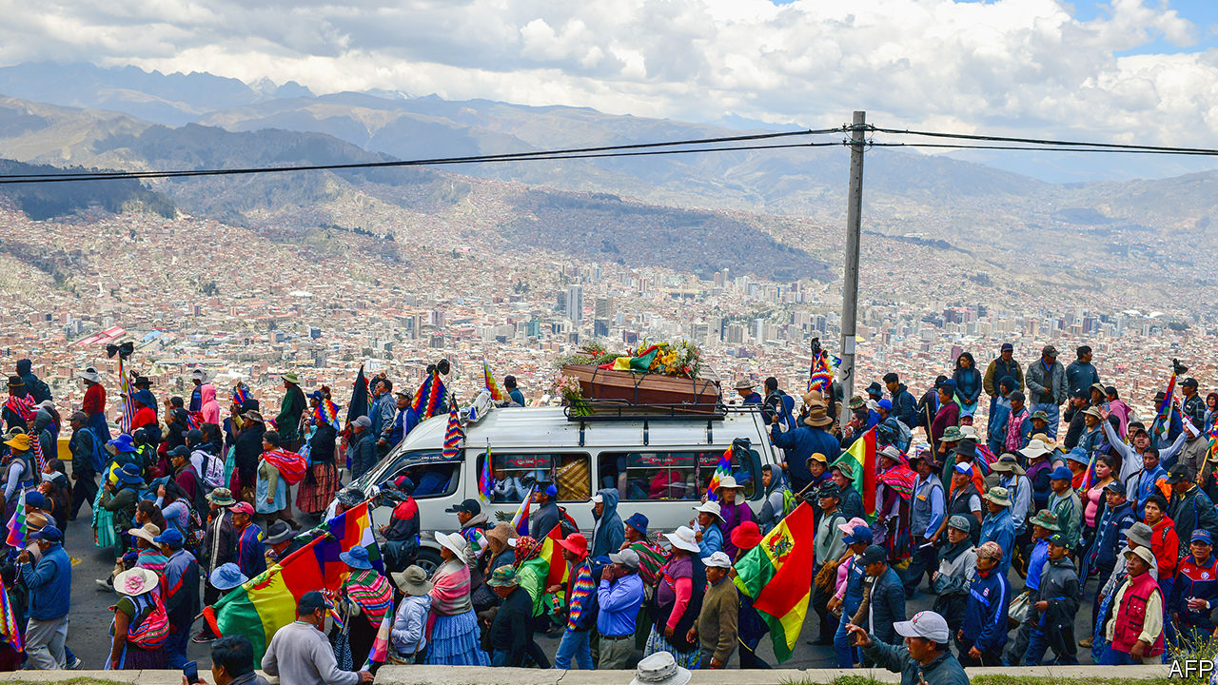

ON A RECENT afternoon, workmen were repairing the wall around the Senkata gas plant in El Alto, a working-class city in the mountains above La Paz, Bolivia’s administrative capital. Backers of Evo Morales, the left-wing president who quit on November 10th, had blocked lorries from leaving the plant and knocked down the wall. On November 19th soldiers opened fire, killing ten people. Fresh paint now covers much of the rebuilt wall, but one mural remains from the chaotic presidential campaign that preceded Mr Morales’s resignation: his face and the word estabilidad (stability) in big capital letters. Restoring that to Bolivia will involve much more than fixing the wall. “The country is coming out of shock,” says Milenka García, a vice-president of El Alto’s neighbourhood association (Fejuve) who represents District 8, an area of cinder-block homes and dusty streets that includes the gas plant.

The crisis began on October 20th, when Mr Morales, who became Bolivia’s first indigenous president in 2006, tried to rig his re-election, sparking protests across the country. He fled to Mexico after losing the support of the police and the army, saying he had been toppled in a coup. His supporters set fire to buses and the homes of politicians and journalists who had criticised him. Opposition protesters burned the wiphala, a multicoloured flag that represents indigenous people, and barricaded the legislature to congressmen from Mr Morales’s Movement to Socialism (MAS). At least 36 people died in clashes between the two groups and at the hands of security forces.

Miraculously, Bolivia has found a way out of the violence. That is largely thanks to a collaboration between two women who were unknown before they stepped into the political vacuum: Jeanine Áñez, the senate’s second vice-president, who became Bolivia’s caretaker president after the people ahead of her in the line of succession resigned, and Eva Copa, a MAS senator who became the head of the legislature. Ignoring Mr Morales’s calls to boycott the interim president, Ms Copa persuaded her party to work with her and other conservative politicians to plan new elections. “The priority in those moments was to pacify the country and stop the violence,” she says.

Bolivia has a new electoral tribunal, which will oversee presidential and congressional elections on May 3rd. International observers and updated software will help ensure that the vote is a fair one, says Salvador Romero, the tribunal’s chief. “The election is the moment Bolivians will come together again,” he predicts.

But a fair vote alone will not ensure estabilidad. That is because on nearly all other issues Ms Áñez, Ms Copa, their supporters and the many other factions with a role in post-Morales Bolivia are angrily divided. Their rifts reflect ethnic, economic and regional splits.

Ms Áñez, a conservative Catholic who had fervently opposed Mr Morales, is not acting like a caretaker. She has eliminated controls on agricultural exports. She has sought closer ties with the United States and joined other democracies in recognising Juan Guaidó, leader of the opposition to Venezuela’s dictatorial regime, as the country’s rightful interim president. She has sent home hundreds of Venezuelan diplomats and Cuban doctors. On December 30th she expelled the Mexican ambassador and two Spanish diplomats, accusing them of attempting to help nine senior officials from Mr Morales’s government escape from the Mexican embassy, where they have sought refuge.

“A transition government isn’t a dead government,” says the interior minister, Arturo Murillo. At his urging, prosecutors are investigating hundreds of politicians and civil servants from the MAS for corruption, sedition, terrorism and electoral fraud. Two-thirds of judges will have to reapply for their jobs, says Álvaro Coimbra, the justice minister. He portrays this as a step towards re-establishing the independence of the judiciary, which Mr Morales had bent to his will.

## Interim aggression

But the crackdown looks like an attempt to weaken the MAS. On November 14th, after broadcasts showed government forces tear-gassing protesters, the communications minister threatened to put journalists on trial for sedition. The ministry has announced plans to censor dozens of community radio stations, which tend to support the MAS. On December 31st authorities arrested four people who had worked on social media for the Morales government, branded them “digital warriors” and charged them with misuse of public funds and sedition. They say they have been denied due process, as do other adherents of the old regime who are under investigation. Mr Murillo has little interest in mollifying the MAS’s supporters. If poor and indigenous people are angry with the government, it’s “because we don’t let them steal, and we don’t give them carte blanche for looting and narco-trafficking”.

All this encourages the false belief that Mr Morales was toppled by a coup, says Jim Shultz of the Democracy Centre, a think-tank in San Francisco, California. The interim government is acting as if “the hand of God came down and told the right to take power”, he says. Diego Pary, a former foreign minister, wonders how fair elections can take place “when one party is being hounded”. When he met a journalist for an interview outside the ministry, he dared not get out of his car.

The MAS itself is divided, both in its response to Ms Áñez’s government and over its future. Its most radical voice is that of Mr Morales, who has moved to next-door Argentina. In a radio interview on January 12th he said that Bolivians should form armed militias “like in Venezuela” to defend themselves against the caretaker government, which he has accused of governing for elites only. He later claimed he was talking about slingshots, not guns. In speeches on January 22nd, when Bolivia celebrates its “plurinational” (multi-ethnic) state, he sounded less combative, focusing on his government’s achievements. Marches on that day were peaceful.

MAS leaders in Bolivia are mostly staying off the streets for now. “It’s not in our interest to mobilise, we have to go to battle at the polls,” says Andrónico Rodríguez, a young organiser of coca farmers who led protests last year. With Mr Morales abroad, moderates like Ms Copa are gaining influence. They are backed by grassroots supporters of the MAS who are disenchanted with Mr Morales. “We’re like the obedient child who always gets ignored,” says Ms García of the El Alto Fejuve, which has been aligned with the MAS. Mr Morales’s government favoured rich farmers and coca growers while El Alto waited in vain for money it was promised, she says. Now groups like Fejuve are helping to restructure the party.

After weeks of assemblies throughout the country, supporters chose as the MAS’s presidential candidate David Choquehuanca, a former foreign minister who is popular among poor Bolivians and, like Mr Morales, is Aymara. They named Mr Rodríguez as his running-mate. Mr Morales countered with his own nominee. On January 19th, at a press conference in Buenos Aires, he declared that Luis Arce, a former finance minister and his confidant, would run for president. Mr Choquehuanca would be his running-mate. That is not the final word. The MAS would discuss Mr Morales’s “proposal”, Ms Copa said. On January 20th the government announced that it was investigating Mr Arce for corruption.

Polls suggest that 20-25% of voters support the MAS. Its candidate, whoever that may be, will join a large field. Ms Áñez, whose government has the backing of roughly half of Bolivians, has not said whether she will run. Another standard-bearer of the right may be Luis Fernando Camacho, a civic leader from the low-lying eastern department of Santa Cruz who led the protests against Mr Morales. Carlos Mesa, a centrist who was Mr Morales’s strongest challenger in October, is also running. Mr Morales’s absence from the race may make it more about issues than personality, says Jorge (Tuto) Quiroga, a former president who helped negotiate his exit and is also planning to run. That may be wishful thinking.

Even if the election is clean, many Bolivians could reject the result. “The challenge facing the next president is to govern for all Bolivians,” says Soledad Chapetón, El Alto’s mayor, who is indigenous but from a party that opposes the MAS. Supporters of Mr Morales burnt her house, but she thinks that reconciliation is possible.

The residents of District 8 are more pessimistic. Teenagers point out that Ms Áñez’s original cabinet had no indigenous ministers (she has since added a few). Parents say that their kids have nightmares about soldiers shooting into crowds. The wife and three children of Pedro Quisbert, a factory worker who was killed outside the gas plant, left to “escape the memories”, says his father, Primitivo, who stayed. Through a crack in the door of his house he blames both sides for the violence, but says he will vote for someone “from the humble class”. The massacre “broke the possibility of dialogue”, he says. It will be up to Bolivia’s next leader to prove him wrong. ■

This article was downloaded by calibre from <https://www.economist.com/the-americas/2020/01/25/the-current-calm-in-bolivia-is-fragile>

|  |  |  |  |
| --- | --- | --- | --- |
|  | Articles | Sections | Next |

|  |  |  |  |
| --- | --- | --- | --- |
| Previous | Articles | Sections | Next |

#### The press pressed

# Brazilian prosecutors go after Glenn Greenwald, an American journalist

The charges against him are a threat to free speech

Jan 25th 2020 | SÃO PAULO

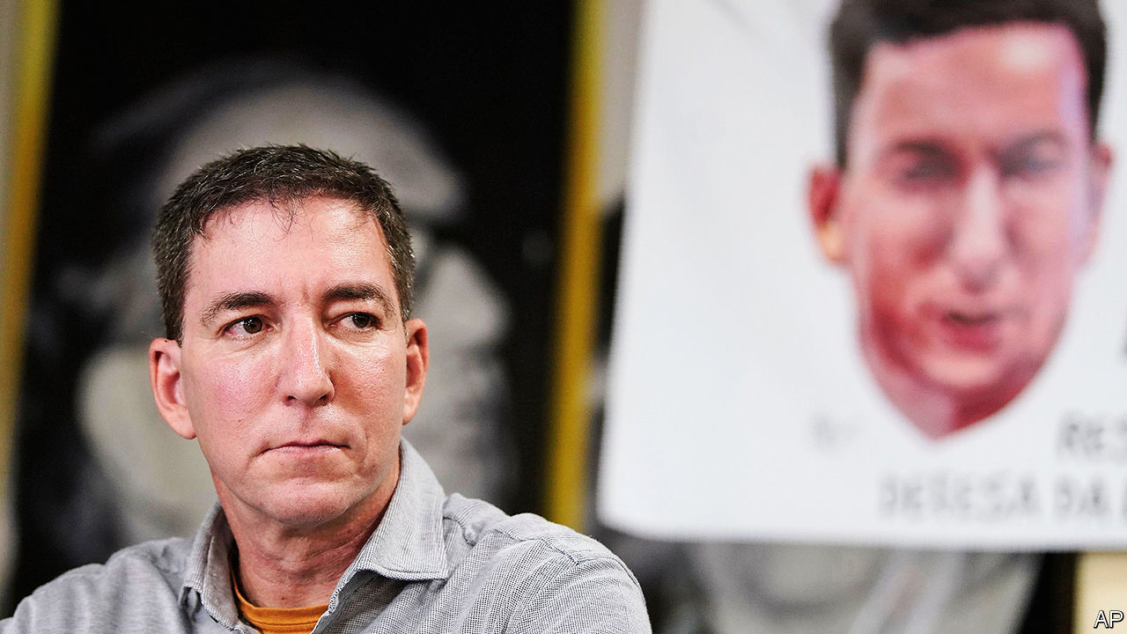

LAST JUNE the Intercept, a news site, published hacked messages that showed improper collaboration between Brazilian prosecutors and judges conducting the anti-corruption investigation known as Lava Jato (Car Wash). The leaks tarnished the image of Sergio Moro, the justice minister, who had been the judge in charge. They enraged Brazil’s nationalist president, Jair Bolsonaro, whose election in 2018 owed much to anger about corruption.

On January 21st prosecutors filed charges against Glenn Greenwald (pictured), a co-founder of the Intercept. They accused him of belonging to a “criminal organisation” that hacked the mobile phones of members of the Lava Jato task-force. The judge overseeing the case may throw out the charges. Even so, they raise questions about how free the press will be in Mr Bolsonaro’s Brazil and whether prosecutors will act independently.

Mr Greenwald, an American, became famous by helping publish Edward Snowden’s leaks of information from the United States’ National Security Agency. In July Mr Bolsonaro suggested that Mr Greenwald might “do jail time” for his Lava Jato revelations, and accused him of marrying his Brazilian husband to avoid deportation. That month, after a rumour surfaced that investigators were scrutinising Mr Greenwald’s bank accounts, a supreme-court judge barred the authorities from investigating him. The judge noted that it is not a crime to publish information obtained illegally. That was a warning to prosecutors: don’t mess with the press.

The case against Mr Greenwald has provoked an outcry. It represents “a threat to press freedom”, tweeted Rodrigo Maia, the president of the lower house of congress. It is not the first since Mr Bolsonaro became president. The government said it would reduce advertising in Folha de S. Paulo, a newspaper, in retaliation for its negative coverage, but relented. This month a judge banned Netflix from showing a comedy that portrayed Jesus as gay. A supreme-court judge quickly overruled him.

Mr Bolsonaro is not responsible for every attempt to stifle speech. But his anti-gay views may have encouraged the judge who sought to ban the Netflix film. His son called the film “garbage”. In choosing a new attorney-general in September, Mr Bolsonaro ignored the candidates on a shortlist presented by prosecutors. That fuelled suspicion that he was seeking to curb prosecutors’ independence. Questioned by journalists about the case against Mr Greenwald, Mr Bolsonaro retorted, “Don’t you have faith in the justice system?” Brazilians are starting to wonder.■

This article was downloaded by calibre from <https://www.economist.com/the-americas/2020/01/25/brazilian-prosecutors-go-after-glenn-greenwald-an-american-journalist>

|  |  |  |  |
| --- | --- | --- | --- |
| Previous | Articles | Sections | Next |

|  |  |  |
| --- | --- | --- |
| The Americas | Sections | China |

Asia

Infrastructure in the Philippines: “Build, Build, Build”

.

Australia’s greenhouse-gas emissions: Smoke and numbers

.

Vietnam’s energy mix: Sunny spell

.

Banyan: Sex, lies and videotape

.

|  |  |  |
| --- | --- | --- |
| The Americas | Sections | China |

|  |  |  |  |
| --- | --- | --- | --- |
|  | Articles | Sections | Next |

#### “Build, Build, Build”

# The Philippines, a country with dreadful traffic, may start to unclog

President Rodrigo Duterte is investing massively in roads, ports and airports

Jan 25th 2020 | MANILA

SHOULD YOU get up at 4am to get to work on time, or risk waiting until five? That is the question confronting many commuters in Manila, the capital of the Philippines, which has some of the world’s worst traffic jams. Geography is one reason: the 2m people trying to get in and out of the metropolis each day must squeeze into a narrow strip between the sea on one side and a lake and hills on the other. But poor urban planning and a dearth of infrastructure investment in recent decades have compounded the problem. Filipinos spend 16 days a year stuck in jams, according to the Boston Consulting Group. The World Economic Forum ranks the Philippines 96th of 141 countries for the quality of its infrastructure. Nearby Indonesia, another nation of thousands of islands, is 72nd.

On January 17th the public-works minister announced that by the time President Rodrigo Duterte leaves office in 2022, he wants to have cut the number of cars that pass along the city’s main artery each day by a third. Such bold declarations have been characteristic of Mr Duterte’s approach to infrastructure. When he became president in 2016 he considered demanding emergency powers from Congress to help him deal with the traffic. In the end, he settled instead on a long-term scheme to spend 9trn pesos ($177bn) on new infrastructure called “Build, Build, Build”. The focus on construction represents a “very bold shift in government priority”, believes Vince Dizon, a presidential adviser.

As the jams in Manila suggest, not much has shifted yet. But change is coming. “Build, Build, Build” involves 100 big projects. Construction is under way on almost half of them. In 2018 the government introduced a law to cut red tape in permitting, partly to speed up infrastructure investments. Some planning committees are meeting three times as often as they used to. Twenty projects were approved in the final three months of last year, says Mr Dizon. Impractical schemes promoted by the president, such as a plan to link all the main islands of the Philippines by bridge, have been quietly set aside.

One of the biggest projects still in the works is New Clark City, which is eventually supposed to house 1.2m people and lots of government offices, in an effort to ease traffic in nearby Manila. The city was planned under Mr Duterte’s predecessor, but embraced by him in an unusual display of political continuity. The first phase was completed in November. Mr Duterte has also presided over the opening of a new airport in the province of Bohol, and of the Philippines’ largest passenger-ferry terminal on his home island of Mindanao.

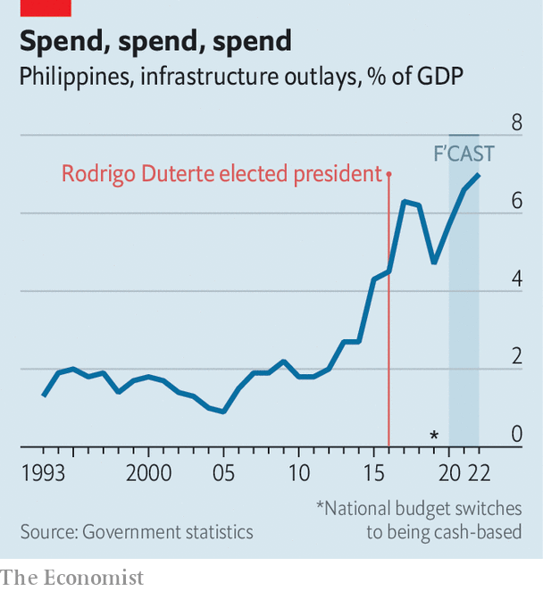

Spending on infrastructure has roughly doubled since the president took office. The plan is for it to reach 7% of GDP by 2022, up from 2.6% in 2015 (see chart). The austere policies of past presidents have left Mr Duterte scope to borrow. Public debt is around 41% of GDP. He has introduced a series of sensible tax reforms, which are expected to help boost government revenue, and diversified the Philippines’ sources of funding. Japan has provided some $12bn in recent years. The Asian Development Bank (ADB) is so enthusiastic about Mr Duterte’s infrastructure plans that last year it lent the Philippines more than any other country bar India. China has also promised $9bn for infrastructure, although it has signed formal agreements to provide only $900m.

Public-private partnerships are also being used. More than a quarter of big projects under “Build, Build, Build” will involve private investors. Ensuring that the terms of concessionary agreements are fair, however, has been an obsession of Mr Duterte’s administration. The president’s ongoing spat with two water companies in Manila over their contractual rights is a case in point. Shares in one of the firms, Manila Water, dropped to a 14-year low at the height of the furore last month. That may worry companies that are thinking about joining the infrastructure push.

The government says that by the middle of 2022 roughly half of the 100 “Build, Build, Build” projects should have been completed. Kelly Bird of the ADB says even finishing 30 would make the programme “hugely successful”. Filipinos are well aware of Mr Duterte’s efforts. A survey by Pulse Asia, a pollster, in December found that 69% of respondents thought his government was doing a “better” job of developing infrastructure than its predecessor.

Obstacles will mount as Mr Duterte nears the end of his time in office, however, and his political power begins to ebb. And once he steps down there is no certainty that his successor will complete his plans. New presidents in the Philippines often kill projects initiated by their predecessors. In 2011 Benigno Aquino, the president of the day, cancelled 66 of 72 car-ferry ports planned by the previous president, Gloria Arroyo, alleging corruption. With luck, though, Mr Duterte’s successor will see the benefit in inheriting dozens of partially constructed projects and a host of shovel-ready ones. A bulging pipeline of sensible projects could prove as important a legacy as the infrastructure Mr Duterte actually manages to build. ■

This article was downloaded by calibre from <https://www.economist.com/asia/2020/01/25/the-philippines-a-country-with-dreadful-traffic-may-start-to-unclog>

|  |  |  |  |
| --- | --- | --- | --- |
|  | Articles | Sections | Next |

|  |  |  |  |
| --- | --- | --- | --- |
| Previous | Articles | Sections | Next |

#### Smoke and numbers

# Australia expresses pride in its dismal record on greenhouse gases

It is still patting itself on the back for questionable achievements a decade ago

Jan 25th 2020 | SYDNEY

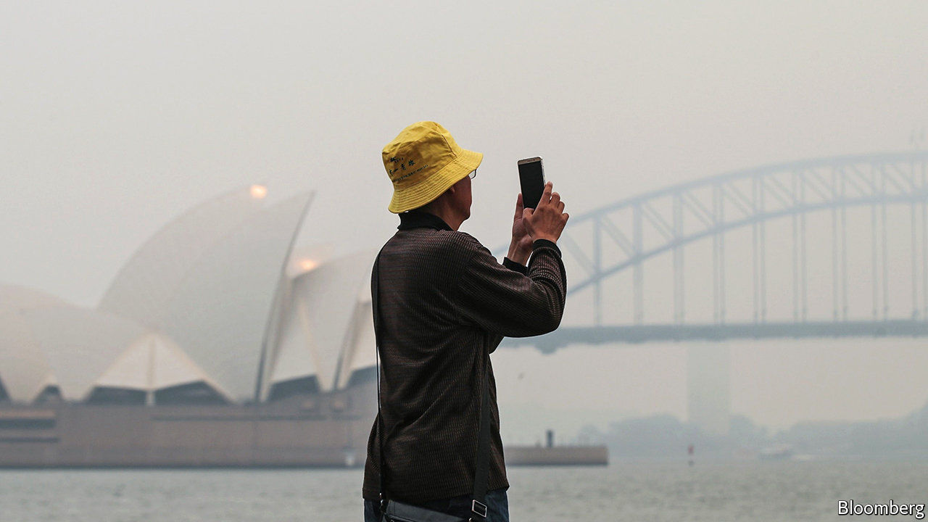

AUSTRALIA’S CONSERVATIVE coalition government has a favourite new catchphrase. It is on track to “meet and beat” its emissions-reduction targets, its ministers chime. The Liberal-National coalition has faced pressure to strengthen its laggardly climate policies since wildfires started tearing across the country last month, but the prime minister, Scott Morrison, has so far declined to do so. Australians are already “carrying our weight” on climate change, he insists.

Australia’s goal under the Paris agreement is to reduce emissions to 26-28% below the level of 2005 by 2030. A previous Liberal government seems to have come up with that target by mimicking America’s pledge, but giving itself an extra five years to achieve it. The European Union, in contrast, promised to cut to 40% below the level of 1990 by 2030—a much tougher target.

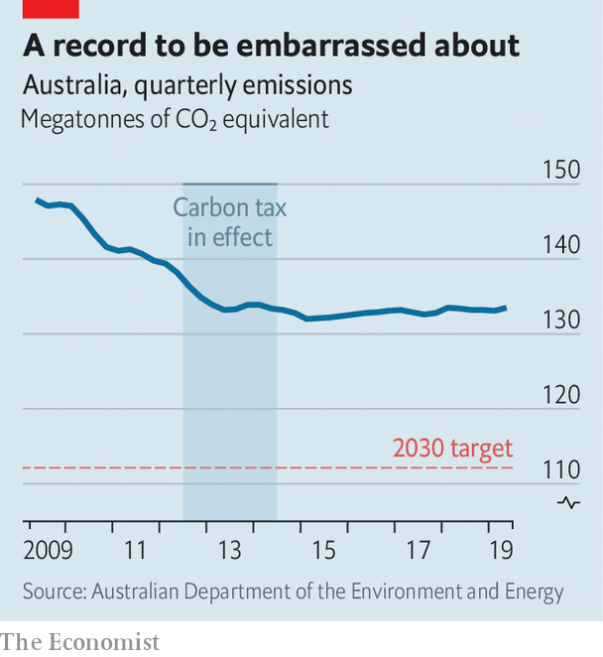

Despite the government’s talk, Australia will not meet its modest aim. Its dependence on cars and coal-fired power makes it one of the world’s biggest emitters relative to population. Its emissions have hardly budged in the six years since the Liberals came to power (see chart). On the government’s own projections, they will fall by only about 16% by 2030, to 511 megatonnes a year, well above the required 447.

The government wants to make up the difference using “carry-over credits” from the Kyoto protocol, the precursor of the Paris agreement. It exceeded its targets under Kyoto, so is “ahead of its mortgage”, Mr Morrison says. Scientists argue that this is especially rich because Australia’s Kyoto targets were piffling. In the first phase of the agreement, it was allowed to increase its emissions by 8%, whereas most rich countries cut theirs. Its stance is akin to “showing up to a university exam and asking for extra credit because you nailed your kindergarten colouring-in”, says Tim Baxter of the Climate Council, an NGO.

Other countries are dumbfounded that a place that stands to lose so much from rising temperatures is “among those trying to water down commitments”, according to Frank Jotzo of the Australian National University. But Mr Morrison became prime minister because his more environmentally minded predecessor, Malcolm Turnbull, was toppled by colleagues after attempting to enshrine an emissions-reduction target for power generation in law. Mr Morrison won a subsequent election by capturing swing seats in Queensland, a state with a weak economy and lots of planned coal mines. The prime minister says he will not do anything that jeopardises the mining and oil industries and so threatens “millions of jobs”.

Lots of Australians, particularly those who do not live in big cities, applaud that position. But recent history suggests that Australia could reduce emissions without scuppering the economy. In 2012 a government led by the Labor Party introduced a scheme which charged big polluters for each tonne of carbon they coughed out. It was repealed two years later by the Liberals, who had labelled it a “giant new tax on everything”. But during its brief life emissions fell and the economy did just fine.

Neither the Liberals nor the chastened Labor Party espouse anything like a carbon tax these days. The Liberals have set up a fund to pay for schemes to plant trees and prevent the clearing of forested land, but have no policies to deter the burning of fossil fuels. Greener voices are being ignored. When the environment minister in the Liberal government that runs the state of New South Wales, Matt Kean, called recently on his colleagues in the national government to abandon carry-over credits, Mr Morrison scoffed, “Most of the federal cabinet wouldn’t even know who Matt Kean was.”

Hope comes from Australia’s states and territories, which are setting themselves demanding emissions targets for the middle of the century. They have less power to clean up transport or industry than states in America, notes Mark Butler, the shadow energy secretary. But South Australia already generates more than half its electricity from wind and solar. The tiny capital region is powered almost entirely by renewables. Australia is as rich in sun and wind as it is in fossil fuels.

Meanwhile, the bushfires sent some 400 megatonnes of carbon dioxide—roughly 75% of Australia’s annual emissions budget—up in smoke in the last three months of 2019. The government does not include these in its emissions count. ■

This article was downloaded by calibre from <https://www.economist.com/asia/2020/01/25/australia-expresses-pride-in-its-dismal-record-on-greenhouse-gases>

|  |  |  |  |
| --- | --- | --- | --- |
| Previous | Articles | Sections | Next |

|  |  |  |  |
| --- | --- | --- | --- |
| Previous | Articles | Sections | Next |

#### Sunny spell

# Vietnam grapples with an unexpected surge in solar power

The energy-hungry country may need fewer coal-fired plants than it thought

Jan 25th 2020 | HO CHI MINH CITY

SOLAR POWER played almost no part in Vietnam’s energy mix in 2017. To speed the technology’s adoption, the government offered that year to pay suppliers a generous $0.09 for every kilowatt-hour produced by big solar farms, but only if they started operations within the following two years. It expected some 850MW of capacity to be installed. Instead, by the end of 2019 the country found itself with 5 gigawatts—more than Australia, with an economy almost six times the size.

The surge is all the more surprising given the terms on offer from Vietnam Electricity (EVN), the cash-strapped state-owned enterprise that runs the national grid. Although the government’s “feed-in tariff” was tempting given that costs typically amount to $0.05-0.07 a kilowatt-hour, EVN only promised to pay for the power it needed on any given day. Developers worried that potential investors would balk at that. As it turned out, they leapt at the chance to cash in on Vietnam’s hunger for power.

The Vietnamese economy has been growing by 5-7% a year for the past two decades. The government has plans to double power generation by 2030, but estimates that supply may run short as soon as next year. It needs to find new sources of power as soon as possible.

Coal is the cornerstone of Vietnam’s energy supply. Under current plans, the fleet of coal-fired power plants will soon triple. But construction has been dogged by regulatory delays, local opposition and flagging investor interest. Building a new plant takes the better part of a decade. Solar farms, in contrast, incite far less opposition and take about two years to build.

The solar boom has not been without problems. Almost all the new facilities are in the sunny south-east, where they overwhelm the local grid and occasionally force EVN to refuse to buy the power they generate—the exact scenario developers had feared. Moreover, the feed-in tariff is expensive. The government is adapting, however. It has begun improving the grid and in November decreed that in future it would not offer a feed-in tariff, but instead auction the right to sell solar power to the grid, with the winner being the firm that offers to do so at the lowest price.

Environmentalists hope that solar’s success will persuade the government to scale back its ambitions for coal-fired plants. Later this year it is due to release new targets for generation capacity in 2030. Wind and solar have almost already met their current goal of providing 10% of power, ten years ahead of schedule. They could easily eat into the 43% share allotted to coal at present. Analysts assume, after all, that prices are likely to continue to move in renewables’ favour. Wood Mackenzie, a consultancy, thinks power from large solar farms in South-East Asia will be at least as cheap as that from almost all coal plants within five years. Given that coal plants have lifespans measured in decades, Vietnam and others risk locking in unduly expensive generation capacity.

In Malaysia a recent auction to build 500MW of solar capacity drew bids for 13 times that. In Cambodia the winning bidder to build a 60MW plant said it would supply power at less than $0.04 a kilowatt-hour, a record low for the region. Although the pipeline of proposed coal plants in South-East Asia remains huge, at around 100 gigawatts, the International Energy Agency, a think-tank, has noticed a gradual shift over the past five years. Approvals for new coal plants have slowed; additions to solar capacity have jumped.

Vietnam’s experience suggests that not all the planned coal plants will be built. Even if that proves correct, South-East Asia will still have a lot more coal-fired generation than environmental activists would like. But solar’s sudden spark in Vietnam should at least change officials’ views of what is possible. ■

This article was downloaded by calibre from <https://www.economist.com/asia/2020/01/25/vietnam-grapples-with-an-unexpected-surge-in-solar-power>

|  |  |  |  |
| --- | --- | --- | --- |
| Previous | Articles | Sections | Next |

|  |  |  |  |
| --- | --- | --- | --- |
| Previous | Articles | Sections | Next |

#### Banyan

# Malaysia’s reformist government has not put an end to sleaze

Its members are too busy plotting against one another

Jan 25th 2020 |

TO SEE HOW topsy-turvy Malaysian politics have grown, consider the case of the previous prime minister, Najib Razak. In 2018 the party he led lost power for the first time since independence. Mainly to blame were allegations of massive graft against Mr Najib, who denied wrongdoing but admitted that almost $700m had found its way into his bank accounts. Soon after he left office, police seized a thumping haul of bling belonging to his wife, Rosmah Mansor, who also denies any crime. It included 567 handbags, 423 watches and 14 tiaras.

Mr Najib faces more than 40 charges of corruption and abuse of power, but his star is rising again. His chutzpah has made him an unlikely hit with the country’s moped gangs, who have taken to calling him bossku (“my boss”). With deft use of social media, Mr Najib has reinvented himself as a man of the people. He paints himself as the victim of a show trial. This week the 94-year-old who replaced him as prime minister, Mahathir Mohamad, who was once Mr Najib’s mentor, expressed bafflement that “people are kissing the hands of thieves and calling them bossku.”

The reinvention of Mr Najib is unlikely to go so far as to return him to the centre of politics, even if he manages to escape imprisonment. Apart from anything, Ms Rosmah is too widely loathed. But his renaissance reflects poorly on Dr Mahathir and the ruling Pakatan Harapan coalition. It promised much when it came to power. By forging an alliance among ethnic Chinese, Indians and Malays, it offered a heartening alternative to the defeated Barisan Nasional (BN) coalition, which had long pursued an often nasty form of identity politics that pandered to the Malay Muslim majority. Equally refreshingly, Pakatan had also promised inclusive economic growth and an end to sleaze.

So much for that. Under Pakatan, everything is subordinate to internal wrangling over the future leadership of the coalition and thus the job of prime minister. In a pre-election pact, Dr Mahathir agreed to head the government for just two years before handing over to Anwar Ibrahim. Twenty years ago, during Dr Mahathir’s previous stint as prime minister, he saw the younger and brilliant Mr Anwar as a threat and had him jailed on trumped-up charges of corruption and homosexual acts, which are illegal in Malaysia. The rift between the two men came to define Malaysian politics, prompting Mr Anwar to leave the ruling United Malays National Organisation (UMNO), the linchpin of the BN, and turn the country’s fractured opposition into genuine contenders for power.

Yet in 2018, the two enemies saw the use of each other. Mr Anwar was again in prison, where Mr Najib had also had him thrown, and so was banned from politics. That meant the opposition needed a credible leader. Dr Mahathir, who in retirement had turned on Mr Najib and UMNO, could bring a crucial slice of Malay voters over to Pakatan’s side. Having helped secure Pakatan’s victory, Dr Mahathir also secured a pardon for Mr Anwar.

But those who muttered that two lions cannot live on the same mountain proved right. Dr Mahathir is now cussedly vague about when he will step down, while a pro-Anwar campaign attempts to discredit the prime minister and his allies. Last year a video was circulated that purported to show one ally, the economy minister, Mohamed Azmin Ali, in bed with a man. Mr Azmin denies it was him. But if the personal attacks echo Mr Anwar’s past treatment, consider that nearly all political insiders believe pro-Anwar people to be responsible for the video’s dissemination.

Meanwhile, Mr Anwar’s former research assistant is suing his political secretary for alleged assault (he denies it). Other modernisers, including Mr Anwar’s daughter, have recoiled from the tone of the debate. It all leaves the direction of Malaysian politics unclear. Dr Mahathir may yet hand over to Mr Anwar later this year. Or he may attempt to abandon Pakatan and forge a new government pandering to Malays, encompassing the rump of UMNO and conservative Islamists. One straw in the wind is the government’s refusal wholeheartedly to condemn a fiery, race-baiting TV evangelist, Zakir Naik, wanted in India on money-laundering charges. The prime minister says ominously that he can work with anyone except Mr Najib.

Meanwhile, the region’s leaders wonder what on earth is going on. An entrepreneur says that the lack of political direction is having an “appalling effect” on the investment climate. Indeed, it is a blow to reform in general.

This article was downloaded by calibre from <https://www.economist.com/asia/2020/01/25/malaysias-reformist-government-has-not-put-an-end-to-sleaze>

|  |  |  |  |
| --- | --- | --- | --- |
| Previous | Articles | Sections | Next |

|  |  |  |
| --- | --- | --- |
| Asia | Sections | Middle East and ... |

China

Viral pneumonia: The Wuhan crisis

.

Chaguan: More equal than others

.

|  |  |  |
| --- | --- | --- |
| Asia | Sections | Middle East and ... |

|  |  |  |  |
| --- | --- | --- | --- |
|  | Articles | Sections | Next |

#### The Wuhan crisis

# The coronavirus discovered in China is causing global alarm

The possible economic impact worries many, too

Jan 25th 2020 | BEIJING AND SHANGHAI

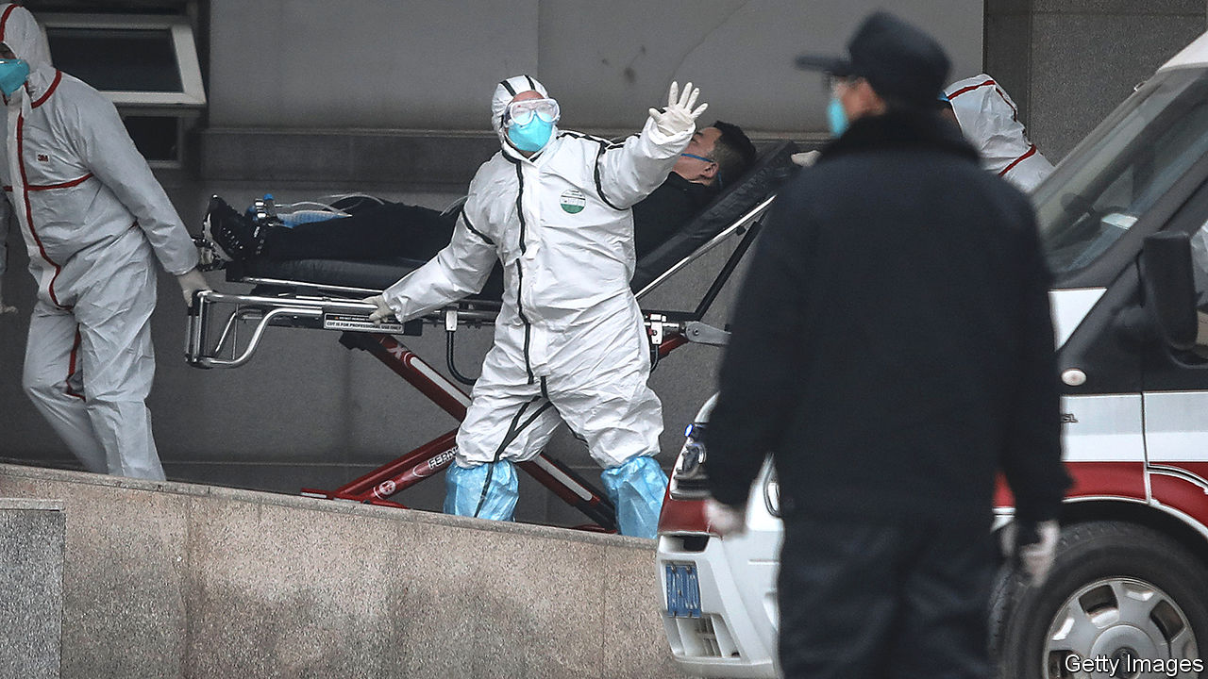

CHINA’S LEADER, Xi Jinping, often warns officials to be wary of “black swan risks”, meaning sudden unexpected events that can harm the economy. People typically assume he means wobbly banks or trade tensions. But the most immediate threat may be a new, sometimes deadly, virus that appears to be spreading. The outbreak raises dark memories of another one 17 years ago that killed hundreds of people and, briefly, nearly halted China’s growth.

The main worry is whether the government can control the virus, which can cause severe pneumonia. The bug is known as 2019-nCoV, or more commonly, the Wuhan virus. It appears to have originated in early December in a fish and animal market in Wuhan, a city of 11m people. On January 20th an official said 14 health workers who had treated patients were ill. This was the first clear evidence that the disease could pass from human to human and therefore spread more widely.

Between January 17th and 22nd the number of confirmed infections grew tenfold. It stood at 618 as The Economist went to press, of whom 17 had died. There are cases in most of China’s provinces. Infected travellers from China have been found in America, Japan, South Korea, Taiwan and Thailand. On January 23nd Wuhan declared a travel ban. Hours later Wuhan’s public transport was halted, airports closed and expressways blocked. A similar lockdown was imposed on two nearby cities, Ezhou and Huanggang.

This has echoes of SARS, a respiratory disease also caused by a coronavirus, the family to which the Wuhan virus belongs. More than 8,000 people in China and other countries contracted SARS between 2002 and 2003. Close to 10% of them died. Data released so far suggest the new virus may be less lethal. Officials tried to cover up SARS, probably increasing its toll. This time, they have been quicker to take preventive measures and give information.

Officials in Wuhan initially downplayed the new virus, but that changed just before the government said that health workers had been infected. On the day of that announcement, Mr Xi said officials should “put people’s lives and health first”, a crucial signal that he would tolerate no cover-ups. The government started providing daily updates. It has appointed Zhong Nanshan, a doctor renowned for disputing the official line during the SARS crisis, to lead an advisory team.

Now that China has switched to crisis mode, few doubt the government’s resolve. But there are still plenty of reasons to worry, both about the impact on people’s health as well as on firms and investors. Just as SARS suggests how a coronavirus might spread, it also has lessons for how such a pathogen might affect an economy. In May 2003 passenger traffic numbers in China plunged more than 40% from a year earlier. Shops, restaurants and hotels all suffered. In annualised terms, quarter-on-quarter growth at the peak of SARS fell to 3.5%, down from more than 12%, according to Wang Tao of UBS, a Swiss bank.

In the case of the Wuhan virus, there are some grounds for optimism. Most hopefully, the government’s faster response could mean that it takes less time to contain it. If experts conclude that the virus is not as dangerous as the one that caused SARS, China might also be able to relax its controls on travel to and from Wuhan before big economic damage is done. Efforts to ensure transparency could reduce panic.

However, Chinese people are far more mobile than they were in the early 2000s. About 450,000 of them travel daily by train in Hubei, the province of which Wuhan is the capital. That is more than double the daily passenger volume in Guangdong in 2002 when that province became a hotspot of SARS. Helped by a vast bullet-train network built over the past decade, passengers from Wuhan will have gone farther and faster than those in Guangdong back then. China is also far more connected to the rest of the world. In 2018 some 205,000 people took flights into and out of China each day, six times as many as on the eve of SARS.

The timing of the new outbreak compounds the difficulty of containing the virus. It has come just ahead of the spring festival, a public holiday which this year runs from January 24th to 30th. In recent days millions have travelled across the country to celebrate with relatives. At transport hubs, travellers’ temperatures are being checked to detect fever. But it may take a week or more for the virus to incubate, so some infected people may not be spotted.

The economy is bigger but less fizzy than it was in 2003. During the SARS outbreak a few big sectors thrived even as others struggled. Exports surged 35%. Spending on infrastructure and housing held strong. Today, however, export growth is far weaker—only 0.5% in 2019. Property sales have started falling after a long boom. And the country has less scope to increase its spending on infrastructure, having already built so much over the past decade. In the first few days after the number of confirmed infections surged this month, Chinese stocks fell about 5%. They could tumble further. During SARS, Hong Kong’s main index declined by nearly 20%.

The part of the economy most hurt by SARS was the services sector, which then accounted for about 40% of GDP. Today the share is higher than 50%. But consumer spending could be more resilient this time because of huge growth in the popularity of online shopping. If they are fearful of venturing out (Wuhan has ordered residents to wear masks in shops and other establishments where people congregate), people can continue to buy goods at home.

China can also draw comfort from the speed with which its economy recovered after SARS was conquered. By the second half of 2003 it was back to double-digit growth. Consumers indulged their pent-up demand for everything from cars to beer. But as the current crisis grows, the grim reality of the present is all that many people—especially the millions confined to Wuhan—are likely to be contemplating. ■

This article was downloaded by calibre from <https://www.economist.com/china/2020/01/25/the-coronavirus-discovered-in-china-is-causing-global-alarm>

|  |  |  |  |
| --- | --- | --- | --- |
|  | Articles | Sections | Next |

|  |  |  |  |
| --- | --- | --- | --- |
| Previous | Articles | Sections | Next |

#### Chaguan

# A year of Euro-summits will reveal much about China’s worldview

Does it want to be the sun around which European planets revolve?

Jan 25th 2020 |

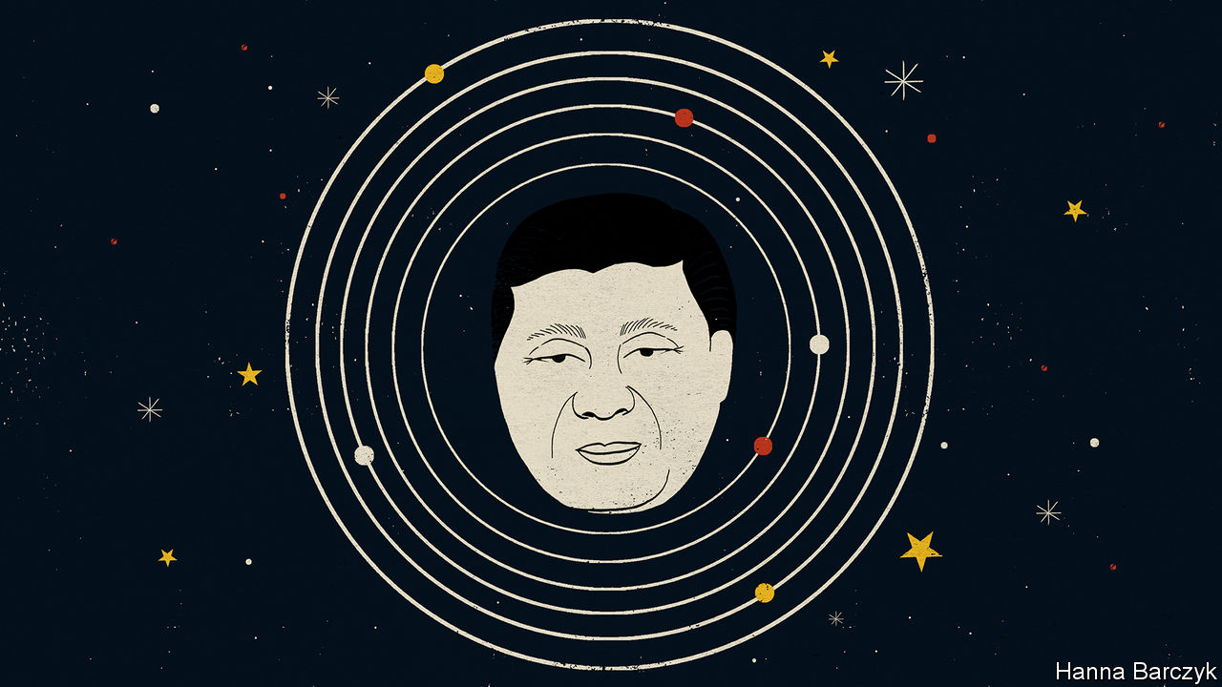

IF JUDGED BY words, rather than deeds, China is the world’s most powerful supporter of European unity. At a time when populist leaders such as President Donald Trump barely conceal their scorn for the European Union and other multilateral institutions, China talks of deepening and strengthening ties with the EU and other international bodies dear to Europeans.

Their great nation’s rise is powered by globalisation, Chinese officials explain. That gives China cause to fear anti-European populism that often overlaps with hostility to trade. As a result, it wants to work with all of Europe on crafting a fairer, more just, multilateral order fit for the 21st century.

There are reasons to be sceptical of such pledges. Start with core principles. China’s worldview is built on absolute deference to state sovereignty, chin-jutting nationalism and a belief that one country should not meddle in the internal affairs of another. In contrast, the belief that small and mid-sized countries can gain by pooling some sovereignty is the EU’s founding idea. Meddling in members’ affairs, to defend inviolable norms, is the union’s point.

This year will test China’s commitment to Europe in deeds, as well as words. Twice in 2020 the country’s leader, President Xi Jinping, will meet European counterparts at summits. The largest will take place in September in Leipzig, co-hosted by Germany and the EU. With Britain out of the club by then, Mr Xi will meet 27 national leaders, alongside the heads of Euro-institutions. European diplomats talk of a meeting of equals: two economic giants discussing such goals as a long-stalled agreement on two-way investments, or action on climate change, and all at a time when America’s commitment to international co-operation is in doubt. Even the place, in former East Germany, sends a message, it is said. Germany’s chancellor, Angela Merkel, wants to show China that western and ex-communist EU members stand as one.

China has a counter-message. In April it will host a summit of a grouping known as “17+1”. Founded in 2012, the club brings together China and 12 EU members—Bulgaria, Croatia, the Czech Republic, Estonia, Greece, Hungary, Latvia, Lithuania, Poland, Romania, Slovakia and Slovenia; and five aspiring ones—Albania, Bosnia and Herzegovina, Montenegro, North Macedonia and Serbia. Recent years have seen growing discontent among EU members of the group. Most have not seen hoped-for Chinese investments in bridges, roads and other infrastructure, and their farm goods and other products still struggle to enter China’s markets. Detecting trouble, China upgraded this year’s 17+1 summit. It is to be hosted in Beijing by Mr Xi, rather than the prime minister, Li Keqiang, who has presided over the group’s meetings to date.

Chaguan asked half a dozen European ambassadors in Beijing whether China was a source of unity or disunity in their continent. The question divided them. One diplomat calls the 17+1 grouping a mostly benign attempt by China to re-establish fraternal links with ex-socialist countries, and no more divisive than the endless bilateral exchanges that bigger countries, like Germany or France, have with China. Still, he concedes, if China sees a chance to get its way by driving wedges between EU members, it will. “The Chinese take the EU as seriously as the EU takes itself. They are taking advantage of the opportunities we give them,” he says.

Other envoys relate how China, a bureaucratic superpower, pushes 17+1 members to attend hundreds of sub-meetings on everything from food safety to cultural co-operation, generating blizzards of Chinese-drafted documents. Each must be checked for phrases which either encroach on areas of lawmaking which members cede to the EU, or which advance China’s worldview. Recent 17+1 drafts talk about co-operation on the basis of the sovereignty of participating countries, worries a diplomat, seeing a coded Chinese challenge to multilateralism and European values. Such papers are a “sneaky way to test how vigilant we are”, he sighs.

China is currently urging 17+1 leaders to express political support for Mr Xi’s global plan for Chinese-led infrastructure projects, the Belt and Road Initiative. Some envoys call the BRI a useful source of investment, and shrug at pressure to praise it as harmless propaganda. Others are more doubtful, noting how strict EU laws on public procurement or sustainable debt mean that rather few Chinese infrastructure contracts are signed inside the union. That encourages China to sign murkier deals on the EU’s periphery.

Some detect serious intent when Chinese officials work tirelessly to fill draft statements with empty-seeming phrases, such as Mr Xi’s call to build a “community with a shared future for mankind”. To that wary camp, it is no comfort when China says this or that document is non-binding, so hurry up and sign. If countries start routinely using Chinese vocabulary in international forums, when disputes arise China will be the logical arbiter, they say.

## Orbiting a red giant

European countries agree on some points. For one, they each crave bilateral favours from China, but fear being left to confront such an assertive giant alone. For a while Chinese officials caused alarm by calling the Leipzig summit a “27+1” meeting, as if Mr Xi were an emperor receiving tributary kingdoms, as one envoy puts it, or a sun around which European planets revolve. Chinese diplomats even questioned whether there would be time for an annual EU-China summit, an event involving the EU’s top officials but not its members’ leaders. China eventually agreed to hold one in late March, and to use it to plan the larger gatherings that follow.

The Europeans also concur that they must keep America in mind when dealing with China. Some diplomats suggest that if China were to agree on an investment treaty with the EU, the price could be an EU promise to keep selling high technology to Chinese firms, no matter what America thinks. But if told to choose between China and America, Europeans’ horror would be unanimous. That is not the Euro-unity that China has in mind. ■

This article was downloaded by calibre from <https://www.economist.com/china/2020/01/25/a-year-of-euro-summits-will-reveal-much-about-chinas-worldview>

|  |  |  |  |
| --- | --- | --- | --- |
| Previous | Articles | Sections | Next |

|  |  |  |
| --- | --- | --- |
| China | Sections | Europe |

Middle East and Africa

Britain in Africa: Boris Johnson woos Africa

.

Lesotho: Murder in the mountains

.

Isabel dos Santos: A self-made something

.

Libya: The spoiler

.

Hacking Jeff Bezos: Alexa, define chutzpah

.

|  |  |  |
| --- | --- | --- |
| China | Sections | Europe |

|  |  |  |  |
| --- | --- | --- | --- |
|  | Articles | Sections | Next |

#### Scrambling again

# Boris Johnson woos Africa

A post-Brexit Britain will need friends

Jan 25th 2020 |

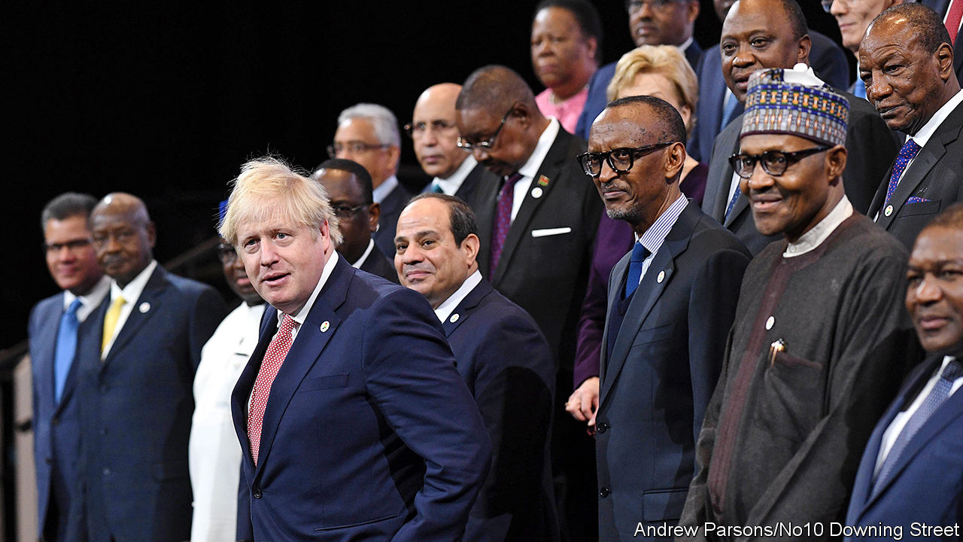

HOW TO PROMOTE a “global Britain” after Britain leaves the European Union? One possibility is to try to revive links with Africa, where Britain was once the leading colonial power. Boris Johnson, Britain’s prime minister, hosted about a third of the continent’s leaders at an “investment summit” in London on January 20th. Most of those running the beefier or friendlier African countries—including Egypt, Ethiopia, Ghana, Kenya, Nigeria and Rwanda—heard Mr Johnson declare that Britain, shorn of the European Union’s trade constraints, is keener than ever to do business and strengthen ties. “Africa is booming,” he said. “Africa is the future.”

But behind the virtuous talk of partnership and goodwill, British officials are arguing vigorously over how to deal with Africa. In the past two decades, the influence of Britain’s Department for International Development (DFID), responsible for dispensing aid to poor countries, has surged. At the same time the muscle of the Foreign and Commonwealth Office, responsible for the harder-nosed practice of traditional diplomacy, has shrunk. “Africa has become a development issue,” laments a diplomat, referring glumly to “the DFID-isation of foreign policy” in Africa.

Partly this is because of cash. Whereas the Foreign Office’s core budget, now £1.1bn ($1.4bn) a year, has shrunk greatly in the past decade, DFID’s has swollen steadily, since by law it must be at least 0.7% of GDP. In 2018 Britain disbursed foreign aid worth £14.6bn, mainly through DFID.

## Britain needs friends

DFID gained its independence as a separate department in 1997, under Tony Blair. Mr Johnson has sounded keen to bring it back under the control of the Foreign Office. But he seems to have been persuaded that DFID should continue to stand alone. Nor has he bowed to the many Conservatives (and others) who want to break the 0.7% pledge. They complain that many departments are still chafing under the spending cuts imposed nearly a decade ago after the global financial crash, yet the aid budget continues to soar. For the time being, however, the 0.7% promise is kept.

In any event, it is widely agreed that Britain’s diminished network of diplomatic missions should be bumped up. As foreign secretary from 2016 to 2018, Mr Johnson promoted a plan to open or reopen a string of smaller ones. He visited more African countries than any foreign secretary since the Conservatives returned to office in 2010. In the past year Britain’s Treasury has been persuaded to pay for 400-odd extra diplomatic posts focused on Africa (based at home or in the continent).

Still, Britain’s diplomatic footprint in Africa is tiny compared with what it was. According to a report issued last year by the British Foreign Policy Group, a think-tank backed by former ambassadors, in 2017 Britain had 231 diplomats (excluding local hires) in 31 of sub-Saharan Africa’s 48 countries. In 16 of those British missions, only one or two diplomats were in situ. Missions to five more countries have since been opened or reopened. France, which had 42 embassies south of the Sahara, counted 1,373 diplomats (excluding local hires) in 2018; China probably has even more. Diplomats from Brazil, India and Turkey, eager to do business and diplomacy in Africa, also outnumber Britain on the ground in various countries.

Another token of Britain’s failure to punch its weight is the paucity of trips to Africa by British prime ministers, compared with the constant round of visits by French and Chinese leaders. The shrinkage of Britain’s diplomatic engagement in Africa in the past two decades was “a massive error of judgment”, says Rory Stewart, one of eight ministers for Africa since 2010. The extraordinarily rapid turnover in that post was yet another reason why Africans got the impression that Britain cared less about the continent than it should have.

Britain is sending 250 troops to Mali to assist a French-led UN force there, is helping to train Nigerian soldiers to fight the jihadists of Boko Haram in north-eastern Nigeria, has sought to bring peace to South Sudan and has deployed special forces in Somalia. But the French far outgun the British on the continent, with a base in Djibouti and more than 7,200 troops on the ground, mostly in the Sahel, where they have been seeking to beat back a sprawling jihadist insurgency.

However, Britain is the only member of the G7 group of rich countries to meet the goal of spending 0.7% of GDP on foreign aid. In absolute terms, only America and Germany are more generous; France is far behind both.

At the summit in London Mr Johnson stressed trade and investment over aid. His officials hail the African Continental Free Trade Area, a deal signed in 2018 by 44 members of the African Union, as a harbinger of Africa’s future as a trading bloc. His predecessor, Theresa May, declared on her sole trip to Africa as prime minister, in 2018, that Britain would strive to become the biggest single investor in Africa by 2022, with the CDC (formerly the Commonwealth Development Corporation), a government-owned private-equity group, leading the way. In terms of investment since 2014, Britain comes fourth after China, America and France, according to the Brookings Institution, a think-tank.

Britain will need to deploy a mix of hard and soft power to advance its interests in Africa. Mr Johnson acknowledged that an issue which particularly annoys Africans, especially businessmen, government officials and scholars, is getting a visa to visit Britain. It is time-consuming and often humiliating. Many of Britain’s understaffed diplomatic missions have no passport office, so would-be visitors are required to travel hundreds of miles to neighbouring countries. It may seem a petty impediment set against the wider aspects of British investment in Africa. But Africans are hardly likely to welcome British investors if they feel unwelcome in Britain themselves. ■

This article was downloaded by calibre from <https://www.economist.com/middle-east-and-africa/2020/01/25/boris-johnson-woos-africa>

|  |  |  |  |
| --- | --- | --- | --- |
|  | Articles | Sections | Next |

|  |  |  |  |
| --- | --- | --- | --- |
| Previous | Articles | Sections | Next |

#### Murder in the mountains

# One first lady is dead in Lesotho. Another has fled

Belated efforts to solve a murder have plunged Lesotho into chaos

Jan 25th 2020 | JOHANNESBURG

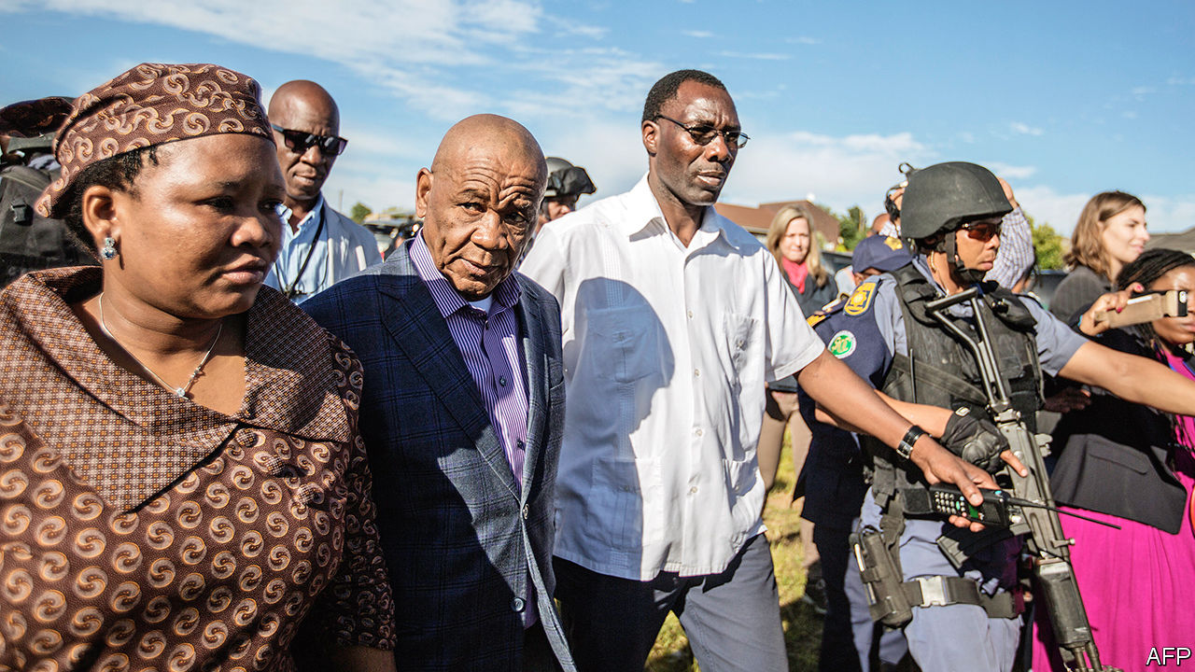

ON JUNE 14TH 2017 Lipolelo Thabane was killed by gunmen outside her home near Maseru, the capital of Lesotho. Two days later Thomas Thabane, her estranged husband (pictured, right), was sworn in as prime minister of the mountainous kingdom. By his side was his new partner, the future Maesaiah Thabane (left), whom he married less than three months later. In his inaugural address Mr Thabane called the death of Lipolelo “senseless”. Yet in recent weeks belated efforts to get to the bottom of the killing have plunged one of the world’s smallest countries into chaos.

Rumours of violent chicanery have long haunted the first family. Mr Thabane’s daughter from his first marriage has alleged that Maesaiah, wife number three, had a hand in the death of Lipolelo, wife number two. The supposed motive: Maesaiah wanted to be the official first lady but was being blocked by the high court, which in 2015 ruled that Lipolelo would retain that role until she divorced Mr Thabane, a process she was drawing out in order to keep the perks of office. Mr Thabane has accused his daughter of trying to topple him so as to help her husband, another politician.

In December the case moved from speculation to allegations. The police issued an arrest warrant for Maesaiah after she went on the run to escape questioning by investigators. They want her and her 80-year-old husband to explain, among other things, why there had been a phone call from the crime scene to a number linked to Mr Thabane. In response, the prime minister tried to suspend the police chief but was blocked by the courts on January 9th. Maesaiah, 42, is still missing. The police have interviewed her husband.

On January 16th an envoy from South Africa, the country that encircles Lesotho and upon which the kingdom is economically reliant, paid Mr Thabane a visit. The next day the prime minister seemed to accept that having a wife on the lam was a distraction from his day job. He said he would resign, though he has yet to give a date. Rivals are already jockeying to replace him.

Part soap opera, part Shakespeare, the case is not the only drama to have befallen Lesotho in its modern history. For most of the century before 1966 the kingdom was a British colony, rather than part of South Africa. After independence that year Chief Leabua Jonathan began two decades of autocratic rule, suppressing opposition and briefly expelling the king (before allowing the monarch to return in a symbolic role). In 1986 the armed forces took over, backed by the neighbouring apartheid regime. Democracy returned in 1993, and with it unseemly squabbles for power among an ever-growing number of parties, which are encouraged to split by a system of partial proportional representation.

These parties have no real ideological differences, says John Aerni-Flessner of Michigan State University. But since there is not much of a domestic economy—most of Lesotho’s income comes from supplying water to South Africa, fees from the regional customs union and remittances—politics is the way to get rich. Lipolelo’s murder is not the first with political consequences in recent years. In 2014 there was also a coup that toppled Mr Thabane, who fled to South Africa fearing for his life, only to regain power in 2017, when his supplanters’ coalition fell apart.

It is unclear why the actions against Mr Thabane and his third wife came when they did. It may have been the eventual product of hard work by dogged detectives. Alternatively, it may reflect how dimly the Basotho elite view the first lady. She is often compared to Grace Mugabe, another relatively young woman who married a veteran African leader and became the apparent power behind the throne.

Whatever the truth, the country can ill afford chaos. Its official unemployment rate is 23.5%, one of the highest in the world. Just 20% of people in rural areas have access to electricity. A legacy of high rates of HIV/AIDS means that life expectancy is 53, compared with 60 in the late 1980s. The immediate victim of this saga was of course Lipolelo Thabane. But the people of Lesotho are victims, too. ■

This article was downloaded by calibre from <https://www.economist.com/middle-east-and-africa/2020/01/25/one-first-lady-is-dead-in-lesotho-another-has-fled>

|  |  |  |  |
| --- | --- | --- | --- |
| Previous | Articles | Sections | Next |

|  |  |  |  |
| --- | --- | --- | --- |
| Previous | Articles | Sections | Next |

#### A self-made something

# What 700,000 leaked documents reveal about Africa’s richest woman

Isabel dos Santos faces charges at home and investigations abroad

Jan 25th 2020 |

ISABEL DOS SANTOS styles herself as a visionary, an entrepreneur and a potential future president of Angola. Her vast fortune was self-made, she boasts. Running Sonangol, Angola’s state oil firm, was a “big personal sacrifice”. Many Angolans “see me as a role model”, she recently told The Economist.

Such claims have always seemed absurd. Ms dos Santos’s father is José Eduardo dos Santos, Angola’s former dictator, who appointed her head of Sonangol from 2016 to 2017. Now more than 700,000 documents obtained by the Platform to Protect Whistleblowers in Africa, a Paris-based advocacy group, and shared with the International Consortium of Investigative Journalists (ICIJ), show how she allegedly milked the state. On January 22nd prosecutors in Angola formally accused her of fraud and mismanagement. She denies wrongdoing.

The ICIJ found a mountain of questionable transactions. There were suspicious payments from Sonangol to companies with links to Ms dos Santos. In 2016, before she was named head of Sonangol, Wise Intelligence Solutions, owned by her and her husband, Sindika Dokolo, was given $9.3m to oversee the company’s restructuring. Wise seemed to have little relevant expertise; it hired Western firms, such as Boston Consulting and PwC, to help. They billed for much less than what Wise received.

In 2017, after Ms dos Santos became chairwoman of Sonangol, Wise was replaced by Matter Business Solutions, owned by one of her friends. After her father stepped down in September 2017, Matter issued a slew of invoices to Sonangol. One, for over €470,000 ($521,000), simply read: “Expenses May-September 2017”. In November, a day after Angola’s new president fired Ms dos Santos, Sonangol made three payments to Matter totalling $58m. Ms dos Santos seems to have approved some after she was fired. She says that’s not true.

A second scheme involved a struggling Swiss jeweller called De Grisogono. Mr Dokolo persuaded Angola’s state diamond company, Sodiam, to invest more than $120m in the firm, of which $98m was borrowed. He says he also invested his own money. But the deal was mostly, if not completely, funded by the state, according to the documents. Nevertheless, Mr Dokolo and his team, not Sodiam, ran De Grisogono—poorly. Glitzy parties provided photo opportunities for Ms dos Santos (pictured, middle), but cost loads. Sodiam, which did not recoup its investment, now wants out. It will be down more than $200m once it pays back the early loans, says its new chief. Those loans, with a 9% interest rate, were issued by Banco BIC, of which Ms dos Santos owns 42.5%.

The firms that helped Ms dos Santos are professing ignorance. But the schemes bear the hallmarks of money-laundering, says Jason Sharman of Cambridge University. Angolan reporters have long argued that Ms dos Santos is less self-made than she claims. Prosecutors in Portugal, the former colonial power in Angola, are digging. (A Portuguese banker implicated in the scandal was found dead, after apparently committing suicide, on January 22nd.) Britain could investigate, too. If a court found that Ms dos Santos’s pads in London and Lisbon were ill gotten, they could be seized. But she is unlikely to end up in jail. She also owns a posh flat in the United Arab Emirates, which isn’t keen on extradition.

This article was downloaded by calibre from <https://www.economist.com/middle-east-and-africa/2020/01/25/what-700000-leaked-documents-reveal-about-africas-richest-woman>

|  |  |  |  |
| --- | --- | --- | --- |
| Previous | Articles | Sections | Next |

|  |  |  |  |
| --- | --- | --- | --- |
| Previous | Articles | Sections | Next |

#### The spoiler

# Khalifa Haftar, the Libyan warlord, is not interested in compromise

And he’s under no pressure from his main foreign backer to make peace

Jan 25th 2020 | BEIRUT

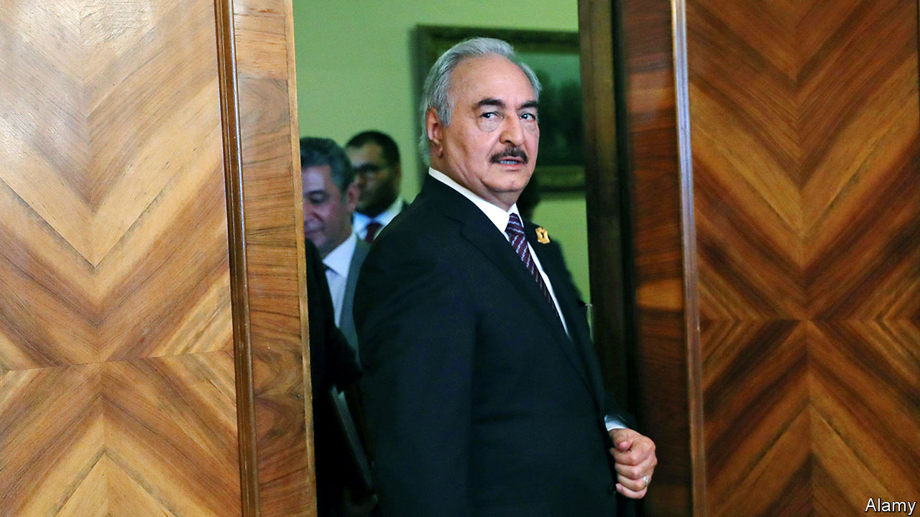

TO CALL IT a success is a sign of low expectations, not high achievements. On January 19th the parties in Libya’s civil war gathered in Berlin for a peace conference. The Libyans themselves—Fayez al-Sarraj, who leads the UN-backed government in Tripoli, and General Khalifa Haftar, the warlord who controls most of the country—were invited only at the last minute. The summit was mostly an effort to plead with foreign powers that have turned a local conflict into a global proxy war.

It ended with a joint promise to respect a UN arms embargo and end outside support for the conflict. The Germans said they were cautiously satisfied. Missing from the final communiqué, though, was any formal ceasefire or threat of sanctions for states that ignore the embargo. Days after the conference, foreign cargo planes were once again shuttling military supplies into the war-torn country.

The UN envoy, Ghassan Salamé, tells anyone willing to listen that such foreign meddling is Libya’s biggest problem. In recent months attention has focused on Russia and Turkey. The former sent hundreds of mercenaries from the Wagner Group, a private-security firm with ties to the Kremlin, to support General Haftar. Turkey then sent its own guns-for-hire, up to 2,000 Syrian militants, to defend Tripoli.

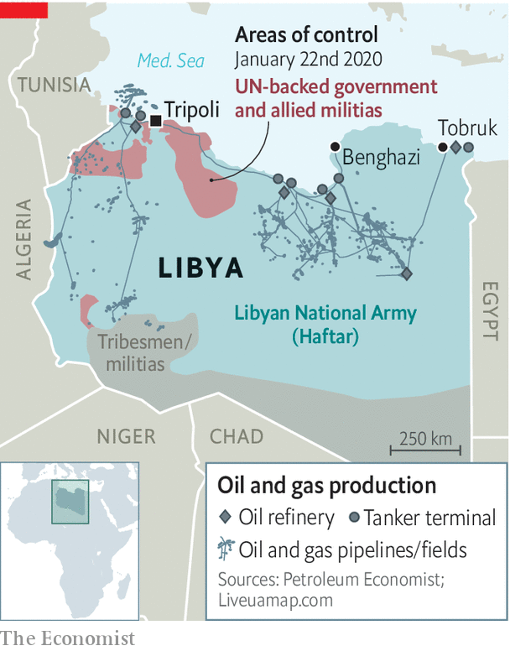

Neither country has really tried to tip the balance of power. Both have economic interests in Libya: billions of dollars in stalled construction projects for Turkey, the prospect of lucrative energy deals for Russia. But both view the country mostly as a bargaining chip in their dealings with each other—they back opposing sides in Syria—and with Europe.

The real spoiler remains General Haftar (pictured). Famously cantankerous, the 76-year-old warlord seems uninterested in compromise. He launched an offensive to capture Tripoli in April hours after the UN secretary-general, António Guterres, landed in the capital to prepare for a peace conference. Summoned to Moscow on January 13th to discuss a ceasefire, he walked out early, angering Russian leaders.

But the general has other considerations. For a start, his biggest tactical advantage is not a few hundred mercenaries. It is his control of the skies, which he owes to the United Arab Emirates (UAE), his most reliable foreign backer. It has deployed a fleet of Chinese-made drones capable of striking anywhere in Libya. A panel of UN investigators reported in December that the UAE also sent air-defence systems and other kit last year. The government in Tripoli cannot compete. Its Turkish-made drones carry only small munitions and have a range of less than 200km. Diplomats say the UAE has urged General Haftar not to accept a ceasefire.

He also worries about dissent in his own ranks. His self-styled Libyan National Army is riven with tribal and regional splits. Some commanders served under Muammar Qaddafi; they naturally mistrust the general, who betrayed the dictator. Big offensives help to submerge those disputes. But the general fears retreat might encourage a challenge to his leadership.

As delegates gathered in Berlin, gunmen aligned with General Haftar cut off oil shipments from Libya’s main ports. The closure has halted almost all of Libya’s production and will starve the Tripoli government of revenue (oil accounts for more than 90% of its budget). These are hardly the actions of a man interested in peace. ■

This article was downloaded by calibre from <https://www.economist.com/middle-east-and-africa/2020/01/25/khalifa-haftar-the-libyan-warlord-is-not-interested-in-compromise>

|  |  |  |  |
| --- | --- | --- | --- |
| Previous | Articles | Sections | Next |

|  |  |  |  |
| --- | --- | --- | --- |
| Previous | Articles | Sections | Next |

#### Alexa, define chutzpah

# Did Saudi Arabia’s crown prince hack the Amazon king?

Muhammad bin Salman has gone after journalists, dissidents—and now, perhaps, the world’s richest man

Jan 25th 2020 | BEIRUT



THREE MONTHS ago, as executives gathered in Riyadh for a conference, a supporter of the Saudi crown prince allowed himself a moment of doubt. The businessman was fond of Muhammad bin Salman’s efforts to open a closed country and diversify its economy. But he fretted that the prince was too impulsive for his own good. He had already locked up relatives, launched an ill-fated war and allegedly murdered a critic. “He can’t get out of his own way,” the businessman said.

On January 22nd UN investigators alleged that the de facto ruler of Saudi Arabia may have hacked the mobile phone of Jeff Bezos, the founder of Amazon, an e-commerce giant. According to a forensic report prepared for Mr Bezos, the world’s richest man received an infected video file on WhatsApp, a messaging service, sent from a number used by the crown prince. It opened a back door on the billionaire’s phone, which was soon used to steal large amounts of data—though the UN did not say exactly what, or how it was used. It called for an “immediate investigation”. The Saudi embassy in Washington, DC, said the accusations were “absurd”.

Surreal as they may seem, though, the allegations make sense. Last year the National Enquirer, an American tabloid, published an exposé about an extramarital affair between Mr Bezos and a television presenter. He, in turn, accused the newspaper of trying to blackmail him with leaked photos. An investigator working for Mr Bezos later accused the Saudi government of being behind the leaks. The Enquirer’s parent company, American Media LLC, has a relationship with the Saudis. In 2018 it published a glossy propaganda magazine extolling the virtues of Prince Muhammad.

On the face of it, the Saudis had reason to go after Mr Bezos. He owns the Washington Post, which counted among its contributors Jamal Khashoggi, a Saudi journalist whose critical columns angered Prince Muhammad. In October 2018 Khashoggi was murdered and dismembered inside the kingdom’s consulate in Istanbul. The CIA concluded that the prince probably ordered the killing (he denies this).

In normal times a Saudi prince hacking America’s richest man would cause a diplomatic crisis. But it is hard to imagine President Donald Trump being too angry. He views Saudi Arabia as a vital ally and has largely turned a blind eye to the prince’s rash behaviour. He imposed no heavy punishment for the murder of Khashoggi, who lived in Virginia. And judging by his tweets, Mr Trump is no fan of “Jeff Bozo” or of the Post’s critical reporting.

Foreign investors may be more concerned. Prince Muhammad has sought to woo them. He met Mr Bezos during a tour of America in 2018 (the men swapped phone numbers at a dinner in Los Angeles). But investors have been turned off by the prince’s “anti-corruption” drive in 2018, during which scores of tycoons were locked up, and the murder of Khashoggi. Foreign direct investment climbed modestly in 2019, to $3.5bn in the first nine months of the year, but it is still well below levels from earlier in the decade. Businessmen may not want to deal with a leader they think may bug their phones.

The same goes for foreign leaders. Intelligence officials in America and elsewhere will no doubt wonder if Mr Bezos was the only target. The president’s son-in-law, Jared Kushner, is known to chat often with Prince Muhammad on WhatsApp.

On the bright side, wags quip, the alleged hack was perhaps another example of burgeoning ties between Israel and the Gulf states. Though the UN could not pinpoint the malware used, researchers believe it relied on Pegasus, spyware designed by NSO Group, an Israeli firm. It is the subject of multiple lawsuits—including one by WhatsApp itself—that accuse it of providing spyware to authoritarian regimes. (NSO Group denies wrongdoing.)

The report, if true, is perhaps most troubling for Prince Muhammad’s own subjects. Scores of the government’s critics have ended up in jail. A Saudi dissident living in Canada, Omar Abdulaziz, claimed in a lawsuit filed in Israel in 2018 that Pegasus was used to tap his phone and monitor his communications with Khashoggi. If the world’s richest man is a target, any Saudi citizen has good reason to worry. ■

This article was downloaded by calibre from <https://www.economist.com/middle-east-and-africa/2020/01/25/did-saudi-arabias-crown-prince-hack-the-amazon-king>

|  |  |  |  |
| --- | --- | --- | --- |
| Previous | Articles | Sections | Next |

|  |  |  |
| --- | --- | --- |
| Middle East and ... | Sections | Britain |

Europe

Poland: Law and Justice v law and justice

.

Russian disinformation: Memory wipe

.

Cyber-security in Germany: Their way or Huawei

.

Romanian farmers: Market-makers

.

France: Brutal facts

.

|  |  |  |
| --- | --- | --- |
| Middle East and ... | Sections | Britain |

|  |  |  |  |
| --- | --- | --- | --- |
|  | Articles | Sections | Next |

#### Shackling judges

# Europe confronts Poland over its trampling on the rule of law

Despite its name, the ruling Law and Justice party is no fan of judicial independence

Jan 25th 2020 | WARSAW

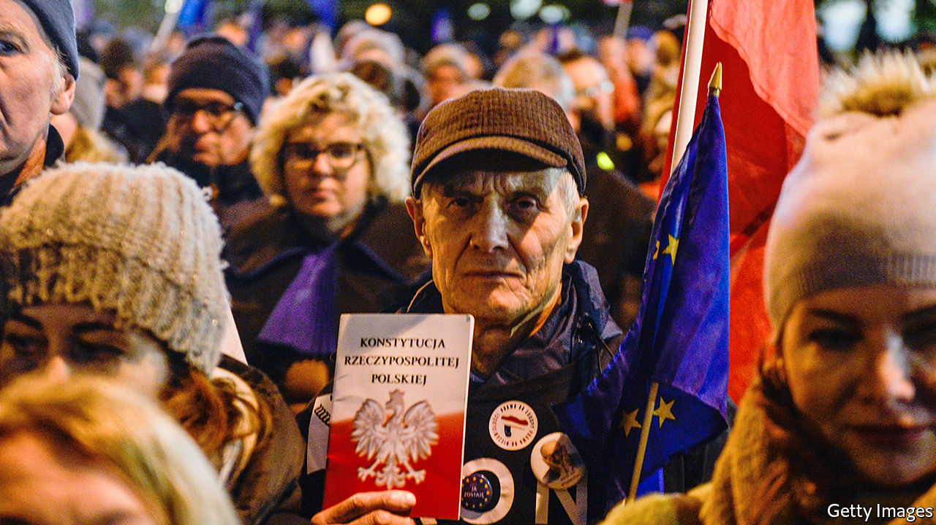

EVER SINCE the populist Law and Justice (PiS) party took power in 2015, Adam Bodnar, Poland’s human-rights ombudsman, has been warning against its relentless efforts to get control of the courts. To illustrate the danger, he uses an expression from communist times: lex telefonica. In the Polish People’s Republic, verdicts were routinely dictated by a phone call from an apparatchik at party headquarters. Today’s government has more subtle techniques, but the goal is the same, Mr Bodnar says: “If a judge has a case on his desk with some political importance, he should be afraid.”

The European Commission is worried, too. It accuses PiS of violating Poland’s commitments to the rule of law under the European Union’s founding treaty. In 2017 the commission took Poland to the European Court of Justice (ECJ) over laws that gave politicians control over appointing judges. (For example, they lowered judges’ retirement age while letting the justice minister pick whom to exempt.) The ECJ ruled against the Poles, who had in the meantime scrapped some of the measures.

Now another ruling by the ECJ threatens to force Poland into an open break with the EU. Last year PiS passed a law creating a disciplinary chamber for the country’s Supreme Court, which has stubbornly resisted government control. The chamber could suspend judges, and its members would be appointed by Poland’s president—a former member of PiS—along with the National Judiciary Council, the official jurists’ association. (This is now controlled by parliament, where PiS has a majority.) The Supreme Court queried the law in the ECJ, which laid out criteria for whether the system violated judicial independence. On December 5th the Supreme Court, applying those criteria, ruled that it does.

The government threw a fit. On December 20th it pushed a law through parliament’s lower house that directs the disciplinary chamber to punish judges who apply the ECJ’s ruling. On January 11th Iustitia, an independent jurists’ association, led a protest march in Warsaw of hundreds of toga-wearing judges from Poland and abroad, including Malgorzata Gersdorf, the Supreme Court’s president. The group calls the new law “unheard of and unimaginable in the circle of civilised states”.

The government says it is being treated unfairly. Under EU treaties, says Andrzej Duda, the president, “Poland has the right to regulate its internal legal order.” The opposite is closer to the truth. The treaties oblige national courts to apply EU law and obey the ECJ. European officials and experts in EU law warn that if one country’s courts are politicised, others may stop accepting their rulings.

That would threaten the legal sinews that hold the union together. Poland is not the only country facing concerns over the rule of law. PiS copied many ideas from Hungary’s ruling Fidesz party. Rule-of-law concerns have been raised in Bulgaria, Malta, Romania and elsewhere. While Poles worry about judicial independence, the EU worries about a threat to its architecture.

In a white paper in 2018, the government offered three justifications for its reforms. One was that the courts had never been properly de-communised. Three decades after the transition, this seems dubious. The average judge is far too young to have served under the communist regime. The government undermined its own case in November by appointing to the constitutional court an elderly PiS lawmaker who had served as a notorious prosecutor for the old dictatorship.

## Quit judging me

Another argument is that cases take too long. The government cites a survey in 2017 showing Poland ranked 24th of 35 developed countries for public satisfaction with the judiciary. Backlogs are indeed long, but judges say the reforms will not shorten them. They have not added support staff or simplified procedures much.

A third claim is that the EU is biased against eastern European countries, since western ones also give governments some say in the judiciary. For example, in Germany, as in Poland, the president of the constitutional tribunal is picked by the government, and cases are heard by smaller panels of judges. But in Poland the court’s president gets to select the panels, and can choose loyal PiS justices.

This pattern of taking bits of other democracies and combining them into something authoritarian was pioneered in Hungary. (Kim Lane Scheppele, a political scientist, terms it the “Frankenstate” approach.) Such complex manoeuvres may fool lay people, but not the experts. “If you have some knowledge of the systems in Europe it’s quite obvious what is going on,” says Kees Sterk, president of the European Network of Councils for the Judiciary. His group suspended Poland’s National Judicial Council in 2018.

“Judges are starting to get disciplinary pressures because of our rulings,” says Tomasz Trebicki, who serves on a Warsaw city court. Those who cross the government are hassled over bureaucratic mistakes or reassigned to different courts. After the ECJ ruled last summer that Poland’s system was politically tainted, several judges asked it whether this meant that colleagues appointed under the new rules were illegitimate under European law. They all faced disciplinary procedures. The government’s new bill would bar such queries.

That bill will probably be rejected by the Senate, where PiS lacks a majority since last autumn’s elections. But it can only send the bill back to the lower house for amendment, not block it. A report by the Venice Commission of the Council of Europe, a legal watchdog, denounces the bill as a blatant violation of judicial independence. (Poland’s justice minister called the report a “parody”.) Meanwhile, the European Commission is taking more drastic steps. On January 14th it asked the ECJ to order Poland to suspend the Supreme Court’s disciplinary chamber, effective immediately.

Ms Gersdorf, the independent-minded Supreme Court president, must retire in April, and PiS will appoint her successor. Last month the court issued a warning that defying the ECJ could eventually force the country out of the EU. “You can’t be a member of the European Union if you don’t have independent, impartial courts,” Koen Lenaerts, the ECJ’s chief justice, agreed on a visit to Warsaw. Most analysts see a less apocalyptic scenario where Polish courts are ignored by other EU countries, sowing chaos in everything from business disputes to cross-border divorces. For Poland, that would be bad. For the EU, a union made of laws, it would be grave. ■

This article was downloaded by calibre from <https://www.economist.com/europe/2020/01/25/europe-confronts-poland-over-its-trampling-on-the-rule-of-law>

|  |  |  |  |
| --- | --- | --- | --- |
|  | Articles | Sections | Next |

|  |  |  |  |
| --- | --- | --- | --- |
| Previous | Articles | Sections | Next |

#### Memory wipe

# Vladimir Putin wants to rehabilitate Stalin’s pact with Hitler

Russia’s latest disinformation campaign is aimed at Poland and the EU

Jan 25th 2020 |

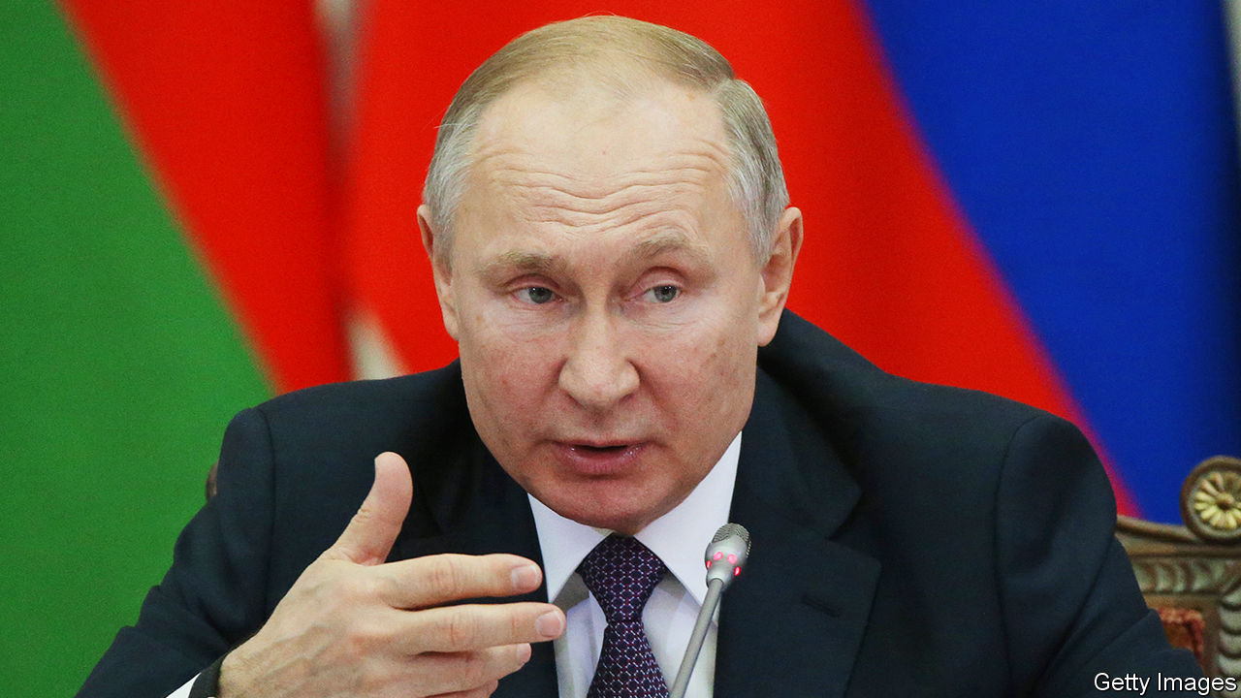

MORE THAN a million people, 90% of them Jews, had been murdered at Auschwitz-Birkenau by the time the Soviet army liberated it on January 27th, 1945. The biggest German death camp in Poland is a universally acknowledged symbol of Nazi evil. Yet the 75th anniversary of its liberation has become a political battleground.

One ceremony to commemorate it will be hosted by Poland on January 27th at the site of the camp. Vladimir Putin, Russia’s president, will boycott it. Another took place four days earlier at Yad Vashem, the Holocaust memorial in Jerusalem. Andrzej Duda, Poland’s president, boycotted that one because Mr Putin was asked to give a speech and he was not. (Yad Vashem said only liberating countries’ leaders could speak—though they included Germany.)

Antipathy between Poland and Russia is ancient. But over the past month Mr Putin has fanned the flames by launching one of the biggest propaganda offensives of his 20-year hold on power, comparable to the anti-NATO speech he delivered in Munich in 2007. This time he tried to upend the entire history of Soviet aggression towards eastern Europe. A key moment in that story is August 1939, when Hitler and Stalin signed a non-aggression pact and agreed to carve up eastern Europe. The next month, the Nazis and the Soviets invaded Poland and the second world war began.

Yet on December 20th, at a summit of leaders of former Soviet republics, Mr Putin delivered an hour-long presentation blaming Poland and its western allies for the outbreak of the war. He noted Poland had previously formed an anti-Soviet alliance with Germany and took part in the division of Czechoslovakia in 1938, implying it had no right to pose as a victim. The Soviets, he told the stunned leaders, had no choice but to make a deal with Hitler, as Western powers would not ally with them against the Nazis. “The Soviet Union never took anything from Poland,” he added. (He did not mention that Soviet troops massacred 20,000 Poles in Katyn Forest in 1940 and, after the war, imposed a communist dictatorship on the country for decades.)

A few days later, speaking to Russian generals and MPs, Mr Putin cited a dispatch by Poland’s ambassador to Nazi Germany in 1938 applauding Hitler’s plan to deport Jews to Africa. “A bastard, an anti-Semitic pig,” Mr Putin commented. Polish Jewish leaders pointed out that the ambassador, Jozef Lipski, had helped Jews flee from Germany to Poland before the war. They warned that distorting the war’s history threatens “the foundation of modern European identity”.

This may be Mr Putin’s goal. He sees it as self-defence. Russia’s regime exploits celebrations of the Soviet victory over the Nazis, hoping that Russians will associate the current Kremlin with historical triumphs. In September the European Parliament passed a resolution blaming Stalin’s pact with Hitler for the war. It denounced “fascist, Stalinist, and other totalitarian and authoritarian regimes” and called for “resilience against modern threats to democracy”—a veiled jab at the Kremlin.

To hit back, propagandists advised the Kremlin to exploit divisions between Poland and the EU created by Poland’s attacks on the independence of its judiciary. Poland had hurt its credibility in 2018 with a bill that would have made it a crime to say that Poles collaborated in the Holocaust (which some did). In a discussion among historians, reported in the Russian press, Fyodor Gaida of Moscow State University laid out the strategy: “If we and the European bureaucrats need a common enemy, I guess Poland will be the first candidate …Our main ally is, yes, Israel. These topics must be developed: Jews in the Red Army and so on.”

Israel has its own reasons to be nice to Russia, which has become a dominant player in Syria. Mr Putin is popular with the country’s Russian immigrants; Binyamin Netanyahu, the prime minister, used pictures of the two of them together during his recent election campaign. None of this has much to do with history, which is always a victim of political battles in the present. ■

This article was downloaded by calibre from <https://www.economist.com/europe/2020/01/25/vladimir-putin-wants-to-rehabilitate-stalins-pact-with-hitler>

|  |  |  |  |
| --- | --- | --- | --- |
| Previous | Articles | Sections | Next |

|  |  |  |  |
| --- | --- | --- | --- |
| Previous | Articles | Sections | Next |

#### Cyber-security in Germany

# Angela Merkel is loth to take sides over Huawei

But German lawmakers may force her to

Jan 25th 2020 | BERLIN

EVERY GERMAN knows the torments of Funklöcher, the patchwork of telephonic dead spots unmolested by radio signals, where smartphones fall silent and internet connections evaporate. Stuck for years in the slow lane of the rich world’s telecoms, Germany is determined not to be left behind as fifth-generation (5G) networks gear up to connect factories, cars and devices. But the government’s plans have hit an unexpected roadblock.

Like other rich countries, Germany has been agonising over whether to let Huawei, a Chinese telecoms giant, bid for contracts to build its 5G networks. Huawei offers experience, expertise and value; its kit makes up 70% of Germany’s 4G network. But securocrats worry that Chinese spooks may exploit “back doors” or other vulnerabilities supposedly built in to Huawei equipment. Others worry about relying on suppliers linked to potential adversaries. What if the Chinese government banned Huawei from “exporting” crucial software patches during a trade dispute with Europe? The American government, which banned Huawei in 2011, has threatened to withdraw intelligence-sharing from Western governments that fail to fall into line.

Germany’s Huawei row has become perhaps Europe’s biggest debate over China policy yet. It taps several sore spots. The country’s large export sector leaves it exposed to trade chills; China and America are its first- and third-biggest trading partners. It is eager to lose its reputation for telecoms backwardness. But it fears another breach with America after splits on Iran, defence, energy and much else.

No wonder the government is divided. Angela Merkel, the chancellor, and Peter Altmaier, her economy minister, wish to keep the door open to Huawei by leaving technical agencies to adjudicate; the foreign ministry and intelligence services are opposed. Even livelier resistance has emerged in the Bundestag. The Social Democrats, junior coalition partner with Mrs Merkel’s centre-right Christian Democrats (CDU), have taken a notably tough line on exposing “critical infrastructure” to Huawei. Opposition parties, such as the Greens, are Huawei-sceptical, too.

That leaves the CDU as a swing player. Its MPs are normally loyal to Mrs Merkel, but for many Huawei is a red line. Norbert Röttgen, head of the Bundestag’s foreign-affairs committee, is trying to convince his CDU colleagues to back a resolution that would urge the government to make foreign telecoms suppliers pass a “trustworthiness” test. Given the links between the Chinese state and business, that could prove impossible for Huawei to meet.

Mrs Merkel, in the twilight of her chancellorship, is losing control of the debate. But she refuses to budge. She fears a Huawei ban would trigger retaliation against Germany’s extensive interests in China; Beijing has a “huge menu” to choose from, says Janka Oertel, an Asia-watcher at the European Council on Foreign Relations. Mrs Merkel also worries about an EU-China summit she will host in Leipzig in September. Rows over Huawei could scupper goals like a bilateral investment treaty.

But Mrs Merkel also has geopolitics in mind. She wants to avoid taking sides in the burgeoning US-China tech cold war. A Huawei ban in Germany, especially if aped by other European countries, could widen the rift. Mrs Merkel chose the occasion of a transatlantic award ceremony this week to argue that China should be tied into the multilateral order, not excluded from it.

Yet MPs are unconvinced. Having failed to win them over, Mrs Merkel may want to delay a Huawei decision until after a discussion among EU leaders in March. A common European strategy could shield countries from Chinese retaliation. The debate also suits those who want a more active European industrial policy. Since the Chinese state props up its firms, dirigistes argue that the EU should help European 5G kitmakers like Nokia and Ericsson.

But delay cuts both ways. On January 29th the European Commission will suggest that governments should consider banning dodgy suppliers, as part of a “toolbox” of 5G security proposals to sway decision-makers who are still undecided. Mrs Merkel may seek compromise by barring Huawei from “core” elements of Germany’s 5G network but not the (more lucrative) “peripheral” antennae. Yet that is not good enough for her critics, who say 5G tech renders the core-periphery distinction defunct. Mrs Merkel would like not to choose. But she may have to. ■

This article was downloaded by calibre from <https://www.economist.com/europe/2020/01/25/angela-merkel-is-loth-to-take-sides-over-huawei>

|  |  |  |  |
| --- | --- | --- | --- |
| Previous | Articles | Sections | Next |

|  |  |  |  |
| --- | --- | --- | --- |
| Previous | Articles | Sections | Next |

#### Rural informality

# A supermarket aims to make Romanian farmers pay tax

So far, without much success

Jan 25th 2020 |

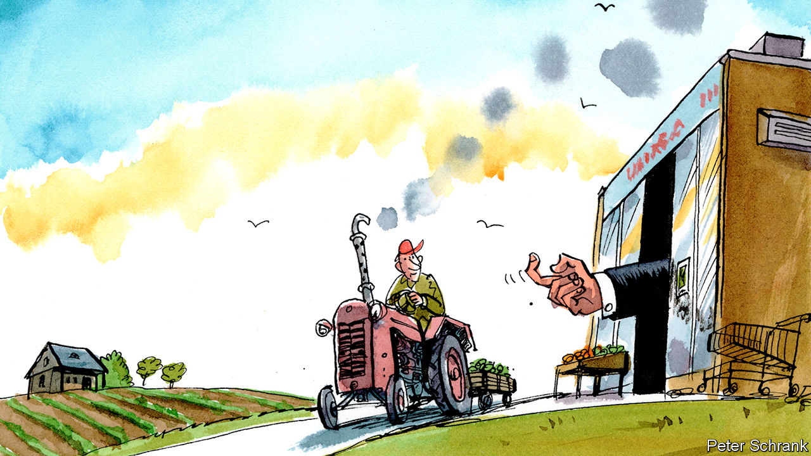

ROMANIA’S NEW state-owned supermarket, the Unirea Agro-Food Trade House, looks like a nod to the communist past. The first two stores, which opened in October, are bare-bones, their shelves stocked with mono-branded staples like pear jam and pork in lard. But this is not a food bank supplying cheap calories to the poor; prices are similar to those at private competitors. Rather, it is an effort to get Romanian agriculture, now largely off the books, to enter the formal economy—and start taxing it.

After the fall of communism, Romania divided its agricultural land between former collective farms (transformed into private companies) and the people who had worked on them. Many of those smallholders have since left the countryside or grown old. Some lease their land to big farming outfits, including foreign ones. But usually they let their neighbours farm it, in exchange for a portion of the harvest.

As a result, Romania has a huge number of farmers (one in three farms in the European Union is Romanian) but an unproductive agricultural sector. The big farms are patchy, and thus difficult to industrialise. The rest are mostly smaller than two football pitches. Farmers eat much of their crop, and sell the rest at informal markets or streetside kiosks.

The government has tried to scale up production by pushing farmers to get credit and insurance, and registering them to tax their sales. It has failed. Farmers complain that the state charges them taxes but provides no subsidies. Many cannot afford the cash registers they would need to collect taxes.

The new supermarket chain changes tactics, from push to pull. It buys only from small farmers, who get a guarantee that their crops will be purchased (and transported to market free). If enough farmers sign up, the agriculture ministry hopes to harvest some of the billions of dollars in taxes that it says go uncollected from farmers.

But the ministry may be counting its chickens before they hatch. So far most of the agricultural producers selling to the new store were already in the system. The agriculture minister who came up with the idea lost his job when the government changed hands in November. The supermarkets may lose their government backers before they win over the customers.

This article was downloaded by calibre from <https://www.economist.com/europe/2020/01/25/a-supermarket-aims-to-make-romanian-farmers-pay-tax>

|  |  |  |  |
| --- | --- | --- | --- |
| Previous | Articles | Sections | Next |

|  |  |  |  |
| --- | --- | --- | --- |
| Previous | Articles | Sections | Next |

#### Brutal facts

# France admits its police are too violent

A minister urges cops to keep their sangfroid, even with rioters

Jan 25th 2020 | PARIS

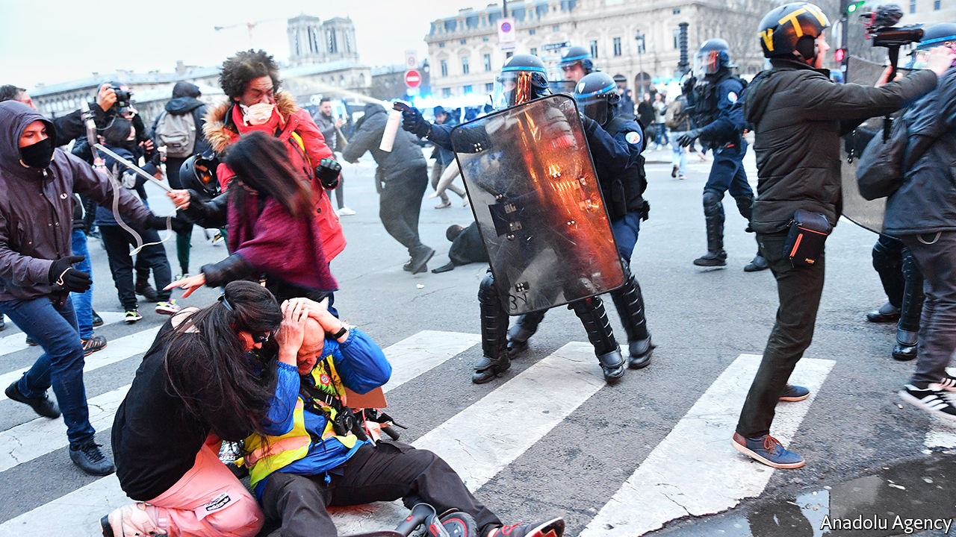

IN ONE VIDEO clip, filmed in the French capital on January 18th, a protester is pinned to the ground on his back and punched several times in the face by a policeman. In another, the previous week, a riot policeman shoots a rubber bullet into a protester at a range of just 2 metres (2.2 yards). Neither of these incidents by itself is more shocking than many others that have taken place over the past year. But for the first time the government has now recognised that the police are too violent.

The Paris public prosecutor has launched an inquiry into each of these cases. Last year the number of investigations opened by the Inspection Générale de la Police Nationale, the force’s internal watchdog, jumped by 20% to 1,400. One reason was the rise of the gilets jaunes (yellow jacket) protests, which often turned violent and elicited a heavy-handed response. Since the movement began in November 2018, according to a count by David Dufresne, a reporter, 25 people have lost an eye, five have lost a hand, and 318 have suffered head wounds. But excessive force is not confined to demonstrations. This month a motorbike courier died after asphyxiating while being arrested in Paris.

At first the French government underplayed the seriousness of the problem. With a hard core of protesters torching cars, vandalising buildings and hurling cobblestones at the police, ministers defended tough policing as a proportionate response to threats to public order. Policemen have been dispatched to deal with scenes that have sometimes resembled guerrilla warfare. In the year to October 2019, fully 1,944 police, gendarmes or firefighters were wounded. During one of the “great national debates” that he held a year ago to calm the protests, President Emmanuel Macron declared that it was “unacceptable” in a country governed by the rule of law to use phrases such as “repression or police violence”.

Yet the accumulation of serious injuries, and the damage this has done to the image of the police, seems to have shifted minds. Last year France found itself the subject of harsh criticism. The office of the United Nations’ human-rights commissioner deplored “serious allegations of excessive use of force” and “disproportionate use of so-called ‘non-lethal’ weapons”. Dunja Mijatovic, the Council of Europe’s commissioner for human rights, urged France to suspend the use of rubber bullets. In the three months to February 2019, 13,460 rubber bullets were fired by the French police—more than twice the number fired during the whole of 2017.

The message seems to have sunk in. This month Christophe Castaner, the interior minister, urged the police to “keep their sangfroid” even in the face of provocation. For his part, Mr Macron acknowledged that there have been cases of police action that are “not acceptable”, stressing that such behaviour undermines the overall credibility of the forces. He has asked Mr Castaner for proposals on how to improve police ethics.

Tension remains high, not least within the police force, where some see the government’s criticism as a betrayal. Exasperation and fatigue contribute to excessive use of force, says one officer, and proportionate violence belongs to the police force’s toolkit. Further incidents may be inevitable. A long-running public-transport strike over pension reforms is coming to an end, and as it does the conflict is radicalising. Mr Macron had to be rushed out of a theatre by security agents on January 17th, after irate protesters tried to force their way in. With or without new police tactics, France’s dispiriting violence looks set to continue. ■

This article was downloaded by calibre from <https://www.economist.com/europe/2020/01/25/france-admits-its-police-are-too-violent>

|  |  |  |  |
| --- | --- | --- | --- |
| Previous | Articles | Sections | Next |

|  |  |  |
| --- | --- | --- |
| Europe | Sections | International |

Britain

Aping ARPA: How to invent the future

.

Management gurus: Losing the title

.

EU citizens: Another Windrush?

.

Discrimination: Not black and white

.

Jobs: Sticky millennials

.

Scottish politics: Battle commences

.

Bagehot: The politics of somewhere

.

|  |  |  |
| --- | --- | --- |
| Europe | Sections | International |

|  |  |  |  |
| --- | --- | --- | --- |
|  | Articles | Sections | Next |

#### How to invent the future

# Recreating ARPA, the most successful research agency in history

The first task for Downing Street is to decide what the new version should do

Jan 25th 2020 |

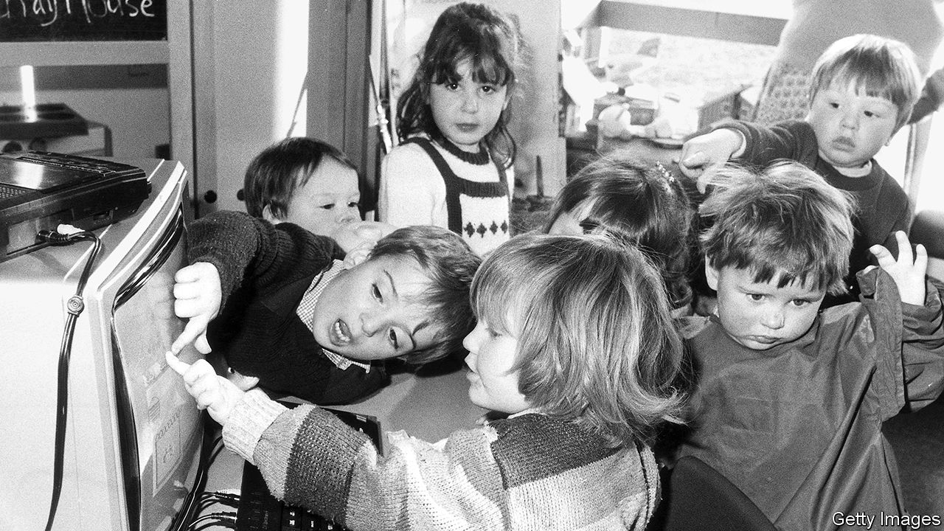

IN OCTOBER 1957 the Soviet Union launched the first space satellite—a development that astonished the American establishment. “Soon they will be dropping bombs on us from space like kids dropping rocks onto cars from freeway overpasses,” fretted Lyndon Johnson, then Democratic Senate leader. Determined never to be surprised again, President Eisenhower established the Advanced Research Projects Agency (ARPA). He gave it a $500m budget (£3.4bn today) in its first year, but no office, no laboratories and no permanent staff. Its job was to “anticipate the unimagined weapons of the future”. How it was to do so was unclear.

The agency ended up shaping the modern world, helping to create missile defence and stealth technology, as well as the internet, the personal computer, the laser and GPS. It did so by rejecting normal procedures. Project managers were given enormous freedom to spend money on what they saw as the most promising technologies, creating communities of brilliant researchers united by a common vision. As Sharon Weinberger notes in “The Imagineers of War”, a history of the agency, ARPA (which subsequently became DARPA, with the D standing for defence) tackled national-security problems “unencumbered by bureaucratic oversight and uninhibited by the restraints of scientific review”. The meeting that led to approval for ARPANET, a forerunner to the internet, reportedly took less than half an hour.

Now Downing Street is trying to recreate it in Britain. Doing so is a long-held ambition of Dominic Cummings, the prime minister’s chief adviser, who has written that he wants to “make Britain the best place in the world to be for those who can invent the future.” As part of this goal, the government has promised to double research funding to £18bn in the next five years. An as-yet-undecided portion of this will go to a new agency, which will spend the cash on the sort of high-risk, high-reward research the private sector eschews. As Mr Cummings has noted, ARPA’s budget was “trivial compared to the trillions of dollars of value” it created.

Officials have been calling science-policy experts in America and Britain for advice about how to make the idea work. One response is the importance of a unifying mission. Unlike ARPA and earlier British schemes to encourage research into new military technologies, the agency will have a civilian focus. The current thinking is that it will be aimed at very pure maths or physical sciences. Mr Cummings has written that researchers will receive no micromanagement, with “bureaucratic cancers treated like the enemy”. Tyler Cowen of George Mason University says that in some ways the approach represents a return to earlier forms of patronage, like that disbursed by the Medicis, rather than the form-filling of modern academia.

## The great not the good

Perhaps the most difficult task will be finding the right people to run the agency. They will need a combination of imagination, energy and expertise. As a report by Pierre Azoulay of the Massachusetts Institute of Technology (MIT) and colleagues notes, since the ARPA model gives such freedom to administrators, the agency’s quality is heavily dependent on their talent, and there tends to be a fast turnover of staff. Those running it will have the chance to decide on the institution’s priorities and on precisely how to hand out its cash. They will also have to create the right spirit, something which may take time. ARPA itself got off to a rocky start, surviving calls for its abolition early on.

The trick is to find research that is absurdly ambitious, but not in fact absurd. The second project funded by the original ARPA in 1958 was an interplanetary spaceship powered by a series of nuclear explosions. The organisation’s head admitted at the time that the tricky thing was doing this in a way that “the inhabitants are not killed”. Other projects that initially seemed beyond the realms of possibility, such as stealth flight, turned out to be within them. In total many more projects ought to fail than succeed. “There’s nothing easier than to borrow the rhetoric of ARPA without the operating principles that make it work,” cautions Mr Azoulay. “One big success can justify all the failure 100 times over.”

Another task is to adapt the model to a very different research system. In the early 1960s, ARPA gave money to great universities, like MIT, Berkeley and Stanford, which have equivalents in modern Britain, but also to independent research institutions, like the Stanford Research Institute and RAND, which have fewer obvious counterparts. One hope is that government will be able to cut red tape in higher education to free dons to do more far-sighted work. Richard Jones, a physicist and science-policy expert at the University of Sheffield, says that a possible overlap with the government’s so-called “levelling up” agenda, to boost deprived parts of the country, would be to build research capacity in new places. The agency’s own location is unimportant, however. “ARPA hasn’t got any labs,” notes Mr Jones. “ARPA is just a bunch of people going around with suitcases, writing cheques.”

If that sounds like the Treasury’s nightmare, that’s because it is. The ministry has resisted previous attempts to loosen research funding, and civil servants are currently trying to work out how to keep tabs on the progress of a British ARPA. Eleven years ago the American government established ARPA-E to develop advanced energy technology. Most observers think it is too soon to judge whether it is a success. In ten years’ time a British equivalent will be vulnerable to an axe-swinging chancellor looking for money to spend on his or her priorities, especially if the agency does not yet have much to show for itself.

Even if everything goes to plan, another internet is an unlikely outcome. The success of the original ARPA was the product of a unique confluence of historical circumstance, government imperative and individual genius. Indeed, DARPA has struggled to reach its early heights, partly because of its more limited remit. Attempting to reverse-engineer the agency is hardly a guaranteed route to success, but that does not mean it is not worth trying. As ARPA demonstrates, unlikely bets do sometimes come off. ■

This article was downloaded by calibre from <https://www.economist.com/britain/2020/01/25/recreating-arpa-the-most-successful-research-agency-in-history>

|  |  |  |  |
| --- | --- | --- | --- |
|  | Articles | Sections | Next |

|  |  |  |  |
| --- | --- | --- | --- |
| Previous | Articles | Sections | Next |

#### Losing the title

# The remarkable similarities between the queen and Alex Ferguson

Two innovative managers who are willing to take tough decisions

Jan 25th 2020 |

THE PARALLELS between a royal family and a football squad are not exact—footballers tend to be more disciplined and better trained than royals—but monarchs and football managers are both in charge of small groups of unusual individuals who are constantly in the public eye. Missteps by one mean disaster for all. So it is not surprising that similarities are emerging between the queen and English football’s most successful manager, Manchester United’s Sir Alex Ferguson.

Both royal and football squads have to be refreshed to keep the fans happy, and Ferguson and Windsor have both shown the ability to nurture young talent to maturity (David Beckham and Ryan Giggs; William and Harry) and to bring in outsiders (Wayne Rooney and Eric Cantona; Kate and Meghan). But new hires do not always work out, and great managers have to be willing to sacrifice talented individuals in the interests of the team. Just as Ferguson sacked Beckham when his ego and his endorsements got in the way of his football, so the queen has dealt ruthlessly with Harry and Meghan. They wanted to be able to stay half in the family, doing some royal work while exploiting their titles for their private interest; and, as the most popular of the royals, they might reasonably have expected that Windsor would accede to their demands. Instead, they have been put on the transfer list, and will lose their royal titles. Like Beckham, they will be relegated to North America.

Neither Windsor nor Ferguson have tolerated incompetence. Just as Massimo Taibi, an Italian goalkeeper, was out in less than a year after a series of gaffes, so Prince Andrew was dropped from the royal squad after his disastrous interview on his relationship with Jeffrey Epstein, a sex abuser. The palace’s announcement that he would be withdrawing from royal duties is more lenient than the treatment that might have been meted out in previous ages, when royals lost their heads rather than their jobs. Still, firing one’s favourite son shows a certain steeliness.

Although Windsor, with 68 years in the job, has surpassed Ferguson, his 27 in post made him the longest-serving manager at the top of British football. Both managers’ long reigns have conferred a degree of stability from which their organisations have benefited. Ferguson’s many years in power enabled him to assert an iron grip, since there was no hope of unhappy players ousting him; Windsor’s long stint in the job—she has taken the titles of Britain’s longest-ever reigning monarch, longest-lived British monarch and longest-reigning queen of all time—enabled her to ease her country through a long period of relative decline.

Monarchies, like football clubs, outlive their incumbents. Since Ferguson stepped down, United have struggled. Manager after manager has failed in his shadow. Windsor’s many fans must hope the similarities do not extend that far.

This article was downloaded by calibre from <https://www.economist.com/britain/2020/01/25/the-remarkable-similarities-between-the-queen-and-alex-ferguson>

|  |  |  |  |
| --- | --- | --- | --- |
| Previous | Articles | Sections | Next |

|  |  |  |  |
| --- | --- | --- | --- |
| Previous | Articles | Sections | Next |

#### Another Windrush?

# EU citizens’ rights after Brexit

Worries about the future disturb EU citizens in Britain—and Brits in Europe

Jan 25th 2020 |

THE BIGGEST argument in the final stages of the EU withdrawal bill this week was over EU citizens in Britain. The House of Lords passed an amendment to give them an automatic right to stay, along with a reassuring document. But as The Economistwent to press the Tory-dominated Commons was overriding all changes to the bill, leaving many EU citizens nervous about their future. They have reason to worry.

After the 2016 referendum, EU citizens in Britain were reassured that nothing would change and they would not become bargaining chips. Similar pledges were made to Britons in the EU. The withdrawal agreement is meant to protect both groups. Yet the EU has expressed concern about the treatment of its citizens, especially after Boris Johnson chose in December to criticise them for treating Britain as if it were their own country.

The numbers are significant. Around 3.5m EU citizens live in Britain, while 1.2m Britons live in the EU. Contrary to myth, most are in work—including 80% of Brits in Europe, for example. Many have complex cross-border families, often with non-EU spouses or stepchildren. All will be affected by Mr Johnson’s determination to stop free movement of people when the transition period ends on December 31st.

EU citizens who want to stay in Britain must apply for “settled status”. Lobby groups (and the Lords) wanted EU citizens to have an automatic right to stay, verified with a document. The settled-status scheme requires proof of residence and, crucially, knowledge of its existence. The Home Office insists it is going well: it has had almost 2.8m applications, with refusals running only in single figures.

Yet the 3m group, which lobbies for EU citizens, cites cases of unexplained delays. As many as two in five applications have, often incorrectly, been granted only “pre-settled status” that is time-limited. The group also frets about what will happen after the scheme’s cut-off date of June 2021. Kuba Jablonowski of Exeter University says no scheme ever manages 100% coverage, and that gaps in official statistics mean the Home Office has little idea how many are eligible. The government says late applications may be accepted, but only with good reason. Its record of deporting Windrush immigrants is not reassuring.

It also makes supervision of the scheme crucial. Applicants can seek administrative review (at a price), but no right of court challenge is given in primary legislation. The absence of physical documents confirming settled status makes EU citizens especially fretful about satisfying picky employers or landlords. An independent monitoring authority is being set up under the justice ministry, but the government has changed the law to allow it to scrap the authority, upsetting Brussels. As a last resort, there is a role for the European Court of Justice in defending its citizens, but this expires in eight years’ time.

Largely lost in the fuss over EU citizens are the neglected Brits in the EU. Since most are already registered (though in France, which has the second-largest number, not all are), they should be safe after Brexit. But they will lose the right to move to other EU countries. This matters because, notes Jane Golding of the lobby group British in Europe, many lawyers and other professionals work across EU borders. Depending on the future negotiations, their qualifications may no longer be recognised by other EU countries.

And here is a final uncertainty, over the future migration regime. A new immigration act is needed this year. But the government awaits advice from its migration advisory committee. Ministers favour an Australian-style points system that gives no advantages to EU nationals. Some have even cast doubt on Britain’s continuing participation in Europe’s Erasmus student-exchange scheme. EU citizens fear that, even with settled status, they may suffer from a hostile environment in future. And they point to the pain of being seen as bargaining chips when, like most Brits in Europe, they had no say on Brexit.■

Correction (January 23rd 2020): This story originally suggested that France had more resident Brits than any other EU country. In fact it has the second-largest number, after Spain.

This article was downloaded by calibre from <https://www.economist.com/britain/2020/01/25/eu-citizens-rights-after-brexit>

|  |  |  |  |
| --- | --- | --- | --- |
| Previous | Articles | Sections | Next |

|  |  |  |  |
| --- | --- | --- | --- |
| Previous | Articles | Sections | Next |

#### Not black and white

# Why second-generation migrants in Britain report more discrimination

They are twice as likely as their parents to say they have been unfairly treated

Jan 25th 2020 |



FEW SUBJECTS are more chewed over in Britain than migration and race. The country will finally leave the European Union (EU) next week, a policy supported by many voters to reduce, or gain control over, immigration flows. Its former prime minister, Theresa May, will be remembered in part for her shoddy treatment of the Windrush generation of Caribbean migrants who were asked to prove their citizenship decades after making Britain their home. And Meghan Markle’s decision to leave has prompted introspection in some quarters and defensiveness in others.

On January 20th Oxford University’s Migration Observatory added some rare crunch to the discussion, with an analysis of data from the European Social Survey. Marina Fernandez-Reino, a researcher, found that migrants were slightly less likely to say they had been discriminated against in Britain than the average reported by their peers in 14 other European countries. But their children were much more likely to feel such discrimination: 32% of second-generation migrants encountered it, compared with 16% of their parents. The same pattern holds in other countries, but the disparity is much greater in Britain.

It is possible that ethnic minorities do indeed face higher rates of discrimination in Britain than elsewhere. An experiment by the academics Valentina Di Stasio and Anthony Heath, published last year, found that fictitious job-seekers with minority backgrounds had to apply for 60% more jobs to get the same number of interviews as Britons with names not traditionally associated with minorities. Researchers found a similar pattern in Spain, Germany, the Netherlands and Norway, too, but in each case the discrepancy between the two groups was smaller than in Britain. “Discrimination in Britain is remarkably high,” says Ms Di Stasio, of Utrecht University. She says Britain ought to perform better than its neighbours since it has a long history of mass migration and a relatively flexible labour market, which might be expected to reduce the disincentive for employers to take a perceived hiring risk. For half a century, studies have found similar prejudice against potential employees with Pakistani or Caribbean roots.

Yet other evidence suggests minorities fare better in Britain than elsewhere in Europe. For instance, about 20% of Britain’s black population report racial harassment in the past five years, the second-lowest rate of 12 EU countries surveyed in 2016. That figure was 32% in France and 48% in Germany. The same report found a smaller disparity in labour-market participation rates than in most other countries.

An alternative explanation is that second-generation migrants may be more aware of their rights in Britain. Omar Khan of Runnymede Trust, a racial-equality think-tank, reckons Britain’s relatively large ethnic minority population brings such issues to the forefront. “There are more people within your in-group who are willing and able to talk about it,” he says.

A paper by Conrad Ziller in 2014 found an association between the strength of a country’s anti-discrimination policies and its citizens’ knowledge of their rights. Sweden was the only European country to rank higher than Britain on both measures. Britain has had anti-racism laws since the 1960s, which are also tougher than elsewhere. “In some countries ethnicity and race are less discussed and people are less aware of [the issues],” says Ms Fernandez-Reino. In Britain “you might be more likely to see inequalities through the lens of discrimination.” Thus the debate generated by Ms Markle’s exit may itself generate greater awareness of future discrimination.

It is also possible that migrants’ children have higher expectations of their success in Britain than their peers elsewhere. Nine-tenths of British migrants believe they can “get ahead if they work hard”, which could lead to a painful gap between expectations and reality. But even if disillusion is more the result of perception than of reality, it may be impacting migrants’ choices. Britain used to be the preferred destination in Europe for those thinking of moving country, but now it has dropped behind Germany and France. ■

This article was downloaded by calibre from <https://www.economist.com/britain/2020/01/25/why-second-generation-migrants-in-britain-report-more-discrimination>

|  |  |  |  |
| --- | --- | --- | --- |
| Previous | Articles | Sections | Next |

|  |  |  |  |
| --- | --- | --- | --- |
| Previous | Articles | Sections | Next |

#### Jobs

# Why young people in Britain aren’t moving job

It’s damaging them, and maybe productivity too

Jan 25th 2020 |

OLDER PEOPLE tend to regard 20-somethings as avocado-toast munching types who flit from job to job. The reality is very different. Job mobility among the young has declined over the past decade.

Even though unemployment is hitting multi-decade lows and the job market continues to tighten—labour-market data published this week showed strong growth and the employment rate at a record high—younger workers remain more wedded to their current jobs than they were before the recession (see chart). There is a similar trend in other rich countries, but it is particularly pronounced in Britain. According to Neil Carberry, chief executive of the Recruitment & Employment Confederation, a recruiters’ trade body, the commonest complaint among his members is of a shortage of candidates.

This is a problem not just for employers, but also for employees. In the labour market, loyalty does not pay: shifting jobs tends to be a good way of getting a salary boost. In 2017, the average pay rise for a worker staying with the same employer was just 1.1% after inflation compared to 5.4% for someone making a change. Young people’s reluctance to move may be part of the explanation for their dismal wage-growth figures. In the five years after the crash, they experienced a larger cut in real wages than their older peers (see chart).

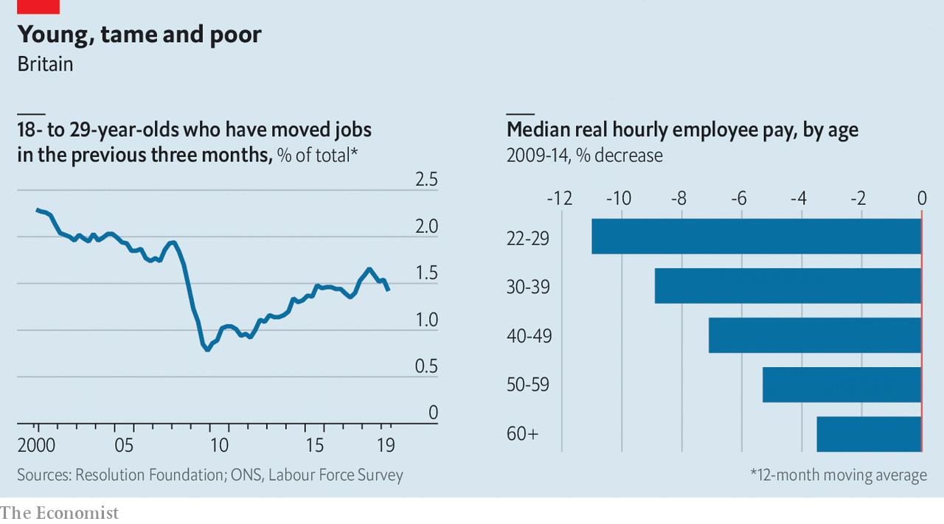

Researchers have long argued that having the simple bad luck to enter the labour market during difficult times can have a lasting impact on young workers. Much of that research has focused on the so-called labour market scarring effect, by which those who experience unemployment early in their careers tend both to earn less than those who do not and to be at greater risk of future unemployment. Young people who experienced unemployment after the early 1980s or early 1990s recessions felt these effects for around ten years.

But the 2008-09 recession was different from earlier downturns. It was the first real test of the impact of Margaret Thatcher’s union-bashing on the jobs market. Trade-union bargaining covered more than 80% of workers in the early 1980s and still more than half in the early 1990s, compared with a third in 2008.

In the most recent recession, even though the fall in output was larger, the labour market performed better. Unemployment peaked at just over 8% in 2011 compared with over 10% in the 1980s and 1990s. But the squeeze in real wages was sharper. As a result, British workers in their 20s today are less likely to have experienced unemployment than their equivalents ten years after the early 1990s recession but are also less likely to have seen strong pay growth. This may have led to a new type of scarring, one marked not by the impact of unemployment but by the experience of weak pay growth.

In the past, the pay levels of those who entered the labour market during a downturn recovered after around six years. But a decade after the recession the 2009 cohort’s earnings have not recovered. Laura Gardiner, research director of the Resolution Foundation, suspects that psychology may partly explain this: in focus groups, she says, younger workers lack confidence in either their own abilities or the opportunities on offer.

Not everybody agrees. Bobby Duffy, a former opinion pollster now at King’s College London, argues that the reduced job mobility of younger people is less about an attitudinal shift and more about a change in circumstances. “I don’t think we have a cohort of shrinking violets all of a sudden.” The relatively sluggish pace of the recovery since 2009 has not provided the same kind of opportunities that the 1990s saw for young people. Regional variations in housing costs may also play a role, dampening down on long-distance moves and hence overall labour market mobility.

These figures may help explain the puzzle of Britain’s awful productivity, which is lower than the competition’s and growing only feebly. If workers do not move from job to job, resources will move more slowly from low-productivity firms to high-productivity ones.

On many measures Britain’s labour market looks in rude health. But until 20-somethings start, once again, moving jobs and pushing for higher wages it may not feel that way to many young people. Britain could do with its millennials acting a little more entitled. ■

This article was downloaded by calibre from <https://www.economist.com/britain/2020/01/25/why-young-people-in-britain-arent-moving-job>

|  |  |  |  |
| --- | --- | --- | --- |
| Previous | Articles | Sections | Next |

|  |  |  |  |
| --- | --- | --- | --- |
| Previous | Articles | Sections | Next |

#### In the dock

# Alex Salmond’s trial will coincide with a reassessment of the SNP’s record

The party faces questions over its health, education and economic policies

Jan 25th 2020 | EDINBURGH

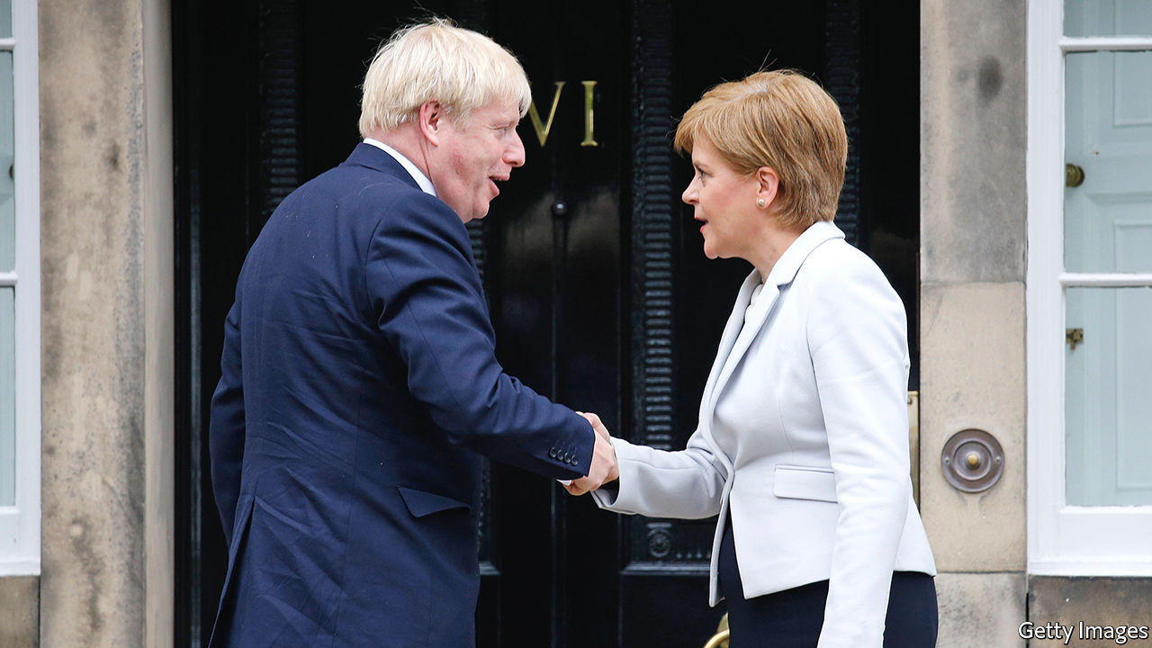

THE SCOTTISH NATIONAL PARTY (SNP) looks in fine fettle. In the general election it secured 48 of Scotland’s 59 seats in the British Parliament, an increase of 13. Surveys regularly show about 40% of voters back it, far more than can be said for its rivals. After 13 years in charge of Scotland’s devolved government, this is an extraordinary achievement. Its pro-EU views chime with those of the majority of voters north of the border. And Scots are unimpressed by the two main Unionist parties under Boris Johnson and Jeremy Corbyn.

But things are not necessarily as rosy as they seem. Nicola Sturgeon, the party’s leader and Scotland’s first minister, is in for a tougher year than she has grown used to. The trial of her predecessor, Alex Salmond, on charges of sexual assault is scheduled to begin in March. Mr Salmond’s case will likely dominate the headlines for months.

The timing is unfortunate for Ms Sturgeon, who wants to use this year to build momentum ahead of Scottish Parliament elections in May 2021. A victory would boost her hopes of calling a second independence referendum (the “yes” campaign failed to convince voters in the first one, in 2014). Mr Salmond’s trial has the potential to derail both ambitions.

If that does not scupper Ms Sturgeon’s plans, the British government is ready to have a go, too. The Tories are determined to avoid another referendum, and have made noises about blocking it however Scotland votes next year. They have set up a Union Unit in 10 Downing Street, with the task of producing arguments and policies that will keep the country together. Lord Dunlop, a former adviser to the Scotland Office, is due to publish a report on strengthening the Union before the summer.

The government is also ready to open its wallet to illustrate the financial benefits of the Union. Though it has yet to decide where and how to deliver the bung, the recent City Deals—which sent billions of pounds to Scotland’s cities—provide a precedent. Cabinet ministers will make regular forays north of the border, which have grown rarer as the SNP has consolidated its grip on power.

Closer to home, she faces another obstacle: her own party’s record in government, which is attracting growing criticism. The SNP’s education reforms are in trouble. Recent surveys show Scotland’s schools are mediocre or failing, and the administration has been forced to concede a review of its reform agenda. It has also been accused of cherry-picking metrics that show the system in a good light while withdrawing Scotland from several measures that allow international comparison, which critics say is to avoid embarrassing results. “We know less now about the performance of Scotland’s schools than at any time since the 1950s,” says Lindsay Paterson of Edinburgh University.

There have also been a series of health scandals. Jeane Freeman, the health secretary, has been accused of covering up allegations that an infection caused by contaminated water at Glasgow’s flagship hospital killed a child with cancer. A new hospital for sick children in Edinburgh was due to be completed last July, but has yet to open its doors.

Nor is the Scottish economy anything to shout about. Its growth rate lags Britain’s and the Scottish government puts the nation’s notional deficit at £12.6bn, or 7% of GDP, compared with 1.1% for Britain as a whole. Scotland has fewer businesses per head than any other part of the country, save for north-east England. Its businesses pull in less revenue than those in the West Midlands, which has a similar population; it has only a little over half the proportion of earners in the highest income tax bracket as in the rest of the UK. Scotland has slipped into the bottom half of the Index of Social and Economic Wellbeing produced by Scottish Trends, an economics consultancy. It now sits alongside Slovenia.

Much lies in the balance. Ms Sturgeon remains Scotland’s pre-eminent politician, and her party is firmly on top. Yet the SNP and the Greens between them hold 68 of the Scottish Parliament’s 129 seats. It would not take much of a shift for a pro-Union majority to be returned next year, and for the prospect of a second referendum to fade. Even if Ms Sturgeon can secure a majority, polls suggest about 50% of voters support independence – higher than the 2014 tally of 45%, but not enough for the SNP to assume victory would be in the bag. It is not only Mr Salmond who is anxiously awaiting a verdict. ■

This article was downloaded by calibre from <https://www.economist.com/britain/2020/01/25/alex-salmonds-trial-will-coincide-with-a-reassessment-of-the-snps-record>

|  |  |  |  |
| --- | --- | --- | --- |
| Previous | Articles | Sections | Next |

|  |  |  |  |
| --- | --- | --- | --- |
| Previous | Articles | Sections | Next |

#### Bagehot

# Brexit and the politics of somewhere

The new crop of Tory MPs have deep roots in their constituencies. That’s going to make a difference

Jan 25th 2020 |

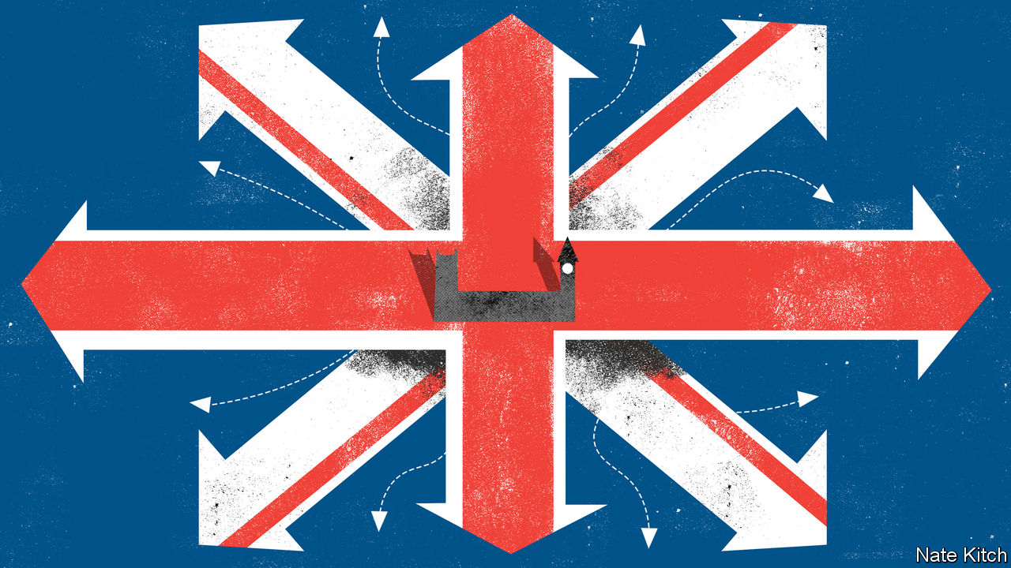

MATT RIDLEY has many roles in life. As the author of popular science books (and former science editor of The Economist) he is a bestselling writer on genetics and evolution. As political pugilist he is one of the most articulate supporters of Brexit. As the Fifth Viscount Ridley he is a pillar of the House of Lords. He now has yet another role—as a guide for newbies to the Palace of Westminster with its winding corridors and arcane practices. The general election in December saw large numbers of Tories elected to the House of Commons from constituencies such as Blyth Valley, next door to Lord Ridley’s Blagdon estate, that have voted Labour for generations: men and women who speak with northern accents (they’re “branded on the tongue” in George Orwell’s phrase) and who never really expected to end up in the House of Commons. The viscount’s class does not make him the obvious man to show newcomers the ropes, but his geographical origins do.

Place used to be central to British politics. Lords took their names from towns or counties. MPs represented particular constituencies rather than getting allocated seats from party lists as is often the case on the continent. The bulk of MPs never really looked beyond their constituencies at high office: ex-miners were content to represent the people of Blyth for the Labour Party just as retired brigadiers were content to represent the people of East Hampshire. But during the Blair-Cameron era place became less important as a caste of professional politicians took over the House of Commons.

These politicians had more in common with each other than they did with the people of Blyth or East Hampshire. They went to the same universities (usually Oxford) where they read the same subjects. They got their first jobs in think-tanks or parliamentary offices. They were parachuted into safe seats in their late 20s (no need for an old hand to show them around the House of Commons!). They quickly gained high office, and if they encountered a hiccup in their career they stayed in London to make money as consultants or else eloped to the United States in search of global fame. David Miliband and Nick Clegg, two archetypical examples of the species, now live in New York and California respectively.

Now place is regaining its importance in British politics. Dean Godson, the boss of Policy Exchange, a right-of-centre think-tank, says that “somewhereisation” is one of the great trends of our time. He points to a prescient book published a couple of years ago, “The Road to Somewhere”, by David Goodhart. The book argued that voters can be divided into “anywheres” who possess portable skills and subscribe to cosmopolitan values and “somewheres” who have deep local roots and embrace more than traditional values; the Brexit result was just one in a series of rebellions by the “somewheres” against a class of “anywheres” who had grown more and more ambitious over the previous decades.

The new Conservative MPs who now make up 30% of the parliamentary party are the latest evidence of the rise of the “somewheres”. Lee Anderson (Ashfield) is a former miner who took part in the strikes of the 1980s. Dehenna Davison (Bishop Auckland) lost her father at 13 when he was punched to death. Jacob Young (Redcar) worked in the chemicals industry, as his father and grandfather did. Ian Levy, the MP for Blyth Valley, is a former mental-health-care worker who surprised everybody, including himself, by overcoming an 8,000 Labour majority.

The big question is how deep this goes. James Frayne, a long-standing advocate of the “provincial tilt” and author of a column on Conservative Home, a website, subtitled “Far from Notting Hill”, worries that the party’s recent advance might have been the result of a confluence of circumstances (Brexit and Corbyn) rather than a sea-change. The upper echelons of the Conservative Party still speak with a strong southern accent. Boris Johnson—born in New York, brought up in Brussels, trained in the duplicitous arts of political journalism—is an “anywhere”.

But the “somewhere” wing is now in the driving seat. Dominic Cummings, Mr Johnson’s chief of staff, was brought up in Durham and put down roots in regional politics running Business for Sterling and campaigning against a North-East Regional Assembly. The Downing Street policy unit is populated by advocates of the “politics of place” such as Oldham-born Munira Mirza and Sheffield-born Liam Booth-Smith. Neil O’Brien, MP for Harborough, points out that in 2017 the party’s geographical centre of gravity was in leafy Buckinghamshire. Now it is in the “wild and windy moors on the edge of Sheffield”. The Tories cannot hold onto its new northern seats without making big changes.

Ideas are being flung around. Most are still without substance—move the House of Lords to York!—but some changes are rooted in reality. The party is planning to move some of its functions out of London. New MPs who were carried into Westminster on the 2019 wave are building local constituency operations. Activists are creating new organisations such as Young Blue Northerners. Policies are being reoriented to appeal to provincial Britain. Under David Cameron and George Osborne the Northern Powerhouse, a scheme to boost economic growth in the north of England, was largely about linking cities into the global economy. Under Mr Johnson it is much more about making poorer people more economically secure (hence the emphasis on police and the NHS) and dealing with the decline of provincial towns.

The shock that Brexit is administering to Britain is likely to do the place plenty of harm, but it may do it some good, too. The political class had come to see its job as representing the state to the people rather than the people to the state. It had also come to resemble a cloistered elite that knew more about New York than old York. Britain is engaged in a process of self-correction. The political system is being reattached to the people it represents. In the process the social contract, which has been frayed almost to breaking-point in recent years, may slowly be repaired. ■

This article was downloaded by calibre from <https://www.economist.com/britain/2020/01/25/brexit-and-the-politics-of-somewhere>

|  |  |  |  |
| --- | --- | --- | --- |
| Previous | Articles | Sections | Next |

|  |  |  |
| --- | --- | --- |
| Britain | Sections | Business |

International

Private diplomacy: Not your average diplomats

.

|  |  |  |
| --- | --- | --- |
| Britain | Sections | Business |

|  |  |  |  |
| --- | --- | --- | --- |
|  | Articles | Sections | Next |

#### Not your average diplomats

# Conflict resolution relies increasingly on diplomatic back channels

It is hard to measure how well they work

Jan 25th 2020 |

TALKS BETWEEN the Colombian government and the FARC rebels were stuck. The two sides could not agree on how to bring those responsible for crimes during the country’s 52-year civil war to account. But with the help of Inter Mediate, a British charity, a way forward was found, involving the appointment of three independent lawyers on each side. In 2015 a pioneering transitional-justice deal was reached.

When official efforts to resolve a conflict are lacking or bogged down, another way must be found. “You need a referee,” says Jonathan Powell of Inter Mediate, “and that has to be someone who’s trusted by both sides.” The involvement of third parties can take many forms. They can help as advisers (as in Colombia). They may open a back channel (as South Africa’s ruling National Party did in order to negotiate an end to apartheid with the African National Congress—representatives of the two hostile sides secretly met in an English country house owned by a gold-mining firm). Increasingly, they establish entire alternative avenues for dialogue. Such diplomacy, known as Track 2, fills the void left by the official sort in Track 1.

The term, first used in 1981 by an American diplomat, Joseph Montville, covers everything from modest workshops to major initiatives. Even the author of a book on the subject, Peter Jones of the University of Ottawa, says Track 2 “defies easy definition”. To complicate matters, some variants merge into Track 1.5 (run privately but with involvement of public officials), while Track 3 connects communities.

They all have one thing in common: they have been growing. “When I first started in the early 1990s, you could probably count on two hands the number of organisations involved in this kind of work, but in the last ten years there’s been a proliferation,” says Hrair Balian of the Carter Centre in Atlanta. One reason, perhaps, is an increase in discord. The UN Office for the Co-ordination of Humanitarian Affairs reckons there were 402 “political conflicts” in 2016, up from 278 a decade earlier. (It defines conflict broadly, including anything from the bloodbath in Syria to tetchy exchanges between Scottish nationalists and the British government.)

Track 2 initiatives proliferated during the cold war. The Dartmouth Conferences fostered contacts between cultural figures, scholars and politicians from East and West; the Pugwash Conferences brought together scientists. With communism’s collapse the need for alternative tracks diminished. The first two decades after the fall of the Berlin Wall brought some 30 major peace agreements, according to David Harland of the Swiss-based Centre for Humanitarian Dialogue (HD), a leader in private diplomacy. But the next decade saw only seven or eight. Technology has enabled smaller groups to pile into conflicts, making them messier and harder for the UN’s state-centric system to handle, Mr Harland argues. Meanwhile, two or three new wars start each year.

These tend to be within countries, not between them. In the trickiest cases, “Track 1 as a conflict-resolution tool has really lost its significance,” says Luxshi Vimalarajah of the Berghof Foundation in Berlin, another leader in the field. The need for more flexible ways to bring the parties together creates a gap for private peacemakers.

Some, like Jimmy Carter, a former American president, have brought skills honed in government. Martti Ahtisaari, a president of Finland and like Mr Carter a Nobel peace laureate, set up Crisis Management Initiative (CMI). Mr Powell co-founded Inter Mediate after, as a British official, striving for peace in Northern Ireland.

For size HD, with some 250 people, could rival the diplomatic service of many a country. At the other end are numerous think-tanks and NGOs. In the middle are expert facilitators like Mr Jones’s Ottawa Dialogue or the United States Institute of Peace (USIP). Nancy Lindborg, USIP’s boss, says that, after a post-cold-war lull, the resurgence of regional and great-power rivalry once again requires more reliance on Track 2 and 1.5.

Peace-building is not the only area for Track 2. In Delhi on February 3rd-5th the US-India Track II Dialogue on Climate Change and Energy will gather, as it has each year in India or America since 2010, supported by the Aspen Institute and other think-tanks. Since Donald Trump dumped the Paris accord, such meetings (like similar sessions with China) offer a chance to explain how much is still happening on the climate front. By one estimate, action at subnational levels could reduce America’s greenhouse-gas emissions by up to 37% compared with 2005 levels by 2030.

As for Track 3, it is a way of trying to ensure that a peace effort is “inclusive, so that you don’t have elite settlements”, says Jonathan Cohen of Conciliation Resources in London. In Yemen CMI is working on local ceasefires and opportunities for a wider range of voices to have their say in the official UN-led peace drive. Women’s representatives “have identified concrete, actionable steps to ensure women’s inclusion in the peace process and in broader political decision-making,” says Sylvia Thompson, who manages CMI’s Yemen initiative.

## Endgame…

Private diplomacy has always existed. But it has acquired not only a fancy name but a reputation and a set of established practices. Its reputation rose with some high-profile successes. The agreement that ended the civil war in Mozambique came through patient work by Sant’Egidio, a Catholic organisation. HD helped to facilitate a ceasefire between Indonesia and separatists in Aceh: the Indonesian government “wouldn’t let a foreign government anywhere near its internal affairs”, recalls Martin Griffiths, who played a leading part (he is now the UN special envoy for Yemen). Similarly, Spain’s desire to avoid mediation by other governments offered an opening for private diplomacy in negotiations with the Basque terrorists of ETA. Whereas officials tend to favour the state, private facilitators can be more even-handed.

Although Track 2 is private, the public sometimes gets a glimpse. “Oslo”, a play, dramatises the back-channel talks in the 1990s between Israelis and Palestinians that led to the Oslo accords. It highlights a vital aspect: deniability. Track 2 creates a safe space where ideas can be aired and proposals tested, without official fingerprints. It can enable contacts with a secretive state such as North Korea, or between adversaries such as Saudis and Iranians.

A Track 2 dialogue may begin with a working paper and an outline of familiar stances before moving on—after an icebreaker dinner—to a more creative discussion. Over time, with luck, trust and familiarity develop. The Oslo meetings made progress in part because many of those involved had taken part in workshops between Israelis and Palestinians organised for years by Herbert Kelman, a Harvard social psychologist. What Mr Jones calls “a facilitated, problem-solving dialogue” can help participants move from parroting fixed positions towards a joint discussion and then joint proposals, which they can take to their respective authorities.

No one would claim that Track 2 is easy, or quick. Facilitators have to “provide the space without dictating solutions”, says Ms Vimalarajah. “I’ve never seen a process that’s been very linear.” This is not a game you get into unless you’re comfortable with a low batting average, notes another expert. “Track 2 is limited, let’s be honest,” says Eugene Rumer of the Carnegie Endowment for International Peace, a think-tank. He has been involved in “no bullshit” exchanges between Americans and Russians on security issues; the modest achievement may be to feed a fresh idea or two back to the Kremlin or the White House. Sometimes facilitators do get tantalisingly close to a breakthrough—on rights for Kurds in Turkey, for example—only to be stymied by a mood change in government.

Is Track 2 worth all the effort? Not everyone is a fan. Diplomats sometimes frown on outsiders’ encroachment. America’s Logan Act of 1799 criminalises unauthorised negotiations that undermine government policy. The ethics of dealing with people who have blood on their hands is tricky.

## …or endless game?

One worry is confusion. “There’s a proliferation of actors,” says Lakhdar Brahimi, a former Algerian diplomat now with The Elders, a group of peace-promoting statesmen. “Nobody can control it.” He points to Afghanistan and South Sudan as examples of “overcrowding”, with a profusion of well-meaning special envoys and NGOs. Quality can suffer, too. “I really question the activities of some NGOs pretending to do Track 2,” says Mr Balian of the Carter Centre, “especially when they start advocating for a particular side in a dispute.”

A second concern is that Track 2 can remain a mere talking-shop. Informal initiatives should be closely connected to official diplomacy from the start: if Track 1 people have not been involved in the initial brief they will not be interested in the debrief. An obvious way of ensuring a credible transmission mechanism is to include some official representatives: hence the increasing popularity of Track 1.5.

A third challenge is measuring effectiveness. Backers—supportive governments, notably Nordic ones, and charitable foundations—want to know if their money is well spent. But how to judge the success of what is typically a long-term enterprise, largely hidden from view? Pathways for Peace, a UN-World Bank study, estimates that spending more on conflict-prevention efforts can save anything from $5bn a year to $70bn. Specific measures for the cost effectiveness of Track 2 are harder to devise.

The full impact can take years to become visible. In Sudan the Carter Centre facilitated a “Guinea worm ceasefire” in 1995, enabling health services to reach remote villages; this led to formal negotiations, a peace agreement and ultimately to the separation of Sudan and South Sudan in 2011. More often it is a matter of building relationships or preparing solutions for use when the political time is ripe.

At its best, unofficial diplomacy complements the official sort. “They could do things that we couldn’t do,” says Michael Keating of his time as UN envoy for Somalia (he has since switched to the private side as head of the Brussels-based European Institute of Peace), “and we could do things that they couldn’t do.” But as this diplomatic ecosystem continues to expand, it needs to evolve, with tighter co-ordination, better measures and, old hands argue, a greater focus on the grassroots. The broader the support at the base, the sturdier a peace is likely to be. ■

This article was downloaded by calibre from <https://www.economist.com/international/2020/01/25/conflict-resolution-relies-increasingly-on-diplomatic-back-channels>

|  |  |  |  |
| --- | --- | --- | --- |
|  | Articles | Sections | Next |

|  |  |  |
| --- | --- | --- |
| International | Sections | Finance and ... |

Business

Bartleby: The number of the best

.

Bushfires and business: Singed but not scorched

.

European earnings: Techno-charged

.

Schumpeter: Moutai madness

.

|  |  |  |
| --- | --- | --- |
| International | Sections | Finance and ... |

|  |  |  |  |
| --- | --- | --- | --- |
| Previous | Articles | Sections | Next |

#### Bartleby

# The number of the best

Finding the optimal size of teams and organisations

Jan 25th 2020 |

HOW BIG should a business team be? It is an enormously important issue for companies. Teams that are too small may lack the skills required to get the job done; teams that are too big may be impossible to co-ordinate.

Similar trade-offs may apply when it comes to firms as a whole. Startups are often short of staff. The founders must play a host of different roles, from obtaining finance to product development and marketing, for which they may not be equally suited. But the upside is that they can have highly collaborative working environments.

People who have worked for startups say the culture changes when the company reaches a certain size. Patty McCord, formerly of Netflix, referred to the “stand-on-a-chair number”—the biggest group that can easily hear the boss address them.

Robin Dunbar, an anthropologist at Oxford University, has done a lot of work on primate groups. His argument is that the size of the group is linked to the size of the brain. With their large brains, humans can cope with larger bands. A larger social group has many advantages, allowing for greater protection and specialisation.

Whereas 150 is sometimes referred to as the “Dunbar number”, the academic himself in fact refers to a range of figures. He observes that humans tend to have five intimate friends, 15 or so good friends, around 50 social friends and 150-odd acquaintances.

Running a larger network can be difficult. So much time is needed to maintain relationships that their quality inevitably suffers. The armed forces have spent millennia experimenting with unit size. A Roman centurion oversaw 100. The modern American army company has 180 members. Britain’s equivalent numbers 120.

These are rough estimates, rather than rigid figures. But it is striking that many group activities seem to be close to a Dunbar number. The Special Air Service, Britain’s elite fighting unit, has four-man patrols; when your life depends on it, you need to have absolute trust in your colleagues. As a result, such groups are limited in size.

Sports-team sizes relate to the playing area. There are five players in a basketball side and six in ice hockey; outdoors there are 11 players in football and cricket teams, and 7-15 in the various forms of rugby. Perhaps this is the optimal size for coaching purposes, or perhaps crowds would struggle to distinguish individual players if teams were larger.

Small work teams may also tend towards these two size ranges. “If you want a committee to decide something, limit it to four to five people,” says Mr Dunbar. “But to brainstorm in a meeting, you need 12-15.” Many companies use “agile” teams which draw employees from across the company; they tend to have between five and nine members.

Most businesses are small. A survey of British firms in 2015 found that only 0.6% employed more than 150 people. Nor are small companies necessarily ephemeral. One study concluded that 89% of organisations that last more than 100 years employ fewer than 300 people.

Another group of long-lasting organisations is religious congregations. The Hutterites, a Protestant group with German origins, limited their communities to 150. They believed that it was possible to maintain solidarity in a group of fewer than 150 people with peer pressure; once you exceeded that number, you needed the equivalent of a police force.

For much of economic history, work was conducted in small units by peasants, tenant farmers and artisans (for example blacksmiths). The advent of powered machinery enabled production at a much larger scale, with workers crowded into factories. These days the rise of the service economy means that workers are no longer concentrated in such large groups.

This may not be a bad thing. It was easy for employees in large factories to regard remote company owners as “them” rather than “us”, and indeed it was easy for business owners to perceive workers as an undifferentiated mass of people and treat them accordingly. Strikes were common.

The modern company may settle on a model with a small group of “core” workers and a larger group of contract workers. The result may be more cohesion within the core staff but the non-core staff may be less well treated. The small core teams may work effectively. The big question will be the effect on morale of those outside those teams.

This article was downloaded by calibre from <https://www.economist.com/business/2020/01/25/the-number-of-the-best>

|  |  |  |  |
| --- | --- | --- | --- |
| Previous | Articles | Sections | Next |

|  |  |  |  |
| --- | --- | --- | --- |
| Previous | Articles | Sections | Next |

#### Singed but not scorched

# Australia’s bushfires have left businesses surprisingly unscathed

That has not stopped bosses preparing for the next inevitable disaster

Jan 25th 2020 |

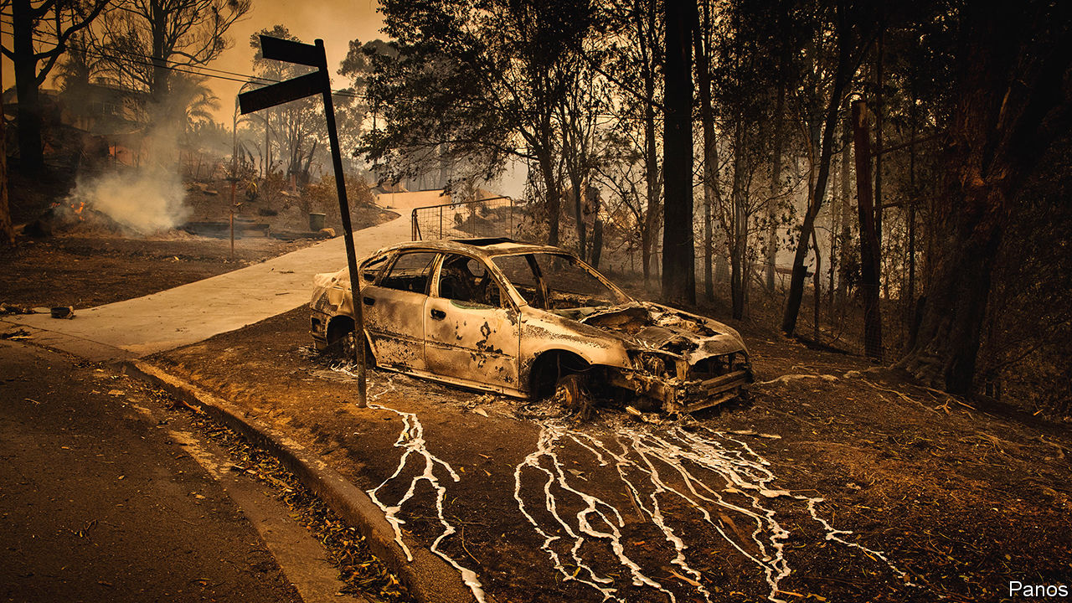

BY MOST MEASURES Australia’s bushfires have caused destruction on an epic scale. They have killed at least 29 people and perhaps a billion animals. Over 100,000 square kilometres of land, an area bigger than Scotland, has been charred. More than 2,600 homes have been destroyed. In big cities, including Sydney and Canberra, the air has turned toxic. Yet on one measure the fire has done less damage: businesses seem to have got off lightly.

The Australian Council of Insurance, a trade body, reckons insured losses so far amount to about A$1.4bn ($900m), making it only the country’s third-most-expensive fire since 1980. By contrast, California’s fires cost $15bn in 2017 and $18bn in 2018. This is because most of Australia’s industry sits in cities. They account for 64% of GDP, slightly above the average for the OECD, a club of mostly rich countries. The fires have stayed in the countryside, limiting damage to businesses. Australia’s big insurers, SunCorp and Insurance Australia Group, are well covered by reinsurers.

Of non-urban industries, tourism and agriculture, each of which makes up about 3% of GDP, were hardest hit. But severe losses in pockets of Australia look small compared with the industry as a whole. The Australian Tourism Industry Council (ATIC) says places engulfed by the blaze have become no-go zones for holidaymakers and room-cancellation rates hit 60% even in unburnt places. Even so, ATIC’s latest estimate is that the fires have cost the industry A$1bn, or 1% of annual sales.

Agribusiness in one battered area, Kangaroo Island off Australia’s south coast, may lose 100,000-odd sheep, a sixth of local livestock, says Matthew Dalgleish of Mercado, a research firm. But elsewhere much of the blaze has consumed national parks rather than farmland. Livestock losses will probably be around 1% of the national total.

The one thing environmentalists may have hoped the fires would kill is Australia’s coal industry, whose carbon-belching made them worse by fuelling climate change. In an ironic twist, BHP, a big miner, said that bushfire smoke contributed to an 11% fall in its production of electricity-generating coal in New South Wales. Three-quarters of the country’s electricity is generated by coal; it is the world’s biggest exporter of the stuff. The fires are licking energy and resource firms’ “social licence” to operate. But the climate-sceptic, coal-friendly government will not strip them of official permits any time soon.

Despite little immediate damage from flames or threat from regulators, the fires are having an effect on business. Katherine Klosowski of FM Global, an engineer-cum-insurer, says clients are paying more attention to risk-reduction measures like clearing spaces between bushland and buildings. Karl Mallon of Climate Risk Engines, an Australian consultancy, says some firms are at last moving from analysing risk to drawing up climate-resilience plans. Bosses know they may not be so lucky when the next calamity strikes.■

This article was downloaded by calibre from <https://www.economist.com/business/2020/01/25/australias-bushfires-have-left-businesses-surprisingly-unscathed>

|  |  |  |  |
| --- | --- | --- | --- |
| Previous | Articles | Sections | Next |

|  |  |  |  |
| --- | --- | --- | --- |
| Previous | Articles | Sections | Next |

#### Techno-charged

# Europe’s earnings recession may be at an end

Thank its also-ran technology companies

Jan 25th 2020 |

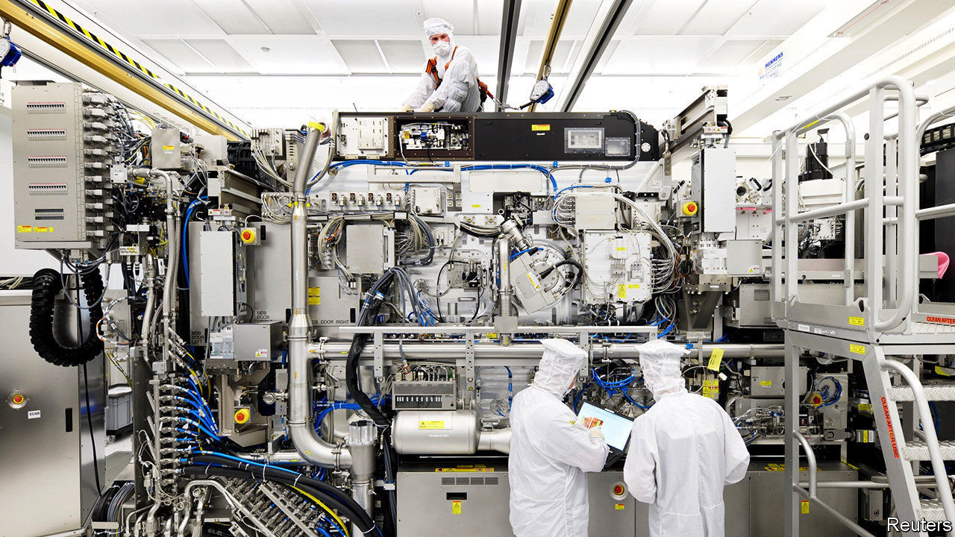

LAST YEAR was one for corporate Europe to forget. Although the continent was not in recession, its firms were—at least in terms of profits. The STOXX Europe 600 index of biggest European companies suffered three consecutive quarters of falling earnings. From July to September these declined by 4.3% year on year. As Europe SA reports results for the decade’s final quarter in the coming weeks, analysts expect a modest earnings bounce of 2.5%.

Much of this is down to technology companies, which are on a tear even as some other sectors look sickly (see chart). Their profits are estimated to have shot up by 23%. ASML, a Dutch company, has reported a 44% jump in earnings, thanks to soaring demand for its specialised chipmaking equipment.

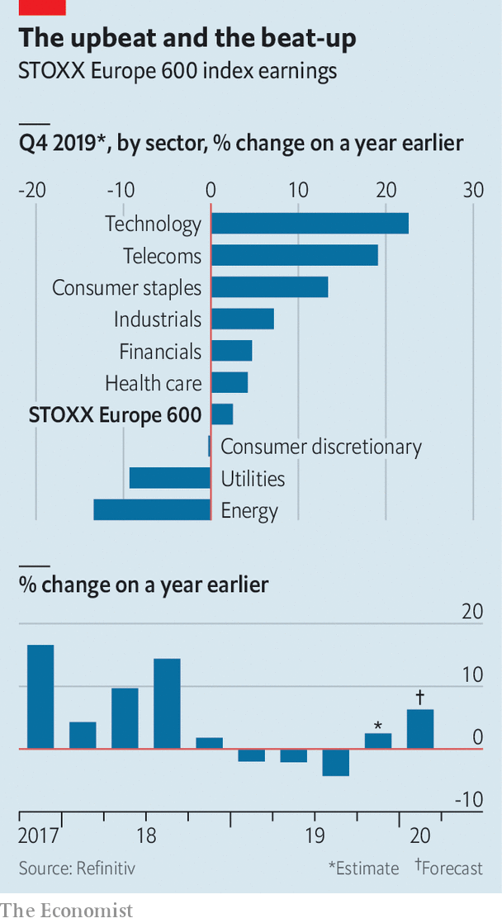

European tech still pales next to America’s titans. At a combined market value of $5.3trn, Apple, Microsoft, Google, Amazon and Facebook are worth as much as Europe’s 40 biggest firms put together. Tech makes up a third of the S&P 500 but only 6% of the STOXX Europe 600. As the likes of ASML keep outperforming the rest of Europe, at least that share will grow.

This article was downloaded by calibre from <https://www.economist.com/business/2020/01/25/europes-earnings-recession-may-be-at-an-end>

|  |  |  |  |
| --- | --- | --- | --- |
| Previous | Articles | Sections | Next |

|  |  |  |  |
| --- | --- | --- | --- |
| Previous | Articles | Sections | Next |

#### Schumpeter

# Moutai madness

The secrets behind the world’s biggest booze sensation

Jan 25th 2020 |

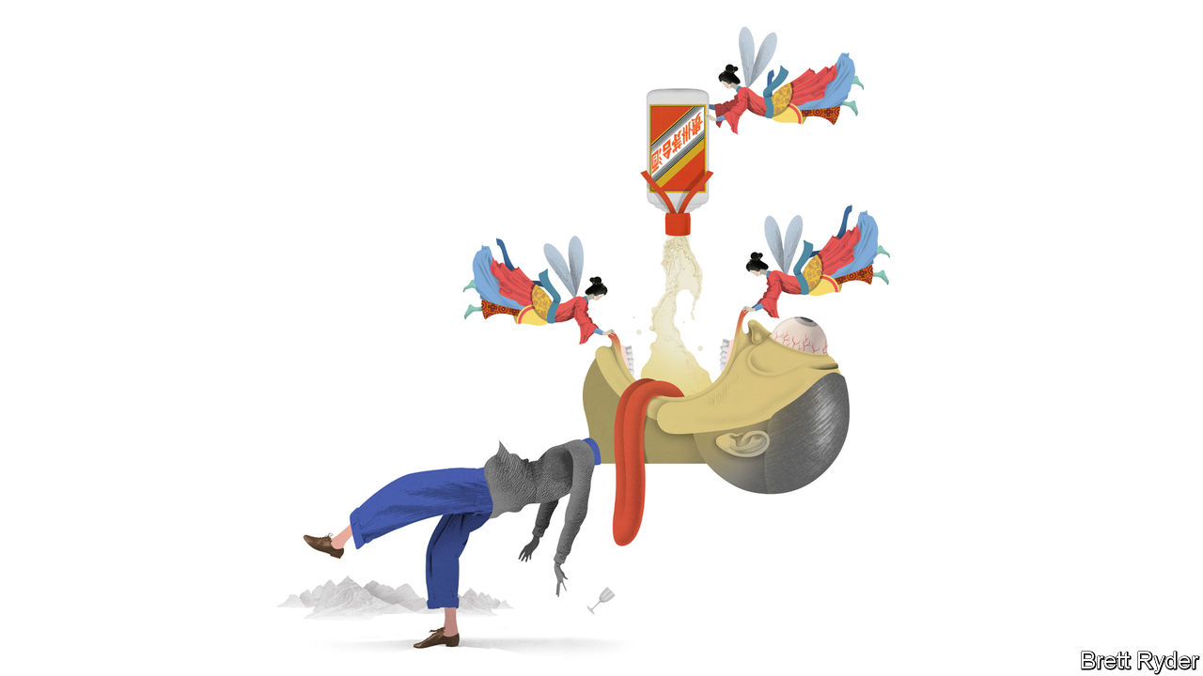

PICTURE A STATE-RUN distillery in the mountains of Guizhou, China’s poorest province. The smell of fermented sorghum fills the air. Barefoot men shovel the grain into pits. Hundreds of women work the bottling line. Visitors are given a snifter. At first it intrigues: the dominant notes are of fermented beans and soy sauce. But then it becomes a Hobbesian battle for survival. One throat-singeing toast leads to 15. In come the “Demolition Girls”, forcing guests to drink bowls of the stuff, until they collapse under the table. Hosting the proceedings is Yuan Renguo, the distiller’s chairman, with “narrow eyes, a receding hairline, and the unsmiling countenance of a trained assassin”.

These scenes, recounted in “Drunk in China”, a new book by Derek Sandhaus, a self-confessed aficionado of Chinese liquor, take place at the headquarters of Kweichow Moutai, the most renowned producer of China’s national drink, baijiu—which will be quaffed by the skinful this Chinese new year. Some might see it as an object lesson in the perils of doing business in China; foreigners are told to avoid the worst pitfalls of baijiu binges by tipping unwanted toasts discreetly into their rice bowls. Far better, though, to focus on the firm itself.

Moutai has been the global booze sensation of the decade. A bottle of its Flying Fairy which sold in the 1980s for the equivalent of a dollar now retails for $400. Moutai’s listed shares have soared by almost 600% in the past five years, outpacing the likes of Amazon. At $200bn, its market value is only $50bn shy of that of Coca-Cola, the world’s biggest beverage company. It cranks out EBITDA margins of 68%, twice that of global rivals such as Diageo.

It does this while disregarding every Western marketing mantra. It is not global, has meagre digital sales and does not appeal to millennials. Its scores pitifully on environmental, social and governance measures. In the Boy Scout world of Western business it would leave a bad taste, in more ways than one.

Moutai owes its intoxicating success to three factors—not all of them easy to emulate. First, it profits from Chinese nationalism. Moutai is known as the “national liquor”. It was used to raise spirits and disinfect wounds in Mao’s Long March. It was Premier Zhou Enlai’s favourite tipple, shared with Richard Nixon in 1972. Its centuries-old craftsmanship—it is distilled eight times and stored for years in earthenware jars—is a source of national pride. It also claims to be hangover-proof, which would make it an invention to rival gunpowder. (Having tested the assertion with a few $30 shots, your columnist cannot in good conscience corroborate it.)

Second, it chose to serve China’s super-rich rather than its middle class. Markets are littered with the corpses of firms that could not compete in the cut-throat battle for Chinese middle-class wallets. And the country’s premium market is massive—at 73m-strong, bigger than the population of France, notes Euan McLeish of Bernstein, an investment firm, and still less crowded with prestige brands than advanced economies. Moutai is to these well-heeled drinkers what vintage champagne is to the rest of the world. French cognacs, Scottish single malts and fine wines rightly smell lucre in China’s high Gini coefficient. So do luxury car brands, global fashion houses and top-end hotels.

Third, Moutai looks beyond affluent millennials and digital natives. The elderly and the middle-aged, it found, can be just as lucrative. Its biggest market now is (male) drinkers in their mid-30s. Many have no siblings, thanks to four decades of China’s one-child policy—which also means their elderly parents can splash out on weddings and banquets. Moutai is often a guest of honour.

Moutai has succeeded thanks to nationalism, elitism and ageism, in other words—not in spite of this unholy trinity. But it faces risks. One is a scandalous reputation. Until President Xi Jinping cracked down on bribery, it was the Communist Party’s drink—and gift—of choice. About two-thirds of the precious firewater ended up lubricating the banquets of government and military officials—and their bank accounts when they sold the pricey gifts back to shops. The price of a bottle of Moutai became known as China’s “barometer of corruption”. When the shenanigans stopped, it temporarily hit the firm’s share price.

More recently, another anti-corruption push has shaken the firm. Mr Yuan, who stopped being chairman in 2018, was arrested last year on suspicion of bribery. According to JPMorgan Chase, a bank, six other top executives were arrested in 2019, some 400 distributors were dismissed for corruption, and Moutai’s e-commerce subsidiary was closed for the same reason.

Next, the government is its largest shareholder—and a meddlesome one. It appears to want prices to remain stable. Exorbitantly priced booze is at odds with its professed socialist ideals. Yet minority investors—including many foreign funds—lament that Moutai’s wholesale price is a third of what it sells for in shops. Raising it could boost the company’s profits further. Many shareholders would also like Moutai to increase direct sales to capture more of the retail value. Instead, in what some see as a travesty of corporate governance, its majority owner has plans to set up its own sales channel. As Mr McLeish delicately puts it, Moutai does not behave like a “value-maximising shareholder company”.

## China’s sin dram

In the long run, its biggest risk may be millennials. As they grow older, health concerns, work-life balance and the desire for more wholesome pursuits than binge-drinking may curb the “Ganbei!” toasting culture on which so much of the demand for Moutai rests. For the time being, though, the party goes on. As Mr Sandhaus writes, citing a saying that has gained currency on Chinese social media: in China it is still better to do one bad thing with your boss than a hundred good things for your boss. That is not a sentiment on which Western marketers would build a business. But in China it has helped create the world’s biggest alcohol brand. ■

This article was downloaded by calibre from <https://www.economist.com/business/2020/01/25/moutai-madness>

|  |  |  |  |
| --- | --- | --- | --- |
| Previous | Articles | Sections | Next |

|  |  |  |
| --- | --- | --- |
| Business | Sections | Science and ... |

Finance and economics

America’s public finances: The great Treasuries binge

.

India’s economy: Good down, bad up

.

Precious metals: Rhodium ride

.

Transatlantic trade tensions: Still frosty

.

Economic growth: Slower is better

.

Derivatives: Fare play

.

Energy markets: Special delivery

.

Free exchange: Tearing up the rule book

.

|  |  |  |
| --- | --- | --- |
| Business | Sections | Science and ... |

|  |  |  |  |
| --- | --- | --- | --- |
|  | Articles | Sections | Next |

#### The great Treasuries binge

# Investors at home and abroad are piling into American government debt

Fiscal profligacy can continue for now, but is it economically sensible?

Jan 25th 2020 |

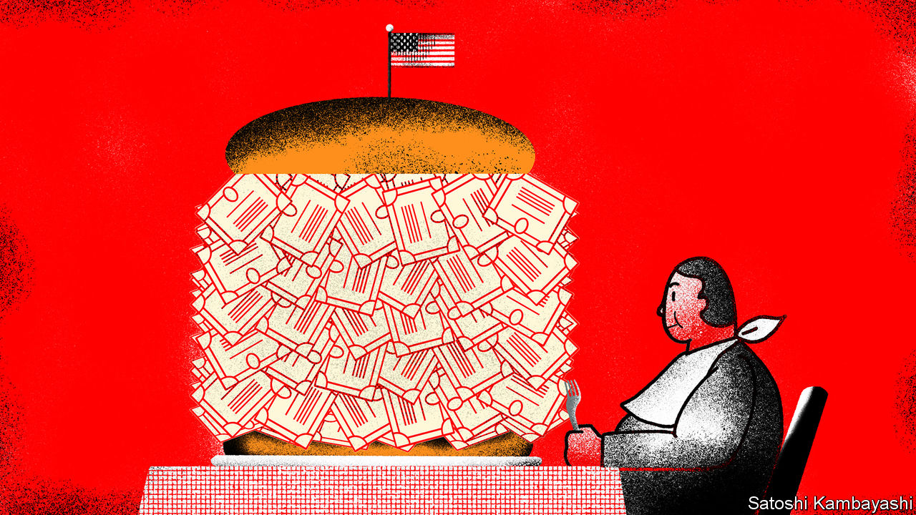

IN THE GOOD old days, America’s budget deficit yawned when the economy was weak and shrank when it was strong. It fell from 13% to 4% of GDP during Barack Obama’s presidency, as the economy recovered from the financial crisis of 2007-09. Today unemployment is at a 50-year low. Yet borrowing is rising fast. Tax cuts in 2017 and higher government spending have widened the deficit to 5.5% of GDP, according to IMF data—the largest, by far, of any rich country.

It could soon widen even further. President Donald Trump is thought to want a pre-election giveaway. Fox News is awash with rumours of “Tax Cuts 2.0”. This month the Treasury announced it would issue a 20-year bond, which would lengthen the average maturity of its debt and lock in low interest rates for longer. All this is quite a change for many Republicans, who once accused Mr Obama of profligacy, but now say that trillion-dollar deficits are no big deal. Democratic presidential candidates, meanwhile, are talking about Medicare for All and a Green New Deal. A new consensus on fiscal policy has descended on Washington. Can it hold?

Fiscal hawks worry that continued high levels of government borrowing will lead to economic chaos as the engine overheats. Many of them felt vindicated by the turmoil last year in the repo market, through which financial firms lend to each other. To buy Treasuries, investors must hand over money to the government. So rising bond issuance caused demand for cash reserves borrowed on repo markets to rise, sending rates soaring. The Federal Reserve was forced to step in to provide short-term funding.

Aside from that hiccup, however, markets have taken America’s debt binge in their stride. In recent months the yield on ten-year Treasuries has been below 2%. Interest repayments, as a share of GDP, are half the level of the early 1990s. That is despite there being a far higher stock of debt relative to GDP, a sign of investors’ voracious appetite for safe assets.

One source of this demand is investors at home. Much has been made of companies’ rising stock of debt. Yet America’s firms are now net suppliers of savings to the rest of the economy—probably because the money they have raised has been recycled to investors through dividends and share buy-backs. Those corporate savings have to be parked somewhere. Treasuries are an obvious destination.

Post-crisis reforms to the financial system have also played a role. Commercial banks, for instance, are now required to hold more high-quality liquid assets. Treasuries are an ideal candidate, points out David Andolfatto of the Federal Reserve Bank of St Louis. Meanwhile, a rule change in late 2016 has reduced the attractiveness of money-market funds that invest in corporate-debt securities. That, in turn, has increased demand for funds that invest solely in Treasuries.

Households have been saving more. When the financial crisis hit, families, fearing for their jobs and pay, began to stash money away. Despite the recovering economy they have not stopped, perhaps because of lingering economic uncertainty. The personal-savings rate is much higher than it was in the 2000s. In the past three years households’ holdings of public-debt securities have risen by 70%.

Domestic investors have soaked up two-thirds of the extra government borrowing since 2016. Foreigners have bought the rest, equivalent to $800bn-worth of Treasuries. As a consequence, America is now an even bigger net borrower from the rest of the world. Its current-account deficit has widened to around 2.5% of GDP.

It is no surprise that investors have an appetite for American debt. Policy uncertainty abounds, not least thanks to Mr Trump’s enthusiasm for threatening trade war. There are few other havens. Germany’s insistence on running super-tight fiscal policy means there is an undersupply of bunds, argues Brad Setser of the Council on Foreign Relations, a think-tank. Traders moan that the market for Japan’s government bonds is illiquid.

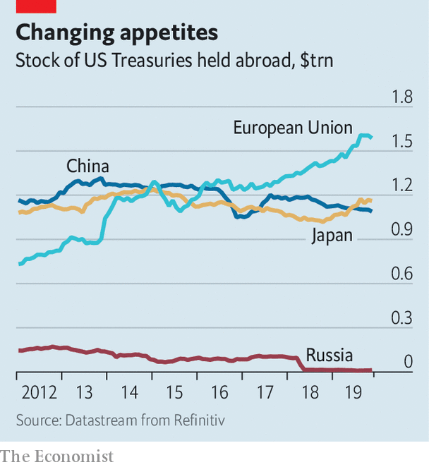

Investors based in Europe appear to have been the most enthusiastic buyers (see chart). In part that reflects some countries’ large trade surpluses. In the past year Norway, a big oil exporter, has doubled its holdings. But that does not explain why Belgium, a country of 11m people, is one of the world’s biggest foreign buyers of Treasuries. Although official purchases by China look stable, some suspect that it is making some of its purchases through Belgian intermediaries.

## Fiscal favours

Can America’s government deficit remain so wide for much longer? Some economists worry that loose fiscal policy at a time of low unemployment will cause the economy to overheat, rousing inflation. That would force the Federal Reserve to raise interest rates, and push up government-borrowing costs. So far, though, there is little sign of that. Inflation is oddly soggy; the Fed cut rates three times last year.

America’s fiscal profligacy may be able to continue for now, especially if the Treasury borrows more at longer maturities. But whether it is economically sensible is a different matter. Despite all the loosening, long-term GDP growth is middling and productivity growth weak. That may be because the splurge has been largely focused on tax giveaways, while federal investment spending has fallen as a share of government outlays. America’s fiscal policy may not be dangerous, but it may not end up doing much good. ■

This article was downloaded by calibre from <https://www.economist.com/finance-and-economics/2020/01/25/investors-at-home-and-abroad-are-piling-into-american-government-debt>

|  |  |  |  |
| --- | --- | --- | --- |
|  | Articles | Sections | Next |

|  |  |  |  |
| --- | --- | --- | --- |
| Previous | Articles | Sections | Next |

#### Good down, bad up

# India’s economy risks swapping stagnation for stagflation

Inflation is not only an onion phenomenon

Jan 23rd 2020 | MUMBAI

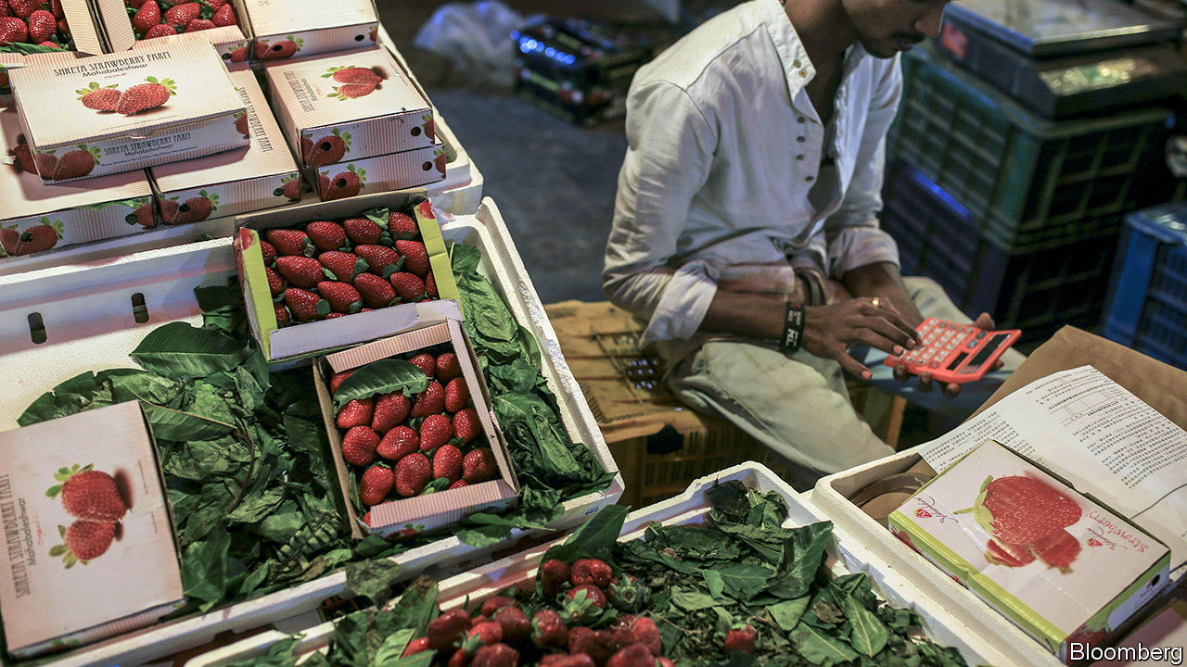

MUMBAI’S CHEFS were quick to spot the latest threat facing India’s economy. As they foraged for ingredients in Crawford market, where hawkers sell fruit, vegetables and other kitchen staples, they began hearing prices quoted not per kilogram, but per quarter-kilo—a forlorn attempt to mask price increases. Returning from a recent shopping spree, one prominent chef checked off the items rising sharply in price: tomatoes, cabbages, aubergines, fish, spices—almost every ingredient, in fact, in the Indian cookbook.

The hawkers had some plausible excuses. The weather has been erratic, and delivery systems unreliable. But although an increase in inflation was widely foreseen, the severity of it was not. Consumer prices rose by over 7.3% in December, compared with a year earlier, the biggest jump since July 2014. Onion prices, up by 328%, contributed 2.1 percentage points to the headline figure all by themselves.

But India’s inflation is not only or everywhere an onion phenomenon. A Mumbai tea-vendors’ association recently recommended a price rise because of the increased cost of sugar and tea leaves, as well as the gas that fuels vendors’ stoves. The National Pharmaceutical Pricing Authority allowed sharply higher charges for 21 drugs, including treatments for leprosy, malaria and tuberculosis, which were in short supply because prices had failed to cover rising costs.

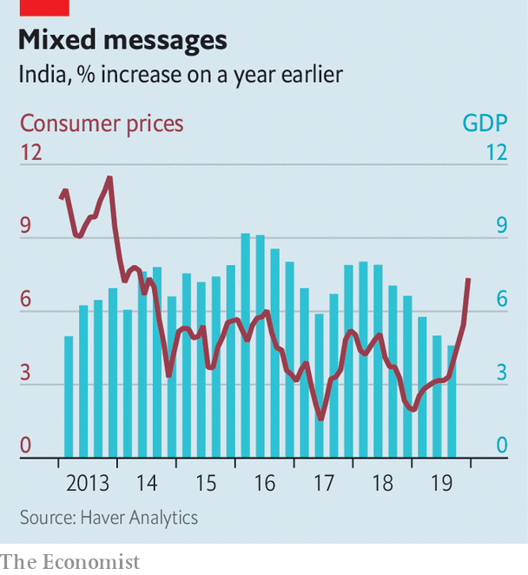

Indian Railways, a government entity, announced an increase in ticket prices in December. Its eroding finances apparently left it no choice. Complaints about rising air fares have been circulating since the collapse of Jet Airways last April. India’s mobile-phone operators have raised tariffs sharply after losing a court battle with the government over licence fees and spectrum charges. Despite a collapse in sales, vehicle prices are rising, a result of costly new regulations. Rajiv Bajaj, managing director of Bajaj Auto, a motorcycle-maker, has complained that the government “is killing the industry”.

This miscellany of misery will complicate the government’s efforts to fight an economic slowdown. India’s GDP grew by only 4.5% in the third quarter compared with a year earlier. That figure would have been as low as 3.1% were it not for a hurried government-spending spree. Yet another splurge is expected in the budget on February 1st. But any increase in demand could prompt an offsetting response from the Reserve Bank of India (RBI), the central bank. It may choose to prolong stagnation so as to avoid the uglier scenario of stagflation.

Stagflation usually begins with a setback to supply, such as India’s unseasonal rains. These misfortunes both lower output (the “stag” part of the phenomenon) and lift costs (the “flation” part). But once prices have increased sufficiently to reflect the scarcer supply, they should in principle stop rising. Some economists expect inflation to begin falling as soon as February. After all, core inflation, which excludes food and fuel prices, remains below 4%.

The problem is that before inflation disappears, Indians may start believing it will stay, making it more likely to persist. In most rich countries that have adopted inflation-targeting, headline inflation usually falls back into line with core measures, which reflect the strength of demand better. But in India the opposite is true. Core inflation usually converges towards the headline number, which reflects more accurately the drain on people’s pockets.

The RBI’s inflation-targeting framework, which it adopted in 2015, was supposed to fight this tendency. It was meant to convince people that the central bank’s inflation target of 4% was a better guide to future inflation than the prices quoted at Crawford market and other emporiums across the country. But the framework has “yet to be fully tested”, according to a recent lecture by Raghuram Rajan, the former RBI governor who introduced it. Mumbai’s chefs will hope it passes the thorough examination it will now undergo.■

This article was downloaded by calibre from <https://www.economist.com/finance-and-economics/2020/01/23/indias-economy-risks-swapping-stagnation-for-stagflation>

|  |  |  |  |
| --- | --- | --- | --- |
| Previous | Articles | Sections | Next |

|  |  |  |  |
| --- | --- | --- | --- |
| Previous | Articles | Sections | Next |

#### Rhodium ride

# Why are rhodium prices on a roll?

They have risen 63% so far this year

Jan 25th 2020 |

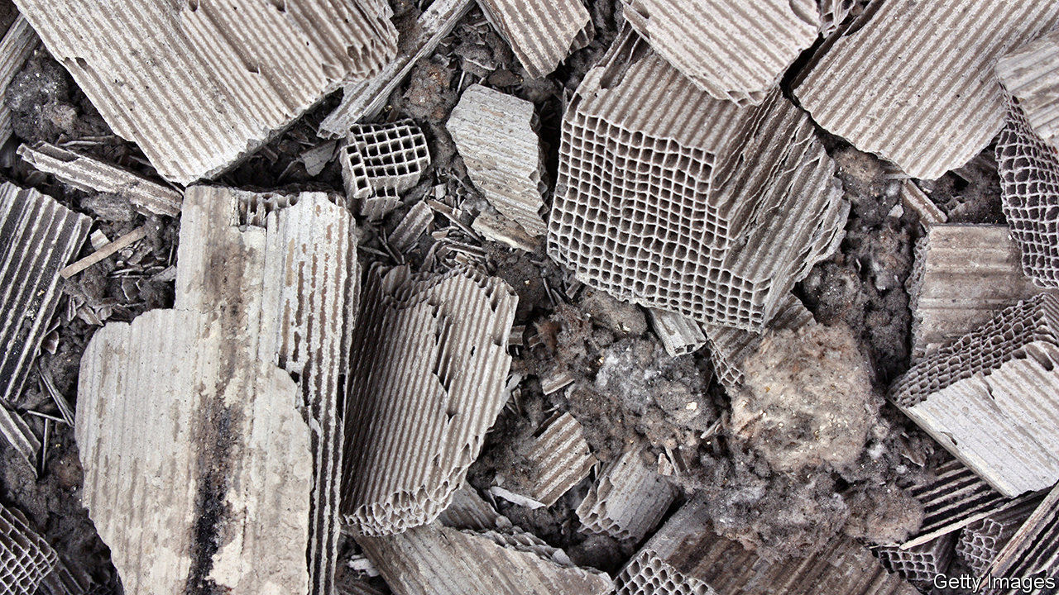

WHEN ANNA SCOTT left her Honda Jazz in a commuters’ car park outside Oxford on January 10th, she had little reason to think that criminals would take an interest in the 12-year-old car. Yet the next afternoon a group of shifty characters were spotted sawing off its catalytic converter. Such incidents have become more frequent across Britain as prices for palladium and rhodium, metals contained in the devices, have rocketed. The price of rhodium has risen by 63% in the first three weeks of January alone, to $9,850 per ounce, around six times that of gold. There is no telling when it will fall back to earth.

Demand from carmakers is surging. More than four-fifths of global demand for rhodium comes from the automotive industry. The metal, together with platinum and palladium, helps convert toxic gases in a vehicle’s exhaust system (such as carbon monoxide) into less harmful substances before they leave the tailpipe. Facing stricter emissions regulations around the world, carmakers are taking even more of a shine to these metals. Although the price of palladium has reached a record high, that of platinum has stayed relatively stable. The contrast reflects a shift in production towards petrol and hybrid cars, which tend to use greater quantities of palladium in their converters, and away from diesel engines, which use more platinum.

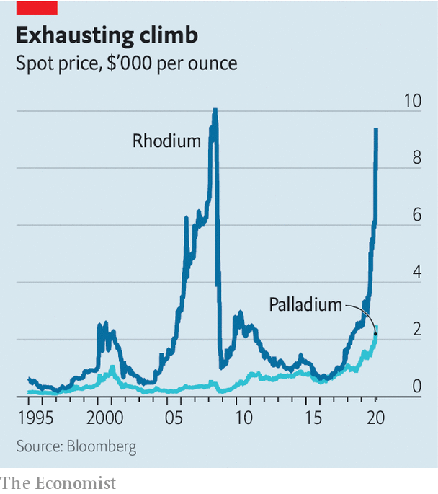

Rhodium is used in both petrol and diesel cars. That is because it is especially good at cleaning up nitrogen oxides, says Roger Breuer, an analyst at Arlington Group Asset Management, an investment firm. Another reason its price is sky-high is the tightness of its supply. More than four out of every five ounces of rhodium are mined in South Africa, extracted in minuscule quantities alongside more abundant metals such as platinum, palladium and gold. According to an analysis by Stantec, a consulting firm, a mine in the Waterberg region of South Africa due to begin development this year will produce 63% palladium, 29% platinum, 6.5% gold and just 1.5% rhodium.

The small size of the rhodium market (just 792,000 ounces last year, about 1% of that of gold) makes it prone to huge price swings. In 2008, after mining in South Africa was interrupted by blackouts, the price climbed above $10,000 an ounce. This time, a lack of capital investment has squeezed supply, according to Impala Platinum, the world’s second-biggest platinum miner.

Rhodium is expected to remain in high demand this year. BASF, a German chemicals giant, reckons that Chinese carmakers’ demand for the metal will increase by 40% in 2020. But because electric vehicles do not use catalytic converters, demand in the longer term is far from assured. Rhodium could quickly lose its sheen.

This article was downloaded by calibre from <https://www.economist.com/finance-and-economics/2020/01/25/why-are-rhodium-prices-on-a-roll>

|  |  |  |  |
| --- | --- | --- | --- |
| Previous | Articles | Sections | Next |

|  |  |  |  |
| --- | --- | --- | --- |
| Previous | Articles | Sections | Next |

#### Still frosty

# Transatlantic trade relations are still tense

Posturing at Davos aside, little of substance has changed

Jan 25th 2020 |

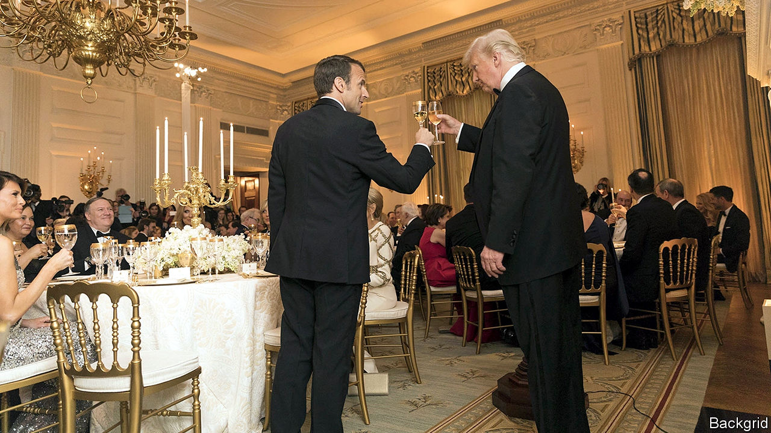

AS RECENTLY AS a week ago, a big transatlantic bust-up seemed inevitable, with the annual meeting of the World Economic Forum at Davos in Switzerland the most likely boxing ring. America had taken offence at France’s digital-services tax, which hits the likes of Amazon, Facebook and Google, on the ground that it discriminates against American companies. The French had insisted that the tax was only a temporary measure and would be repealed as soon as governments were able to reach a multilateral agreement on tax reform. The Americans, unconvinced, were poised to whack duties on $2.4bn of French champagne, beauty products and handbags.

But then on January 19th America’s president, Donald Trump, struck a temporary truce with his French counterpart, Emmanuel Macron. France would suspend the collection of revenues from its tech tax, and the Americans would suspend their tariff threats.

A love-in at Davos, then? Not quite. Soon after the apparent ceasefire, tensions began to rise again. The elite assembled at the Swiss resort were treated to plenty of theatrics. Steven Mnuchin, America’s treasury secretary, warned the British government that its version of a digital-services tax would not escape punishment. When Sajid Javid, the British chancellor of the exchequer, informed the audience that Britain would prioritise a trade agreement with the European Union (EU) over one with America, Mr Mnuchin seemed hurt, saying “I thought we’d go first.”

For his part Mr Trump, fresh from agreeing a “phase one” deal with China (see Free exchange), and expected soon to sign into law a revised trade deal with Canada and Mexico, flexed his dealmaking muscle. First he repeated an old threat to apply tariffs on imports of European cars. Then he said that he thought he could do a deal with the EU before the next presidential election in November. His administration has hobbled the dispute-settlement system of the World Trade Organisation (WTO). But on January 22nd he held an impromptu news conference with Roberto Azevêdo, the WTO’s director general, promising “dramatic” action.

How to interpret all the high-altitude hot air? In truth, there are few surprises. Few watching America’s reaction to France’s digital-services tax would have expected Britain to escape Mr Trump’s wrath. And it has been clear for some time that Britain will have to focus on establishing a new trading relationship with the EU, its largest and closest neighbour, before getting into serious talks with America.

As for the transatlantic trade relationship more broadly, Mr Trump’s statements this week were hardly new. They will not generate anything more than a shallow trade deal with the EU—though that might suffice for Mr Trump. Mr Azevêdo has no concessions to offer the president, as the WTO is driven by its members.

Even Mr Trump’s truce with Mr Macron may involve less than meets the eye. On January 22nd Bruno Le Maire, France’s finance minister, admitted that the biggest sticking point—that America wants companies to be able to opt out of an international tax agreement—had not been addressed. As The Economist went to press the squabbling parties were due to hold more meetings. Some still hope a deal can be forged before the end of this year, under the auspices of the OECD, a multilateral forum. If not, an almighty punch-up looms. ■

This article was downloaded by calibre from <https://www.economist.com/finance-and-economics/2020/01/25/transatlantic-trade-relations-are-still-tense>

|  |  |  |  |
| --- | --- | --- | --- |
| Previous | Articles | Sections | Next |

|  |  |  |  |
| --- | --- | --- | --- |
| Previous | Articles | Sections | Next |

#### Slower is better

# Is low economic growth a sign of success?

Yes, says Dietrich Vollrath, an economics professor, in a new book

Jan 25th 2020 |

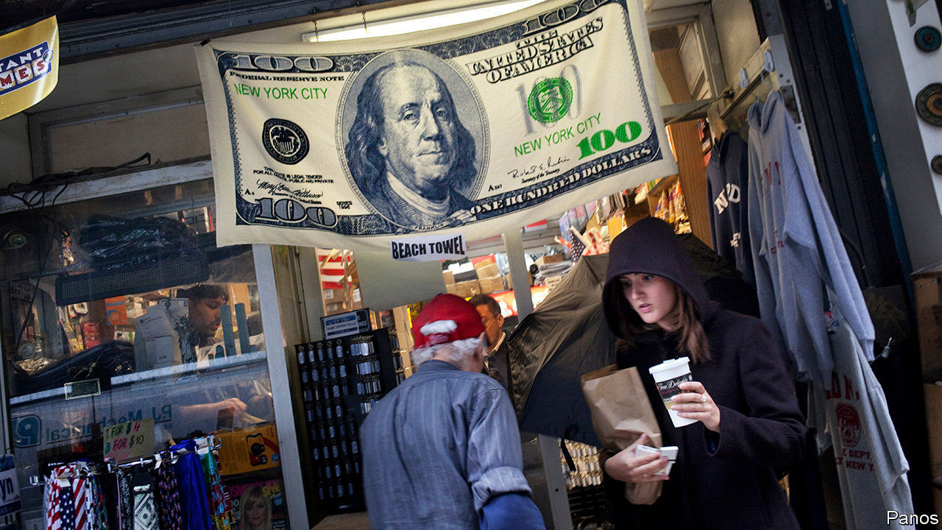

Fully Grown: Why a Stagnant Economy is a Sign of Success. By Dietrich Vollrath. University of Chicago Press; 296 pages; $27.50 and £20.

BETWEEN 1950 and 2000, GDP per person in America grew at an average annual rate of 2.3%. In 2000-18 that pace fell by roughly half. Often this slowdown—also seen in other rich countries—is taken as a sign that economic policy has failed, and that policymakers must inject stimulus or somehow restore capitalism’s lost dynamism. But for Dietrich Vollrath of the University of Houston, low growth is reason for cheer. In a new book he argues that America’s growth has slowed because so much in the economy has gone so well.

A big chunk of America’s economic advance in the 20th century was driven by improvements in “human capital”, the size and the skills of the workforce. In 1910 only a tenth of Americans completed high school; by the 1970s four-fifths were graduating. Many more now go on to college. A baby boom after 1945 increased the workforce; women piled into paid work in the 1970s and 1980s. All this added nearly a percentage point to annual per-capita GDP growth from 1950-2000. Since then, however, human capital has shrunk, reducing growth by 0.2 percentage points a year. It is the chief culprit behind the slowdown.

Human capital started shrinking, Mr Vollrath shows, for two main reasons. First, more people retired as the population aged. Second, the average level of education stopped rising quickly. Younger Americans entering the workforce are still more educated on average. But an ageing population means there are fewer of them to replace less-educated older workers.

These trends, he argues, are both linked to something good: women are choosing to have fewer children. That in turn reflects the fact that they are richer and have more control over their fertility. True, more babies would have meant more well-educated workers. But to lament demographic drag is to care more about GDP than about women’s welfare.

Neither physical nor human capital explains the rest of the growth slowdown. It comes from what economists call “total factor productivity” (TFP). Slowing TFP growth is often taken as a sign that technological progress has dried up. Mr Vollrath suggests another cause: economic activity has shifted towards service industries, where productivity gains are harder to achieve. Though growth-inhibiting, this is a good thing. People buy more services as they get richer.

What of the various other unwelcome forces often thought to be dragging the economy down? Mr Vollrath is unconvinced. The rising market power of some firms may have reduced investment, but investment does not explain much of the growth deceleration, and corporate concentration may even have boosted productivity. Restrictive planning rules prevent people from moving house, and so from taking more productive jobs. Though that weighs on GDP, it cannot explain such a prolonged growth slowdown. Economics has “no definitive finding” about the effect of inequality on growth. And so on.

Mr Vollrath backs his case with plenty of references to recent important economic papers. Impressively, the book remains digestible. The author’s number-crunching is formidable; good luck to anyone who takes issue with his forensic accounting. Yet it is not a reason to be complacent. Mr Vollrath pins much of his argument on the improvement in women’s welfare. Why then do surveys find that women became unhappier in the final decades of the 20th century? Oligopolies and regulatory capture may not affect overall GDP, but they could still worsen Americans’ welfare by making the economy unfair, or, say, by intruding on their privacy.

Mr Vollrath has not established some hitherto unknown cause for cheer; ageing and the shift to services are forces long familiar to economists. But his triumph is in showing the degree to which these make economic growth an unreliable measure of success. Attempting to capture progress in a single number is a fool’s errand. ■

This article was downloaded by calibre from <https://www.economist.com/finance-and-economics/2020/01/25/is-low-economic-growth-a-sign-of-success>

|  |  |  |  |
| --- | --- | --- | --- |
| Previous | Articles | Sections | Next |

|  |  |  |  |
| --- | --- | --- | --- |
| Previous | Articles | Sections | Next |

#### Fare play

# Airbus will help airlines hedge volatile ticket prices

But will airlines and travel groups get on board?

Jan 25th 2020 |

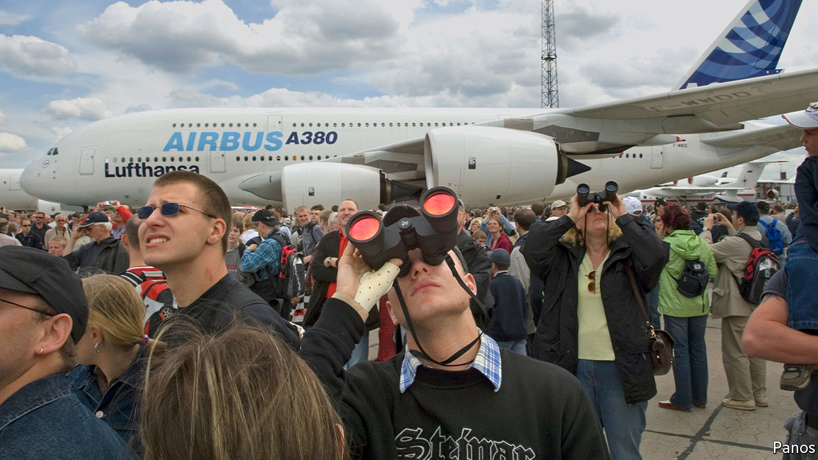

THERE IS NOTHING that maddens online shoppers more than seeing air fares rocket just as they are about to click “buy”. Yet price turbulence may be an even bigger headache for airlines. Whereas carriers have some control over fares, these can be buffeted by surges in supply or demand, caused, say, by economic slumps or political rows. Over the past five years, ticket prices on a given date (net of taxes and fees) have varied by an average of 7% in Asia and 16% in Europe. Even in North America, where airlines have more pricing power, volatility hovers around 7%. Most carriers have to wait until less than 90 days before take-off for 90% of their ticket revenues. So they are hard to forecast—a big problem, as airlines often commit billions of dollars years in advance to buy planes.

Fortunately for them Airbus, the world’s largest planemaker, has a fix. On January 20th it launched Skytra, a London-based exchange through which airlines can access futures, options or swaps to hedge against big swings in ticket prices. Those derivatives contracts will be based on indices that track daily changes in the price of travel (measured as a cost per passenger per km). Airlines can buy these through banks and brokers that join the exchange. Skytra expects to get the thumbs-up from British regulators in the summer.

If the new tool helps carriers stabilise earnings, it would also reassure Airbus, which is sitting on an order backlog of 7,482 aircraft—nine years’ worth of production. Nineteen airlines folded last year; with better risk management the number might have been lower. Boeing, Airbus’s rival, has seen hundreds of its 737 MAX planes grounded after two crashes. Uncertainty over when they will fly again makes hedging all the more attractive. More data and greater processing power have also helped make hedging easier, says Elise Weber, one of Skytra’s founders.

Sceptics say the platform could struggle to take off. Airlines have not been voracious users of derivatives. Some do not even hedge fuel prices, their biggest cost: only 40% of the kerosene set to be consumed in the next year is hedged. Few Asian and Middle Eastern carriers buy hedges because they do not really understand them, says an executive at a rival exchange. More complex derivatives that reference ticket prices could flummox them.

For the market to work, the airlines need counterparties. These could include businesses that buy blocks of plane tickets, such as travel agents or hotel chains, suggests Matthew Tringham, a co-founder of Skytra. But few make use of simpler existing hedges against swings in weather or currency. And few would feel able to forecast ticket prices better than the airlines themselves. Low demand would limit liquidity and make trading dear. That could deter banks and brokers from acting as market makers, further sapping liquidity.

At least Skytra is well-equipped. On January 23rd it said it had chosen Nasdaq, the world’s second-largest stock exchange, as its technology provider. Mark Howarth, its boss, has worked at London’s stock exchange and Chi-X, an Asian venue. That will cheer City types who question Airbus’s markets nous. Airlines and travel groups may take longer to get on board. ■

This article was downloaded by calibre from <https://www.economist.com/finance-and-economics/2020/01/25/airbus-will-help-airlines-hedge-volatile-ticket-prices>

|  |  |  |  |
| --- | --- | --- | --- |
| Previous | Articles | Sections | Next |

|  |  |  |  |
| --- | --- | --- | --- |
| Previous | Articles | Sections | Next |

#### Special delivery

# Competition, sanctions and the new geopolitics of Russian gas

Rising Russian supply puts Europe’s energy policy to the test

Jan 25th 2020 |

IN JANUARY 2009 Gazprom, Russia’s state-owned energy giant, cut off gas supplies through Ukraine, one of several disputes in which Russia wielded its energy might. Eleven years later, it seems poised to become even more dominant. Europe’s gas production is declining. Russia has both rising supply and new ways to export it. On January 8th President Vladimir Putin celebrated the launch of TurkStream, a pipeline to bring Russian gas to Europe. American sanctions on Nord Stream 2, a controversial gas pipeline from Russia to Germany, required pipe-laying companies to wind down activities by January 20th. That will delay the project, not stop it.

Yet on January 12th Ditte Juul Jørgensen, the European Commission’s director-general for energy, told industry experts gathered in Abu Dhabi that Europe had become less vulnerable: “Our energy security and our longer-term security is in a different situation now compared to what it was in 2009.” Indeed, Europe has sought not energy independence, but energy competition. As gas courses through new Russian pipelines, that will be put to the test.

Europe’s gas market has been transformed in the past decade. Demand fell after the financial crisis and has not fully recovered, in part due to a ramp-up in renewables. Australia and America have helped bring a boom in liquefied natural gas (LNG). Additional LNG terminals, pipelines and gas-storage facilities have sprouted across Europe, often aided by public investment. Europe imported 123bn cubic metres of LNG last year, nearly twice as much as in 2017, reckons S&P Global Platts, a commodities and analytics outfit.

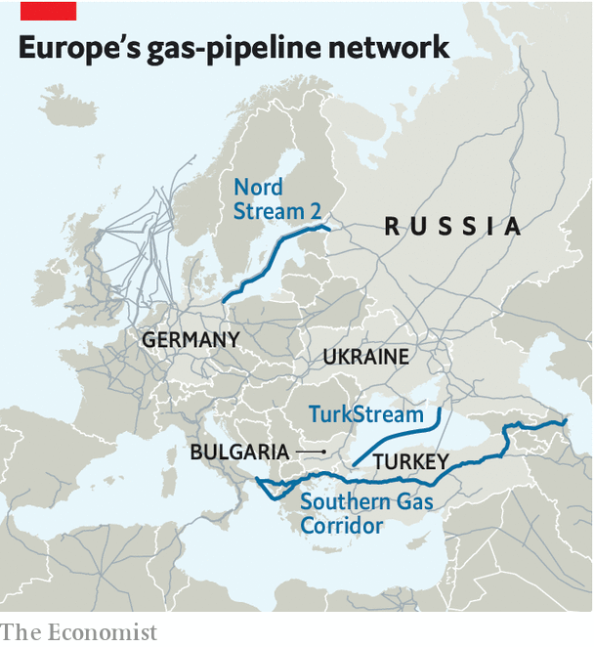

These supplies of gas, combined with new means of storing and transporting it, have helped support a spot market, which in turn has made the rigid contracts and oil-linked pricing long favoured by Gazprom look less tenable. In 2018 oil-linked pricing accounted for only 24% of Europe’s gas market, according to the International Gas Union, compared with 78% in 2005. “The market has become more competitive, flexible and significantly more efficient,” says Ira Joseph of S&P Global Platts.

New European Union (EU) rules and legal proceedings have promoted competition, too. Owners of gas infrastructure, for instance, must allow third parties access to their pipelines. Last year the EU extended its gas regulations to pipelines connecting member states to external countries. Construction continues on the Southern Gas Corridor, to connect Azerbaijan to Europe.

None of this means that Europe is free of Gazprom. Nord Stream 2 is challenging the EU’s new gas rule in court. In January it also asked German regulators for an exemption. Russian gas remains plentiful and relatively cheap. The International Energy Agency (IEA), a forecaster, expects the share of Russian pipeline gas in the European market to fall only slightly, from 37% in 2018 to 33-36% by 2024. But LNG makes it harder to fleece pipeline customers. Supply agreements with Gazprom now let customers resell Russian gas. In 2018 Gazprom launched an electronic-sales platform, which allows it to maximise sales and serve buyers wanting flexibility.

Two big questions loom. The first is whether Russia will, despite all this, bully customers. Some, such as Bulgaria, remain very reliant on Russian gas. In December Gazprom signed a transport deal with Ukraine’s Naftogaz, but Russia’s willingness to comply with the terms is debatable. It is even less clear if Nord Stream 2 will abide by the EU’s transparency and access rules. Richard Morningstar, a former American ambassador who leads the Global Energy Centre at the Atlantic Council, a think-tank, would prefer America to announce contingent sanctions—punishing Gazprom and its partners if, say, the company violates its gas agreement with Ukraine.

The second question is how Europe’s climate ambitions affect natural gas. In December the European Commission outlined a plan for carbon neutrality by 2050. This may depress demand for Russian gas, says Kateryna Filippenko of Wood Mackenzie, an energy-data firm. It may also sap support for infrastructure that would help countries still unduly dependent on Russian gas. On January 22nd a committee of the European Parliament voted to make 32 gas projects eligible for public funding, despite criticism from the European Climate Foundation, a lobby group. The parliament is due to vote on the list next month.

In the meantime, Russia is hedging its bets. By 2024 gas demand in China will be more than four times that in 2010, according to the IEA. On December 2nd Gazprom marked the opening of Power of Siberia, the first pipeline to bring Russian gas to China. It will face ample competition—from coal and renewables as well as from domestic gas production, LNG and other sources of piped gas. Russia can still throw its weight around in global gas markets. But it may bump into a rival. ■

This article was downloaded by calibre from <https://www.economist.com/finance-and-economics/2020/01/25/competition-sanctions-and-the-new-geopolitics-of-russian-gas>

|  |  |  |  |
| --- | --- | --- | --- |
| Previous | Articles | Sections | Next |

|  |  |  |  |
| --- | --- | --- | --- |
| Previous | Articles | Sections | Next |

#### Free exchange

# The costs of America’s lurch towards managed trade

China’s vow to buy more American goods carries the risk of waste and distortion

Jan 25th 2020 |

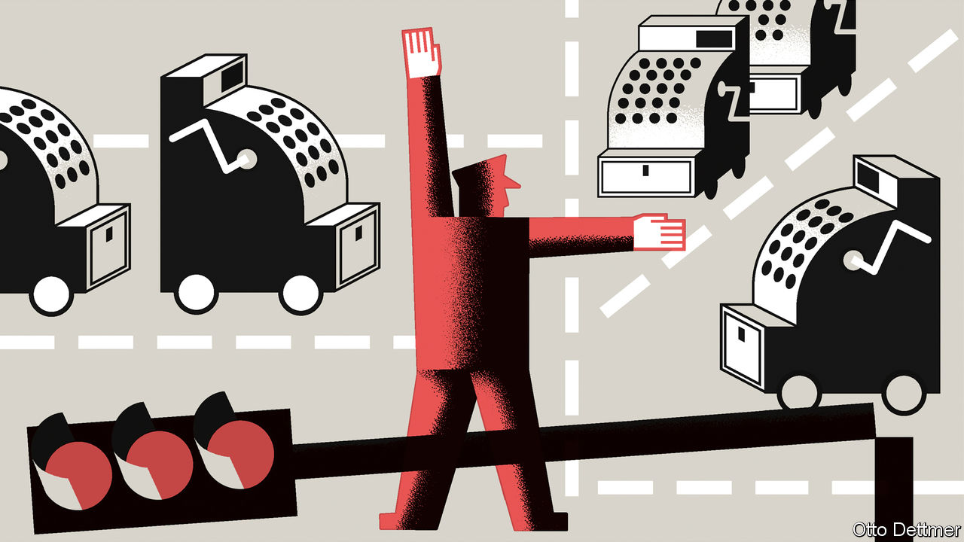

STANDING BEFORE the global glitterati at the World Economic Forum in the Swiss mountain resort of Davos, President Donald Trump bragged of a “transformative change” to America’s trade policy. The newly inked “phase one” deal with China, he said on January 21st, would lower trade barriers and protect intellectual property. He crowed about China’s promise to buy an extra $200bn of American services, energy, agricultural produce and manufactured goods over the next two years. He was not exaggerating. The agreement on a level of purchases, rather than on the rules of trade, does indeed mark a fundamental shift in American policy. But not one for the better.

America has embraced outcome-based rules in its trade relations before. Mercantilists like Mr Trump manage trade in two ways: either by restraining foreigners’ sales to America, or by encouraging them to buy more American goods. In the 1980s American negotiators spent most of their efforts on the first, as they faced political pressure to contain a burgeoning trade deficit and became convinced that Japan’s trade practices were unfair. At their peak, these “voluntary” restraints affected around 12% of all exports to America, including cars, steel, machine tools, textile products and semiconductors.

Voluntary import expansions, where a trading partner agrees to import more, as China has, were less common. Most famously, Ronald Reagan’s administration negotiated a commitment from the Japanese government that 20% of its semiconductor market would be imported. The aim was not so much to target the trade deficit directly, but to prise open what America thought was an unfairly closed market. The hope was that the intervention would jolt suppliers into investing in new economic relationships and lead to a sustained shift in trade patterns.

A generous interpretation of Mr Trump’s deal with China is that he is simply trying to do the same. He is not alone in feeling that China’s market shuts out outsiders, or that its policymakers do not always play fair. Veteran trade negotiators tell of haggling away one Chinese trade barrier, only for another to pop up elsewhere. (Economists recognise this problem as the difficulty of writing down a “complete contract” that covers every contingency.) An outcome-based trade deal, tied to easily verifiable trade flows, should help to overcome distrust, and could force China to provide real market access. If it led to more investment in supply-chain infrastructure, then it could have lasting effects.

It could even be argued that managing trade with China would be easier than it was with Japan. Later attempts to repeat Reagan’s semiconductor tactic failed, as Japan’s government had grown tired of cajoling its private sector into changing its sourcing decisions. It had no direct control over who bought the managed products, and had to resort to pleading letters to firms, as well as surveys asking about who they were buying from. By contrast, China’s government has the purchasing power of its state-owned enterprises at its disposal, and sway over the private sector too.

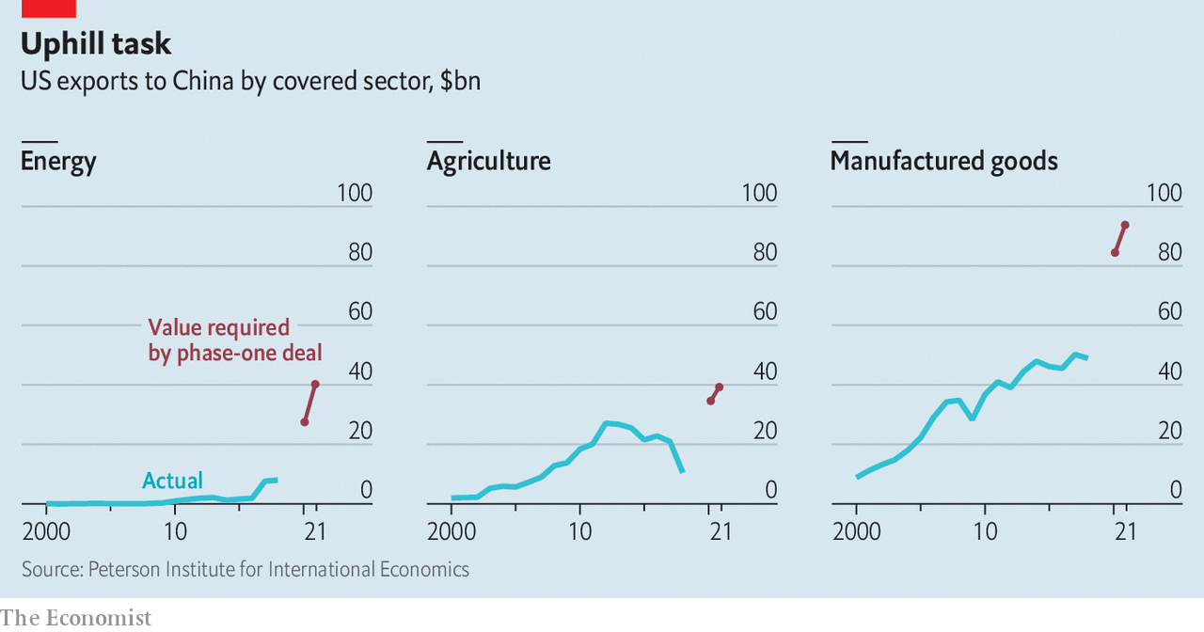

Dig into the details of Mr Trump’s new deal, though, and the risks of waste and distortion become clear. The agreed increase in sales to China is large and rapid. According to an analysis by Chad Bown of the Peterson Institute for International Economics (with whom your columnist hosts a podcast), China has, in effect, pledged to increase its purchases of certain American agricultural products by 60%, and manufactured products by 65%, by the end of this year compared with levels in 2017 (see chart). This must happen regardless of economic conditions in China. Whereas Japan agreed to increase the share of imported goods in domestic demand, China has signed up to buy fixed dollar amounts.

The risk is that China has promised to buy products that it either will not need or would rather get from elsewhere. State-owned enterprises could suck up American commodities and leave them to rot. American exporters, lured by higher prices to Chinese buyers, could switch from more sustainable relationships to ones that fizzle once their artificial advantage ends. Or China could resort to logistical gymnastics to make it appear that it is buying American, such as by transporting goods from third countries through America. It could also have more American goods shipped directly to China, rather than through Hong Kong, so that they appear in the mainland’s trade figures.

Another danger is that China simply diverts trade from its other trading partners, prompting complaints that the biggest actors are carving up markets between themselves—and carving others out. Admittedly, members of the World Trade Organisation (WTO) are already allowed to agree on broad tariff cuts among themselves, which could lead to similar diversionary effects. But trade deals are permitted, whereas discriminatory managed-trade arrangements are not. And if, as Mr Bown warns, Brazilian and Argentine sellers of soyabeans or Russian and Canadian lobster-traders find themselves pushed out of China’s market, they are unlikely to react well.

## Managed decline

If the deal sticks, it will threaten the world’s trading system. That system, ironically, is the result of America’s turning away from managing trade in the 1990s. Realising that it could not preach the virtues of free markets while itself practising something so different, America sought the creation of the WTO, as a shift towards a system based on rules rather than power. Mr Trump’s presidency has consistently undermined those rules, and the deal with China again reinforces the idea that they do not matter. Now that he has won his share of the Chinese market, other countries may demand the same.

But the deal could also very easily fall apart, ushering in another round of hostilities. America is tightening its export controls, which could limit the goods available for China to buy. So, whatever the deal’s fate, disruption looks inevitable. Whether Mr Trump will still be in office when that becomes clear remains to be seen. Official figures on whether China’s purchases have met this year’s target will not become available until early 2021, after the presidential election. ■

This article was downloaded by calibre from <https://www.economist.com/finance-and-economics/2020/01/25/the-costs-of-americas-lurch-towards-managed-trade>

|  |  |  |  |
| --- | --- | --- | --- |
| Previous | Articles | Sections | Next |

|  |  |  |
| --- | --- | --- |
| Finance and ... | Sections | Books and arts |

Science and technology

Neuroscience: Fly atlas

.

Personal identification: Finding it in one’s heart

.

Animal colouration: Beetle drive

.

|  |  |  |
| --- | --- | --- |
| Finance and ... | Sections | Books and arts |

|  |  |  |  |
| --- | --- | --- | --- |
|  | Articles | Sections | Next |

#### Neuroscience

# The biggest, most detailed map yet made of brain cells

It is part of a fly’s brain, but other brains will follow

Jan 25th 2020 |

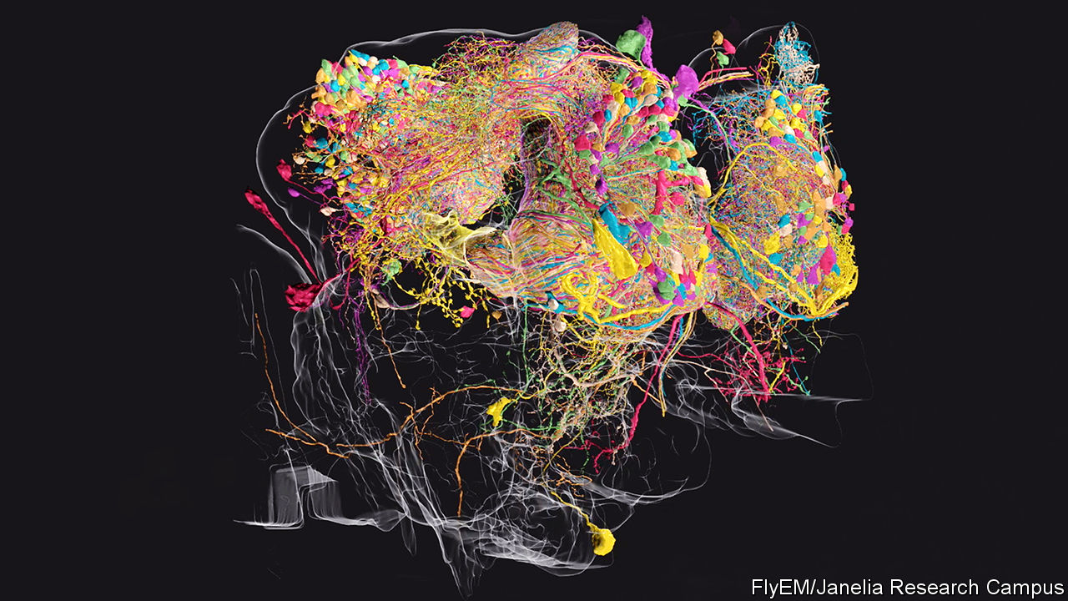

AT THE BEGINNING of the 20th century Santiago Ramón y Cajal, a Spanish neuroscientist, became known for his exquisite drawings of the branching, treelike cells of the brain and spinal cord. In 1906 he was awarded a Nobel prize for this work, which gave the world its first glimpse into the structure of these neurons, and an inkling of how they are arranged in an animal’s central nervous system.

A century later Cajal’s legacy—supercharged by modern microscopy, heavy-duty robotics and a dollop of machine learning—is thriving. The objective now is to create connectomes. These are three-dimensional maps of all the neurons in entire brains, and how those neurons link together. This week sees the publication of an important step on the road to a complete brain connectome: a map of about a quarter of a fruit fly’s cerebral capacity.

That map, of what its cartographers refer to as the fly’s hemibrain—a set of around 25,000 neurons in the centre of the organ—has been more than a decade in the making. It is the brainchild of Gerry Rubin, a biologist who was also responsible for mapping the fruit fly’s genome as a proof of principle for the Human Genome Project. Dr Rubin is now boss of the Janelia Research Campus in Virginia, a part of the Howard Hughes Medical Institute that is dedicated to neuroscience. The hemibrain connectome is the first phase of the campus’s FlyEM project, to map the fruit fly’s entire brain, which contains around 100,000 neurons. That is a drop in the ocean compared with the 85bn in a human brain, or even the 70m in a mouse brain. But, like the fly’s role in the Human Genome Project, it will be a proof of principle.

## Flying high

Each of the hemibrain’s neurons is connected to hundreds of others through junctions called synapses, for a total of more than 20m synapses. These neurons and synapses form circuits that are responsible for a fly’s ability to learn, navigate, sleep and tell the time of day. The only full connectome created so far is that of C. elegans, a nematode worm which has either 302 or 385 neurons in its nervous system, depending on whether it is hermaphrodite or male (there are no purely female C. elegans). The neurons in C. elegans have around 7,000 synapses between them. Mapping the fly hemibrain is thus a big step forward.

Elucidating the connectome of C. elegans involved techniques Cajal himself would have recognised. The researchers who did it sliced their worms into thin sections using diamond knives, stained the slices to show the cells within them up more clearly, and then took electron-microscope pictures of the result. Identifying neurons and synapses within the thousands of images thus obtained was a task for expert human eyes.

Dr Rubin and his crew have automated things. One of the teams on the campus has, for example, developed a way to speed up the slicing and imaging part of the operation. This technique, which works like an atomic-scale sandblaster, fires a beam of gallium ions at a sample of brain tissue. That etches off a layer of the tissue a few nanometres thick from the sample’s surface. A scanning electron microscope (SEM) then takes a picture of the newly exposed surface. That done, the gallium beam etches away another few nanometres and the process is repeated until the whole sample has been studied.

The microscopes involved have been built especially for FlyEM. They sit on air-filled pads to minimise vibrations that might ruin the images, and the room containing them rests on its own concrete slab, to separate it from the remainder of the laboratory. Moreover, while run-of-the-mill SEMs usually operate for hours at a time at most, the FlyEM machines are designed to operate continuously for months.

The result is millions of high-resolution images that have been stitched together to create 3D representations of the fruit fly hemibrain (see image above of the olfactory pathway). The next step was to label the neurons and synapses within. Doing that manually, in the way used for C. elegans, would have taken centuries, according to Stephen Plaza, the project’s manager. Clearly this was a non-starter. So he turned to Google for help.

Computer vision has improved enormously in recent years and is routinely used to scan through hundreds of hours of CCTV or satellite images to identify objects of interest to the authorities. Modern artificial-intelligence (AI) algorithms perform better than people at classifying images and, between 2015 and 2018, doubled their performance in object segmentation, a trickier task that involves picking multiple objects from a single image. At Janelia’s behest, Google trained one of its AI algorithms to recognise neurons and synapses within the FlyEM images. As this algorithm scrolled through the pictures, it also attempted to trace the fibrous protuberances called dendrites and axons that connect one neuron to another.

To start with, the researchers trained the AI on pictures that had already been marked up by human experts. As it churned through further images, human proofreaders checked its decisions and fed errors back to it, so that it could improve its understanding of what neurons look like in different contexts. As the AI got better, the manual workload lessened and the speed with which images were correctly annotated shot up. With the AI’s help, Dr Plaza and his team of 50 proofreaders cut the time required for the annotation down from centuries to a couple of years.

## For all mankind

The FlyEM data released this week are available to all neuroscientists, professional or amateur, to use as they see fit. Anyone with an internet connection can look up lists of neurons that are connected to each other and see 3D diagrams of what each of those cells, with its myriad dendritic and axonal branches, looks like.

At Janelia, several groups are already mining these data to glean insights. Vivek Jayaraman’s team, for example, studies how a fruit fly’s brain helps the insect first to understand its orientation in space and then to employ that information to help it navigate. Until now Dr Jayaraman has worked with theoretical models of which parts of the brain might talk to each other. The hemibrain map has shown him the actual physical connections between the neurons involved. He, Dr Rubin and other researchers at Janelia will publish their insights over the coming months.

With the hemibrain complete, FlyEM’s researchers expect to finish the rest of the fruit fly connectome within the next two years, and thus to gain further insights into fly neurology. But other consequences of the project are crucial, too. The advances in automation and machine learning that are being made through it will be as valuable as the biological insights. And, as the technology gets better, connectome reconstructions will happen faster, allowing the mapping of bigger brains in larger numbers.

In the future, the aim is to obtain connectomes for several strains of mouse and, eventually, several people too. Looking at the differences in wiring between typical and atypical brains might shed light on conditions such as schizophrenia and autism. Looking at the differences between human brains and those of other species may help explain just what it is that makes humans neurologically special.

Dr Rubin estimates that assembling a mouse connectome would cost around $500m (more than ten times what FlyEM will have cost when finished). He is confident such a project could be started within ten years. A human-brain connectome would be orders of magnitude more difficult. But not, he reckons, impossible. In 1990, at the beginning of the Human Genome Project, he recalls that many scientists thought sequencing animal genomes would always be too expensive and difficult. Those detractors said that biologists should choose between mouse and human, since it would probably be impossible to do both. “And now”, he points out, “we have projects where we’re going to do 10,000 human-genome sequences.”■

This article was downloaded by calibre from <https://www.economist.com/science-and-technology/2020/01/25/the-biggest-most-detailed-map-yet-made-of-brain-cells>

|  |  |  |  |
| --- | --- | --- | --- |
|  | Articles | Sections | Next |

|  |  |  |  |
| --- | --- | --- | --- |
| Previous | Articles | Sections | Next |

#### Personal identification

# People can now be identified at a distance by their heartbeat

And then dealt with, if they are enemy operatives

Jan 25th 2020 |

BEFORE PULLING the trigger, a sniper planning to assassinate an enemy operative must be sure the right person is in the cross-hairs. Western forces commonly use software that compares a suspect’s facial features or gait with those recorded in libraries of biometric data compiled by police and intelligence agencies. Such technology can, however, be foiled by a disguise, head-covering or even an affected limp. For this reason America’s Special Operations Command (SOC), which oversees the units responsible for such operations in the various arms of America’s forces, has long wanted extra ways to confirm a potential target’s identity. Responding to a request from SOC, the Combating Terrorism Technical Support Office (CTTSO), an agency of the defence department, has now developed a new tool for the job.

This system, dubbed Jetson, is able to measure, from up to 200 metres away, the minute vibrations induced in clothing by someone’s heartbeat. Since hearts differ in both shape and contraction pattern, the details of heartbeats differ, too. The effect of this on the fabric of garments produces what Ideal Innovations, a firm involved in the Jetson project, calls a “heartprint”—a pattern reckoned sufficiently distinctive to confirm someone’s identity.

To measure heartprints remotely Jetson employs gadgets called laser vibrometers. These work by detecting minute variations in a laser beam that has been reflected off an object of interest. They have been used for decades to study things like bridges, aircraft bodies, warship cannons and wind turbines—searching for otherwise-invisible cracks, air pockets and other dangerous defects in materials. However, only in the past five years or so has laser vibrometry become good enough to distinguish the vibrations induced in fabric by heartprints.

According to Jacob Khurgin of Johns Hopkins University, in Baltimore, the best laser vibrometers can measure a displacement of just ten picometres (trillionths of a metre). His team’s development of the necessary photonics—“a sexy word for optics”, he says—has been paid for by the Office of Naval Research, the air force’s Office of Scientific Research, and DARPA, another government defence-research outfit. Such precision cannot be obtained by the obvious means of measuring changes in the time it takes reflected light to travel to and from a surface. Instead, laser vibrometers detect changes, caused by the Doppler effect, in the reflected beam’s frequency. If it is bouncing off something moving towards the detector, its frequency will be shifted to the blue end of the spectrum. If the reflective surface is moving away, the shift is to the red.

According to Candice Tresch, a spokeswoman for the CTTSO, SOC has now received its first batch of Jetson heartprint readers. Though keen to avoid “tipping our hand to an adversary”, she is willing to give out some technical details. The beam involved is infrared, and therefore invisible to the human eye. The devices work best, she says, when a suspect is neither running nor in a moving vehicle. And they have a gimbal that helps keep the beam focused on the suspect for the 30 or so seconds it takes to obtain a good heartprint reading. She will not, however, discuss the process by which heartprint libraries might be built up in the first place. One starting point, presumably, would be to catalogue the heartbeats of detainees in the way that fingerprints and DNA samples are now taken routinely.

Confirming the identity of enemy targets is not the only job imaginable for this high-precision form of laser vibrometry. The stress of telling a falsehood can alter someone’s heartbeat, so it could improve lie-detection technology, according to Wang Chen-chia, an engineer at Brimrose, another firm working on heartprint vibrometry. Dr Wang reckons that it might also be employed by customs officials, as the heartbeats of nervous smugglers are likely to differ from those of ordinary travellers. And it has potential medical uses, too. Brimrose hopes to run a clinical trial employing it for the detection of arrhythmia and other heart problems.

Nor need vibrometry be restricted to optical frequencies. A team at the State University of New York, Buffalo, led by Xu Wenyao, is designing a device that emits radio waves and captures return signals that have bounced off, and been modified by, a person’s vibrating chest cavity. The advantage of this approach is that it can penetrate materials opaque to light waves, such as walls and heavy clothing. A prototype can, says Dr Xu, read heartprints from as far away as 50 metres.

Dr Xu envisages markets for the device ranging from cardiac diagnostics to the identification of authorised users of computers and vehicles. Governments, he says, could employ the technology to identify masked protesters. He does note, though, that this could be stymied by protesters wrapping their torsos in tinfoil—a version of the tinfoil hats allegedly loved by those paranoid about government snooping, perhaps. But this time, one that works.■

This article was downloaded by calibre from <https://www.economist.com/science-and-technology/2020/01/25/people-can-now-be-identified-at-a-distance-by-their-heartbeat>

|  |  |  |  |
| --- | --- | --- | --- |
| Previous | Articles | Sections | Next |

|  |  |  |  |
| --- | --- | --- | --- |
| Previous | Articles | Sections | Next |

#### Animal colouration

# Bright, iridescent beetles are surprisingly well camouflaged

On the right sort of leaf they are hard to spot

Jan 25th 2020 |



THE JEWEL beetle is so called for a reason. When illuminated, the insect’s carapace dazzles with a sparkling green prismatic spray. That this bright colouration sends some sort of signal to the world has long seemed obvious. Most researchers assume that the signal in question is either a warning to predators or a display of fitness to mates. Work published this week in Current Biology by Karin Kjernsmo at the University of Bristol suggests, however, that the jewel beetle’s iridescence is neither of these. It is instead an “antisignal”, intended not to show the animal off, but to hide it.

Much animal colouration is the product of pigments. A jewel beetle’s hue is different. It is generated by tiny structures that diffract light falling on them, creating an interference pattern from which colours emerge. Dr Kjernsmo questioned the idea that jewel beetles and species like them use their colours to attract mates, because such sexual selection usually results in only the male being brightly coloured, rather than both sexes, as with jewel beetles. She also questioned the idea that beetle colouration is a warning. For such a warning to work an organism must either be toxic to consume or dangerous to approach. Jewel beetles are neither. Nor do they mimic any known creature with these properties, which is the other way that something which looks like warning colouration can evolve (albeit as a bluff, rather than the real thing). There is, however, a third variety of defensive colouration. This is crypsis, in which colour acts as camouflage.

At first sight, it seems absurd that colouration as bright as a jewel beetle’s might be cryptic. But intuition is not data, so Dr Kjernsmo decided to do some experiments. First, she and her colleagues built dummy beetles out of epoxy resin using silicone dental moulds created from the shed exoskeletons of real beetles. They then painted these dummies in a range of colours not sported by real beetles, namely violet, ocean blue, a mix of peacock green and metallic green, and black. They also made some dummy beetles that were iridescently coloured like real ones, by gluing the exoskeletons of real beetles onto the replicas. Lastly, they created yet further dummies that were the colour of real beetles, but without the iridescence.

For the experiment they pinned the dummies to dead mealworms, to provide a reward for any predator taking an interest, and then attached them to plants like beech, hazel, holly and ivy that were growing in a local nature reserve. They then monitored each dummy 2, 24 and 48 hours later. If the mealworm had been eaten, the dummy was recorded as probably having been attacked by a bird. If it had had its fluids sucked out, a spider was probably responsible. If it had been chopped into bits, the culprits were likely to have been ants.

The research team found that 646 of the 886 dummies they had deployed were attacked by birds. They also found that iridescent and black dummies took longer for the birds to discover, and were more likely to survive for the full 48 hours.

The survival of black dummies, which are presumably hard to spot, was no surprise. What intrigued Dr Kjernsmo was the survival of the iridescent dummies. She therefore ran another experiment, this time involving people. She distributed more dummies through the woods and asked volunteers to find them. Each of 36 participants was equipped with a laser rangefinder and asked to walk along one of the two paths. Participants were told to stop and point the rangefinder at a model as soon as they saw it. This yielded two sets of data: whether a model was spotted and, if it was, how close it had to be to a hunter to be noticed.

The upshot was that when models were on glossy leaves such as holly and ivy they were indeed much harder to spot—something presumably true of real beetles as well. So, in this species at least, iridescence really does act as cryptic colouration. As long as a beetle chooses the right leaf to perch on.■

This article was downloaded by calibre from <https://www.economist.com/science-and-technology/2020/01/25/bright-iridescent-beetles-are-surprisingly-well-camouflaged>

|  |  |  |  |
| --- | --- | --- | --- |
| Previous | Articles | Sections | Next |

|  |  |  |
| --- | --- | --- |
| Science and ... | Sections | Economic and ... |

Books and arts

Art and genocide: Caught on paper

.

Opera stars: The high life

.

American history: Safe havens

.

The future of work: If you can get it

.

|  |  |  |
| --- | --- | --- |
| Science and ... | Sections | Economic and ... |

|  |  |  |  |
| --- | --- | --- | --- |
|  | Articles | Sections | Next |

#### Caught on paper

# For child survivors, drawing is therapy—and a tool of justice

From the trials of Nazis to the genocide in Darfur, children’s sketches have provided vital evidence

Jan 25th 2020 |

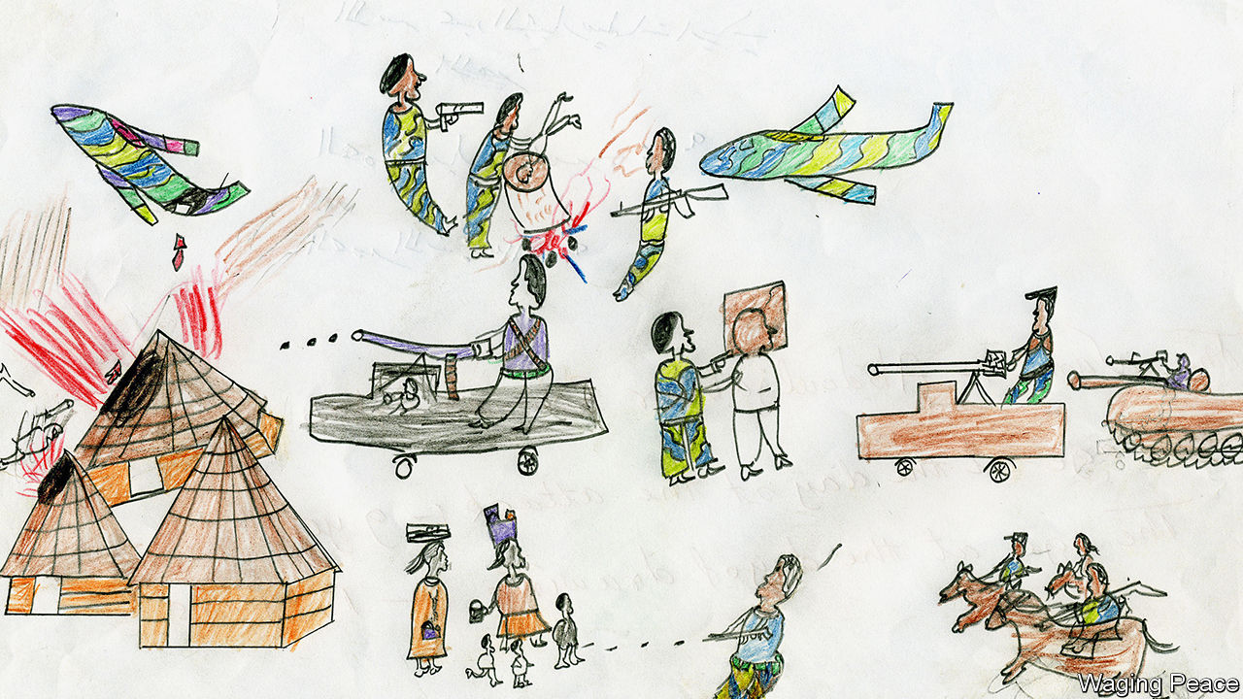

ABDUL JABBAR was nine years old when he was given some coloured pencils and asked to draw scenes from his life in Darfur. Like hundreds of thousands of others he had been driven from his village in a ferocious assault by the Sudanese army and their merciless accomplices, the Janjaweed, meaning roughly “evil on horseback”. Abdul Jabbar was surviving in a refugee camp—but at least he had survived. His drawing records the fates of some who did not. Here a young child is being thrown into a fire (see above). In the middle of the picture, a hooded man is being shot at close range. Towards the bottom, a soldier is cutting off another man’s head.

This drawing, and hundreds of others, were collected by Anna Schmidt (not her real name), a humanitarian worker for Waging Peace, a British NGO. She met Abdul Jabbar in a refugee camp in Chad, to which many Darfuris had fled. She was there to gather evidence of what had really happened in Darfur since full-scale conflict had erupted four years earlier, in 2003. The Sudanese government of President Omar al-Bashir claimed that its forces had carried out only a limited counter-insurgency operation, which rebels had provoked. Others suspected something much worse. For all the authorities’ sophisticated attempts to cover up their atrocities, the children’s drawings helped give the lie to the official version of events.

Ms Schmidt remembers that it was the mothers who urged her to talk to the children. “If you really want to know the truth,” they told her, “speak to them. Don’t just take it from us.” At first she wanted them to write about their experiences. Many, however, preferred to draw. They were asked simply to give an account of life in their villages; Ms Schmidt was shocked by the visceral images they produced.

Time and again, the same motifs recur. Helicopter gunships swoop low, bringing fire from the sky even as the people below are still sleeping. Next come the Janjaweed, on camel or horseback, followed closely by regular Sudanese troops in their “technicals”, pick-up trucks with heavy machine-guns mounted on the back. The detail—down to the flashes on the troops’ uniforms, clearly identifying them as regular Sudanese soldiers—is remarkable. The government claimed that this was never an ethnic conflict, but the children tell a different story. Often the victims are rendered with grey or brown skin, whereas their attackers are coloured pink. This indicates that the villagers are non-Arab, African groups (often Masalit), while their assailants come from Nilotic Arab tribes. In other words, this was ethnic cleansing and, as the International Criminal Court (ICC) was to rule, a genocide.

Some of these haunting images are on display at the Wiener Holocaust Library in London until April 1st. As Barbara Warnock, the curator, avers, they “provide crucial evidence of the experiences of child survivors of the genocide in Darfur”. They have previously stirred viewers elsewhere in Europe and in North America. But this new exhibition comes at a poignant moment for Sudan, and for the prosecution of the most grievous crimes against humanity.

## The art of suffering

Except for remote satellite images of incinerated villages, there was no contemporaneous photographic proof of the carnage in Darfur. That means the children’s sketches may be the most important visual representations of the killings that the world is ever likely to see. In 2007, as it investigated possible war crimes in the region, the ICC admitted the drawings as “contextual evidence”; Mr Bashir was himself indicted for genocide in 2010. Yet, tragically, the suffering is by no means over.

Despite a popular revolution in Sudan that toppled Mr Bashir and his regime last year, peace has yet to reach Darfur. Fierce fighting in early January killed roughly 50 more people, and displaced a further 40,000, according to the UN. After years of denial, the new Sudanese government has promised to investigate crimes in the region. The children’s drawings could yet be used in that process, even if Mr Bashir himself is never hauled off to the ICC.

Precedents for such use were set by war-crimes trials following the Holocaust. The best-known children’s drawings of that era are from Theresienstadt, a holding camp in Czechoslovakia in which Jews were imprisoned before many were transferred to death camps farther east.

Twelve thousand children passed through; few ultimately survived. Some were encouraged to draw by Friedl Dicker-Brandeis, a pioneer of art therapy. Although the Nazis used Theresienstadt as a show-camp to fool delegations from the Red Cross about the horror of the Final Solution, the truth breaks through in the drawings. One frequent motif is food—reflecting the hunger in a place where over 30,000 people were deliberately starved to death. Some of the images are all the more evocative for their eerie normality.

One Theresienstadt artist, Yahuda Bacon, also survived Auschwitz, which was liberated 75 years ago, on January 27th 1945. Soon afterwards, the 16-year-old drew his memories of the camp. Those pictures, including sketches of the gas chambers, were presented as forensic evidence in the early 1960s at the trials of Adolf Eichmann in Israel and of Auschwitz personnel in Frankfurt. Other drawings were considered, too.

These examples could yet have a bearing on the latest genocide, of the Rohingya Muslims by the Myanmar army. Last year Save the Children, a charity, asked youngsters in Rohingya refugee camps to draw what they wanted to tell the world, as part of their therapy. Again, some rendered extraordinarily detailed portrayals of the destruction of their homes and their flight to relative safety in Bangladesh (see below).

As yet, there is no plan to enlist these as evidence. But as courts whirr into action—on January 23rd, as The Economist went to press, the International Court of Justice was due to issue a ruling on the slaughter—interest in them may grow. Experience shows that, uncluttered by adult artifice, children can provide the most honest impressions of unspeakable acts, and the most searing. ■

This article was downloaded by calibre from <https://www.economist.com/books-and-arts/2020/01/25/for-child-survivors-drawing-is-therapy-and-a-tool-of-justice>

|  |  |  |  |
| --- | --- | --- | --- |
|  | Articles | Sections | Next |

|  |  |  |  |
| --- | --- | --- | --- |
| Previous | Articles | Sections | Next |

#### The high life

# Jakub Jozef Orlinski is not a typical opera star

A distinguished countertenor, he is also a keen breakdancer

Jan 25th 2020 |

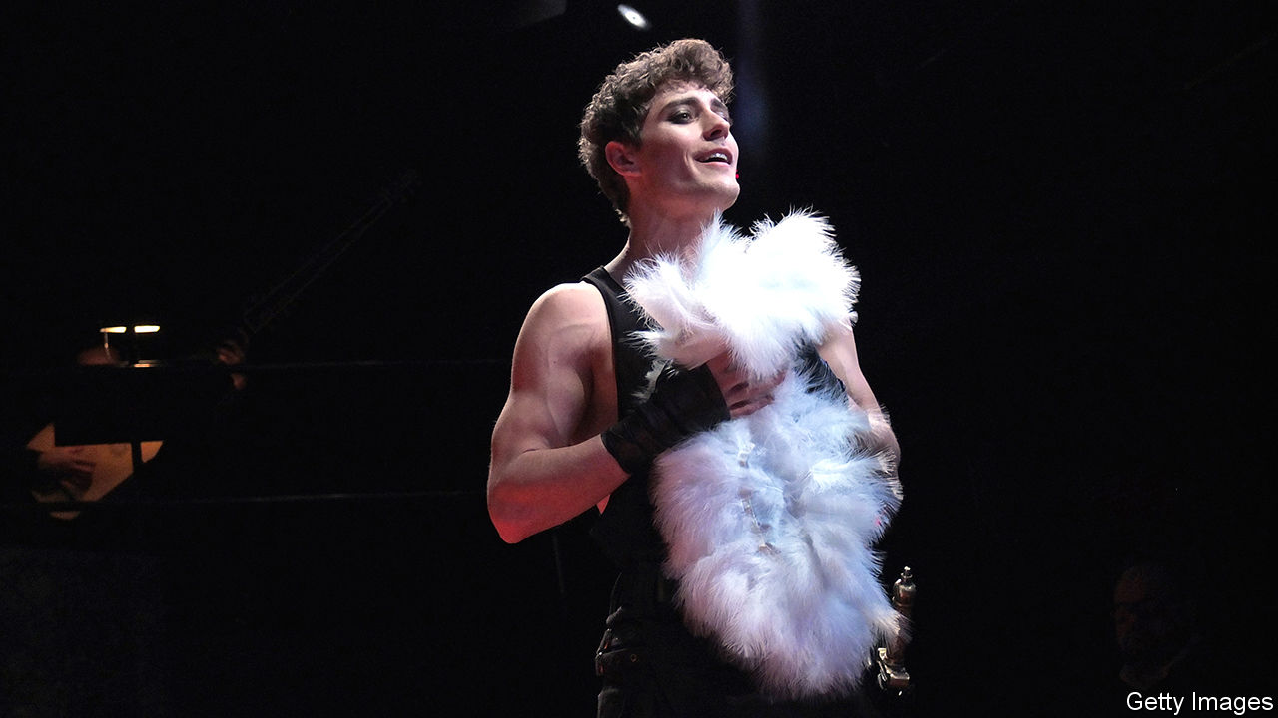

WHEN BREAKDANCING, splayed fingers jabbing to the beat, legs akimbo above improbable head-spins, he seems supremely macho. When performing arias and oratorios, brows arched above plaintive eyes, he seems as innocent as a chorister. In person, Jakub Jozef Orlinski is a vivacious yet plain-talking Polish opera star, who also maintains a deep commitment to street dance.

He grew up in the leafy Zoliborz district of Warsaw, where, with his friend Piotr, he joined a local choir as an alto at the age of eight. Piotr had the more beautiful voice, Mr Orlinski says modestly, but he had the staying power. He attended the Fryderyk Chopin University of Music in Warsaw, then the Juilliard School in New York. “He was like a sponge,” says Edith Wiens, who taught him there; “his disciplined work habits were astounding.” He knew nothing of harmony when he began his studies, and was unable to read music, but he emerged a masterful countertenor—the top of the vocal range for male voices—who sings in an ethereal falsetto.

Modern countertenors mostly sing parts originally intended for others. In previous centuries, castrati were the only male performers to reach these lofty registers; composers wrote specifically for them. In works by, for instance, Purcell and Handel, there were also roles for male singers whose natural range extended beyond their modern counterparts’. Men used to be smaller, explains Simon Ravens, a musicologist, and natural speaking and singing voices were generally much higher. The upshot is that there is very little music expressly designed for modern, falsetto countertenors like Mr Orlinski. They have to be adaptable.

“I started going to competitions,” Mr Orlinski says of his early career. “I wasn’t winning at first, but I met a lot of people.” Some were directors of opera festivals, who wield the same sort of clout as the scouts who determine the future of pop. The ploy paid off. Now 29, Mr Orlinski’s schedule is booked up for years to come. He has already made two records; last summer he sang the lead in Handel’s “Rinaldo” at the Glyndebourne festival in East Sussex, after the mezzo-soprano who had been cast pulled out.

Opera has a reputation for being staid and exclusive, but, perhaps because of his appealing looks as well as his artistry, Mr Orlinski is reaching new audiences. A former pin-up for Levi’s and Nike adverts, he has a big following on social media. When your correspondent met him, he had just performed at Sofia University in Bulgaria. The hall was packed with students who, he reckons, were impressed. So, he remembers, were a group of breakdancers on a recent trip to Switzerland.

“I looked up the local [breakdance] crew in Zurich and joined their training session,” Mr Orlinski says. After that, “I got them tickets and they came to see me sing. They couldn’t believe it!” His combination of talents and interests might seem eccentric, but look closely, and they chime. In breakdancing, anything goes. In ornamentation—the flourishes of notes that punctuate musical phrases—there is the same sort of licence, especially in the Baroque pieces that Mr Orlinski frequently sings. Both marry finely honed technique with the thrill of freedom. ■

This article was downloaded by calibre from <https://www.economist.com/books-and-arts/2020/01/25/jakub-jozef-orlinski-is-not-a-typical-opera-star>

|  |  |  |  |
| --- | --- | --- | --- |
| Previous | Articles | Sections | Next |

|  |  |  |  |
| --- | --- | --- | --- |
| Previous | Articles | Sections | Next |

#### Safe havens

# When America’s open road wasn’t open to all

Candacy Taylor tells the story of the real Green Book

Jan 25th 2020 |

Overground Railroad: The Green Book and the Roots of Black Travel in America. By Candacy Taylor. Abrams Press; 360 pages; $35.

ESPECIALLY IN AMERICA, travel has always been associated with freedom and opportunity. Immigrants sailing to a new world, pioneers heading West in search of virgin land, or lost souls hoping for a second chance—in each case, physical mobility has seemed essential to the social kind. But as Candacy Taylor demonstrates in her new book, “the open road wasn’t open to all”. As the author sets out in heartbreaking detail, for Americans of African descent the simple act of leaving home was often a dangerous undertaking.

Published from 1936 to 1967, the “Negro Motorist Green Book”—from which the Oscar-winning film of 2018 takes its name—helped make travel possible, if not exactly worry-free. In a country where lynchings and other attacks on black people were common, the guide was not only a convenience but often a lifesaver. As the understated tag-line on the edition of 1956 put it, “Carry your GREEN BOOK with you—you might need it.”

Along with informative articles, the guide listed hotels, restaurants, petrol stations and other essential services, many of them black-owned, where African-American customers would not be harassed or humiliated. It enabled readers—up to 2m at the height of its circulation in 1962—to avoid businesses where they were unwelcome and steer clear of “sundown towns”, where black visitors spotted after dark faced arrest, or worse. The Royce Café in Edmond, Oklahoma, for instance, proudly puffed the town as, “A Good Place to Live. 6000 Live Citizens. No Negroes.”

Though the “Green Book” mapped a geography of hate, it strived to maintain an upbeat tone, urging its readers to participate in the increasingly popular pastime of leisure travel. A feature titled “Let’s Go Places” identified the limited number of public places where, Ms Taylor says, black Americans could “swim, picnic and relax on the beach”. The “Railroad Edition” of 1951 insisted that “every effort has been made to assure a more pleasant journey”.

Despite the grim history that it recalls, “Overground Railroad” is not simply a chronicle of cruelty and despair (though both are abundant). In the face of systemic oppression, black culture and many black communities thrived. The book is full of stories featuring Duke Ellington, Ella Fitzgerald, Langston Hughes and countless other luminaries who led creative lives in the face of almost daily indignities. Prevented from mingling freely with their white compatriots, African-Americans created their own vibrant hubs, in Harlem, Denver’s Five Points and South Central Los Angeles. All this is documented in loving detail by Ms Taylor, through both text and photographs, many taken as she made her own pilgrimage to sites listed in the guide.

“Overground Railroad” is at its best in the small details that capture both the bitter and the sweet of lives and pleasures pursued in the teeth of injustice. Descriptions of “Green Book” favourites conjure a bygone era—such as Dooky Chase’s Creole restaurant in New Orleans, which Ray Charles celebrated in song, or the Dew Drop in the same city, which hosted performances by the drag queen Patsy Vidalia, as well as singers including James Brown, Sam Cooke and Otis Redding. By contrast, for all her legitimate indignation at past and present outrages, Ms Taylor’s musings on the wider political context rarely offer fresh insights. The strength of this book about a book lies in the street-level views through which the American road unspools in all its compromised glory. ■

This article was downloaded by calibre from <https://www.economist.com/books-and-arts/2020/01/25/when-americas-open-road-wasnt-open-to-all>

|  |  |  |  |
| --- | --- | --- | --- |
| Previous | Articles | Sections | Next |

|  |  |  |  |
| --- | --- | --- | --- |
| Previous | Articles | Sections | Next |

#### If you can get it

# Robots may well take your job—eventually

Or so reckons Daniel Susskind in “A World Without Work”

Jan 25th 2020 |

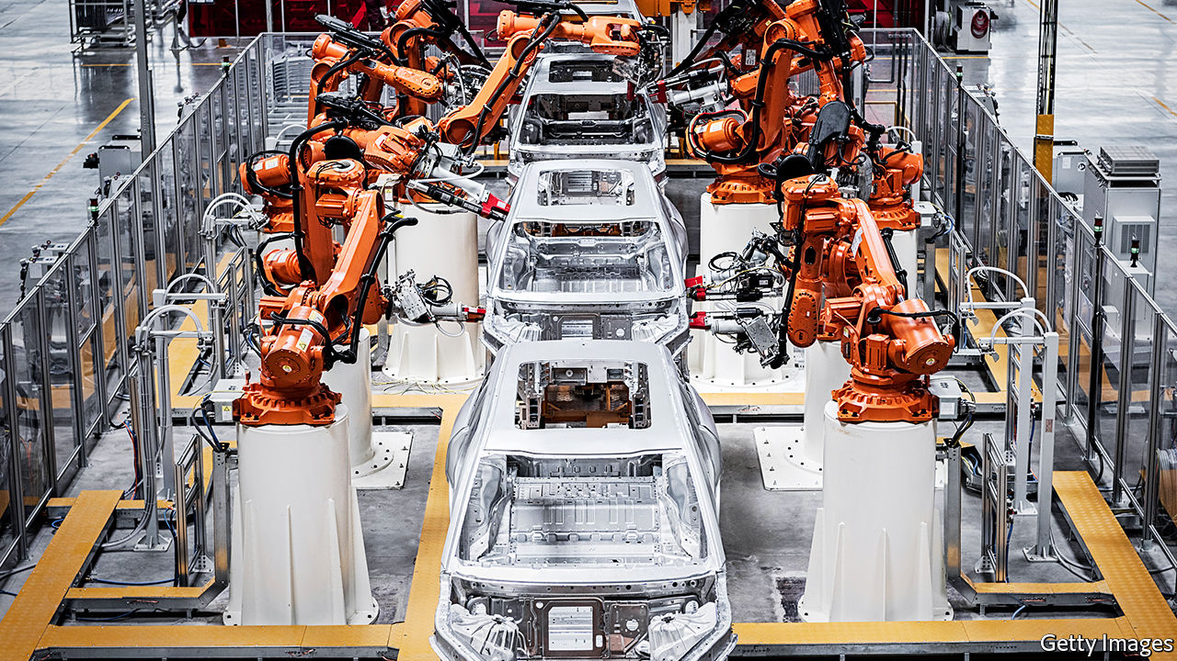

A World Without Work. By Daniel Susskind. Metropolitan Books; 307 pages; $28. Allen Lane; £20.

INNOVATORS ARE not always welcome. In 1589 William Lee made his way to the English court, hoping to be granted a patent for his invention, a knitting machine. Queen Elizabeth I turned him down: “Consider thou what the invention could do to my poor subjects,” she enjoined. “It would assuredly bring to them ruin by depriving them of employment.”

The fears of Good Queen Bess have echoed down the centuries—from the Luddites, who smashed textile machinery in the early 19th century, to John F. Kennedy, who warned of the dangers of automation during his presidential campaign of 1960. In the 21st century the concerns have switched to robots and artificial intelligence (AI); 30% of American workers believe their jobs are likely to be replaced by robots and computers in their lifetime.

Daniel Susskind has written about this issue before in “The Future of the Professions”, co-authored with his father, Richard. That book focused on the threat posed by machine-learning to doctors, lawyers and the like. His new tome is a much broader look at the economic and social consequences of automation.

In the past the relationship between machine and human labour has been driven by two factors: the substituting effect, which caused people to lose jobs, and the complementing effect, which allowed employees to do their work more productively. The author worries that, in the future, the substituting effect will dominate. Advances in AI have been so rapid that machines will eventually be better than people at most activities, he says, and so will be the “default choice” for performing them. A few highly paid humans will still be employed, but the rest will either struggle to find work or fall into the “precariat”, stuck in jobs that are not just poorly paid but unstable and stressful.

Mr Susskind thinks that this scenario will require a change in political thinking. Part of his answer would be a “conditional basic income”, paid by the government and financed by taxes on the better-off. Rather than being universal, this would come with provisos: recipients would have to make some contribution to society, such as providing social care or teaching children. Given all the superabundant free time, societies will also need a more coherent leisure policy, coaxing people away from their smartphones and televisions.

This gloomy view of the impact of technology is plausible. But so is a more optimistic outlook, as the economist Roger Bootle showed in “The AI Economy: Work, Wealth and Welfare in the Robot Age”, published last year. Mr Bootle argued that AI and robotics would improve productivity and economic growth, and release people from performing the most humdrum tasks. As for employment, there will always be demand for services with the human touch, just as there is an appetite for “artisanal” loaves as well as sliced white bread.

Which of these visions is right? Recent history has not vindicated either the optimists or the pessimists. Employment has surged in both America and Britain, suggesting that technology has not led to widespread labour replacement. On the other hand, growth in productivity has consistently been extremely disappointing, indicating that technology is not yielding the hoped-for increases in prosperity. This record is a shaky basis on which to make forecasts. Mr Susskind wisely hedges his bets, declaring that “in all likelihood, there will be enough work for humans to do for a while yet.” The problem, he says, lies in the long run.

Perhaps. The truth is that, seductive as prognostications like Mr Susskind’s may be, it is impossible to be sure whether the latest advances will in the end have mainly benign or malign economic effects. Books like his are a useful summary of the current debate on an important subject. But they are not crystal balls. ■

This article was downloaded by calibre from <https://www.economist.com/books-and-arts/2020/01/25/robots-may-well-take-your-job-eventually>

|  |  |  |  |
| --- | --- | --- | --- |
| Previous | Articles | Sections | Next |

|  |  |  |
| --- | --- | --- |
| Books and arts | Sections | Graphic detail |

Economic and financial indicators

Economic data, commodities and markets

.

|  |  |  |
| --- | --- | --- |
| Books and arts | Sections | Graphic detail |

|  |  |  |  |
| --- | --- | --- | --- |
|  | Articles | Sections | Next |

# Economic data, commodities and markets

Jan 25th 2020 |

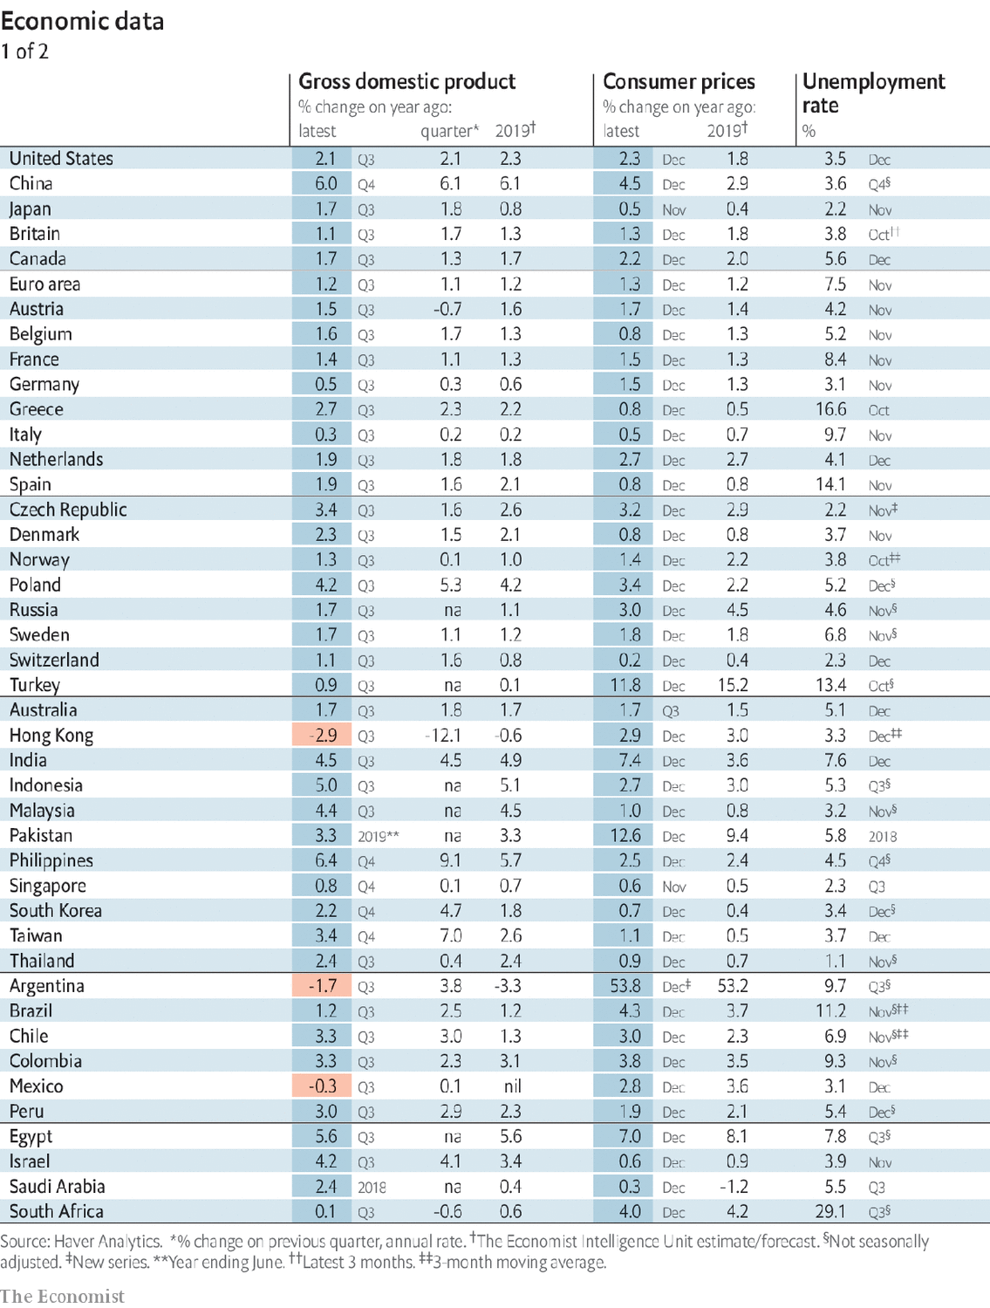

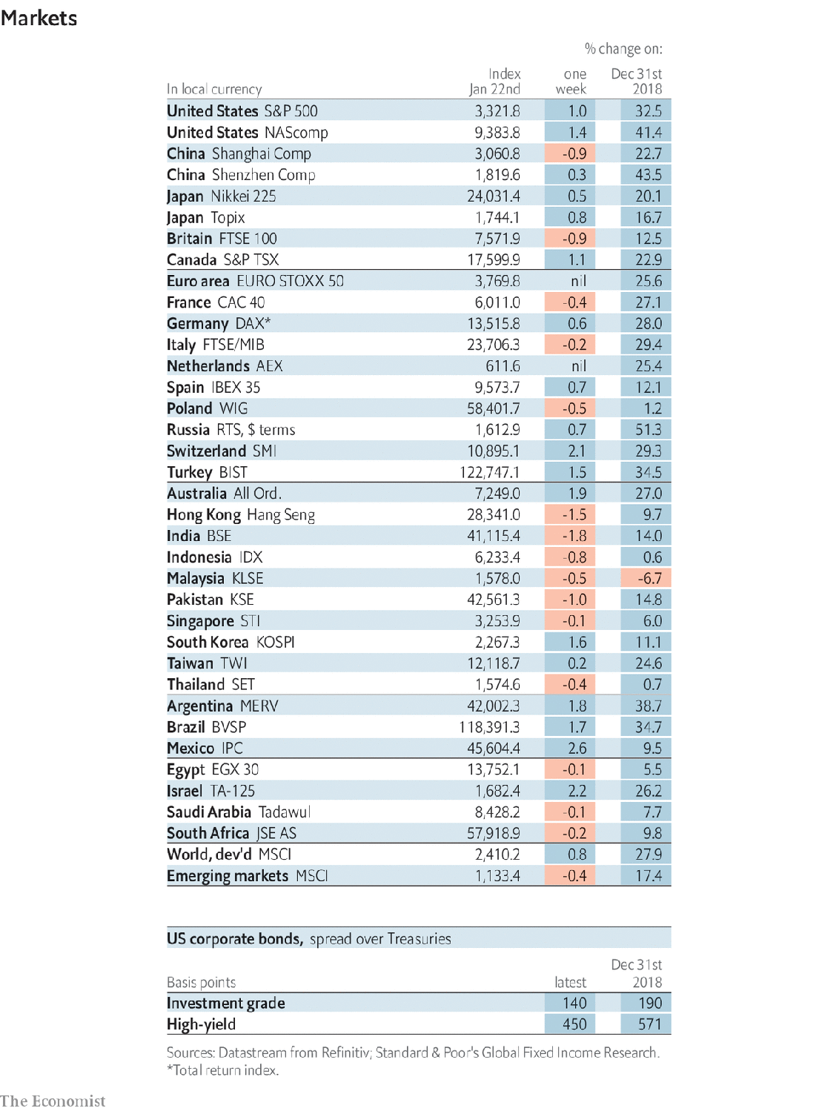

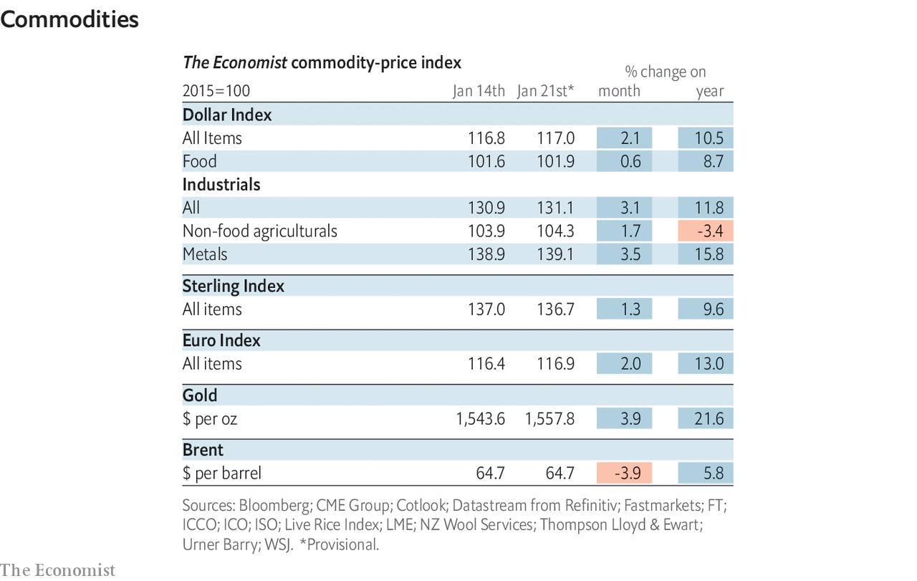

This article was downloaded by calibre from <https://www.economist.com/economic-and-financial-indicators/2020/01/25/economic-data-commodities-and-markets>

|  |  |  |  |
| --- | --- | --- | --- |
|  | Articles | Sections | Next |

|  |  |  |
| --- | --- | --- |
| Economic and ... | Sections | Obituary |

Graphic detail

|  |  |  |
| --- | --- | --- |
| Economic and ... | Sections | Obituary |

|  |  |  |
| --- | --- | --- |
| Graphic detail | Sections |  |

Obituary

|  |  |  |
| --- | --- | --- |
| Graphic detail | Sections |  |